SOUTHAMPTON SOLENT UNIVERSITY

SCHOOL OF MEDIA ARTS AND TECHNOLOGY

BSc (Hons) Web Design and Development

Academic Year 2016-2017

N.HOCKEY

Researching, designing and testing a cloud-based resource scheduling application for small – medium sized creative teams

Tutor: M.Reid May 2017

This report is submitted in partial fulfilment of the requirements of Southampton Solent University for the degree of BSc (Hons) Web Design and Development

# **List of Contents**

[List of Contents 2](#_Toc481595177)

[List of Figures 4](#_Toc481595178)

[List of Tables 5](#_Toc481595179)

[Acronyms 6](#_Toc481595180)

[1. Introduction 7](#_Toc481595181)

[2. Aim and Objectives 9](#_Toc481595182)

[3. Literature Review 11](#_Toc481595183)

[**4.1 Purpose** 18](#_Toc481595184)

[**4.2 Scope of the System** 18](#_Toc481595185)

[**4.3 Product Perspective** 18](#_Toc481595186)

[**4.4 User Interface Requirements** 19](#_Toc481595187)

[**4.5 Functionality** 19](#_Toc481595188)

[**4.6 Constraints** 21](#_Toc481595189)

[5. Methodology 22](#_Toc481595190)

[6. Planning 25](#_Toc481595191)

[**6.1 User Research** 25](#_Toc481595192)

[**6.2 Personas** 27](#_Toc481595193)

[**6.3 User Journey and Empathy Mapping** 28](#_Toc481595194)

[**6.4 Competitor Analysis** 28](#_Toc481595195)

[**6.5 Mood Boards** 28](#_Toc481595196)

[**6.6 Site Map** 28](#_Toc481595197)

[**6.7 Wireframes** 29](#_Toc481595198)

[7. Design 31](#_Toc481595199)

[**7.1 Branding** 31](#_Toc481595200)

[**7.2 Design** 32](#_Toc481595201)

[**7.3 Design Features** 36](#_Toc481595202)

[**7.3.1 Creating A Project** 36](#_Toc481595203)

[**7.3.2 Editing A Project** 38](#_Toc481595204)

[**7.3.3 Adding A Task** 39](#_Toc481595205)

[**7.3.4 Viewing Schedule** 39](#_Toc481595206)

[**7.3.5 Setting Up App Integration** 40](#_Toc481595207)

[8. Prototyping 42](#_Toc481595208)

[9. Testing 44](#_Toc481595209)

[10. Results 46](#_Toc481595210)

[11. Evaluation and Conclusions 47](#_Toc481595211)

[12. Recommendations for Further Work 48](#_Toc481595212)

[13. Appendices 49](#_Toc481595213)

[**Appendix X – Waterfall Methodology** 49](#_Toc481595214)

[**Appendix X – Spiral Methodology** 51](#_Toc481595215)

[**Appendix X – Survey Results** 53](#_Toc481595216)

[**Appendix X – User Interviews** 56](#_Toc481595217)

[**Appendix X – Personas** 68](#_Toc481595218)

[**Appendix X – Site Map** 72](#_Toc481595219)

[**Appendix X – Medium Fidelity Wireframes** 74](#_Toc481595220)

[**Appendix X – High Fidelity Designs** 80](#_Toc481595221)

[**Appendix X – Sketch Plugins** 98](#_Toc481595222)

[**Appendix X – Comparison of Medium Fidelity Wireframing Tools** 99](#_Toc481595223)

[**Appendix X – Comparison of Prototyping Tools** 100](#_Toc481595224)

[**Appendix X – Design Features** 101](#_Toc481595225)

# **List of Figures**

Figure 1: The Idea Bureau Website

Figure 2: Basic Gantt Chart Diagram

Figure 3: Types of Dependencies

Figure 4: 2016 Tech Nation Report

Figure 5: Usability Testing Statistics Nielsen Norman

# **List of Tables**

Table 1: User Interface Specifications

# **Acronyms**

HTA – Hierarchical Task Analysis

IA – Information Architecture

SVG – Scalable Vector Graphic

UI – User Interface

USP – Unique Selling Point

UX – User Experience

QA – Quality Assurance

# **1. Introduction**

The Gantt chart was created in 1903 by Henry Laurence Gantt with the purpose helping to manage and plan projects according to Trainer (2012). These charts are used as a visual way of documenting the duration of a project and its progress. Gantt (2016) reveals that years ago these charts were prepared by hand, however in a projects life-cycle schedules change and this is a natural occurrence. When this does inevitably happen the Gantt charts need to be amended / redrawn in order to remain consist with a projects schedule. As soon as the Gantt chart comes out of sync with the project it becomes redundant. Managing client expectations then becomes impossible. On both small and large scale projects this was not a convenient medium for Gantt charts to exist.

When personal computers became available in the 1980s, digital and more complex Gantt charts could be created. This meant that the natural changes in a projects life-cycle could be better managed and conveyed to teams. Paymo (2016) states that as Gantt charts became accessible on web-based application the popularity of this project management tool increased. Gantt charts are one of the most popular project management scheduling tools in the creative industry according to Heaton (2016b). These charts became digitalised over 100 years ago, yet user’s needs are still unfulfilled, especially within the creative industry.

This project is a result of the team at The Idea Bureau wanting to create a product to help solve the issues with managing projects in creative teams. The Idea Bureau is a small digital workshop located in Taunton, Somerset. The company’s ethos is to create engaging digital experiences that have a positive impact around the world. After having tried and tested a vast amount of project management tools in the industry, The Idea Bureau feel that it is now time to design and build a tool that can work for creative teams effectively. The Idea Bureau’s website can be found at [www.theideabureau.co](http://www.theideabureau.co) and Figure 1 provides a preview of the website.

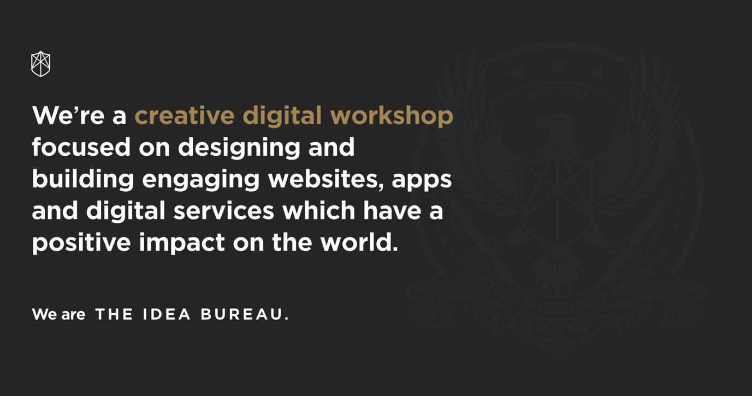

**Figure 1 – The Idea Bureau Website**

Working alongside the team at The Idea Bureau is going to involve being in constant communication about the different phases of this project. Having regular meetings and check-ins will be essential in the progression and high quality delivery of this project.

# **2. Aim and Objectives**

The aim of this project is to identify the growth in the creative industry and how there is a demand for project management tools within this industry. A suitable solution will be designed based on users’ needs and the final output will be a clickable prototype.

1. Carry out research into the history of Gantt charts and the progression over the last 100 years, competitor’s analysis, the growth of the creative industry and how these charts are currently used in the industry will be carried out to gain a solid understanding. This research will be achieved by 19th March 2017 and roughly 50 hours will be spent on this.
2. Carry out quantitative and qualitative research into user’s behaviours to an industry based standard. The data gained from this will inform design solutions and the overall user experience of the end product. 10 hours will be spent on this and it will be done by 29th March 2017.
3. Analyse research findings in order to identify trends and anomalies before moving forward and creating personas, user journey’s and empathy maps. A UX workshop will be essential so that research findings can be shared with the team at The Idea Bureau. A total of 20 hours will be spent on this and it will be achieved by 4th April 2017.
4. Using the research gathered wireframes and rapid prototyping will be done to allow for exploration of IA and UI components. This will be done by 13th April 2017 and 10 hours will be spent on this.
5. This will result in high fidelity designs created in Sketch, an industry standard UI design tool. These designs will then be synced with InVision to create a professional prototype for user testing purposes. 50 hours will be spent on this and it will be finished by 23rd April 2017.
6. The final clickable prototype will be tested on a minimum of 5 users. All of this data will be analysed and necessary design improvements will be considered. 15 hours will be spent on this and it will be done by 3rd May 2017.

# **3. Literature Review**

With milestones and deadlines constantly changing, project management is a difficult task, no matter what sized team. Teams can easily fall behind if there is no effective guidance and tracking from a project manager, and this is why Gantt charts are a beneficial way of dealing with client / team member’s expectations. Nishadha (2012) reveals that Gantt charts provide a visual representation of the project pipeline and what is expected.

A Gantt chart is the best graphic available for project managers as it is the most useful and insightful diagram. Figure 2 shows a basic diagram of a Gantt chart.

**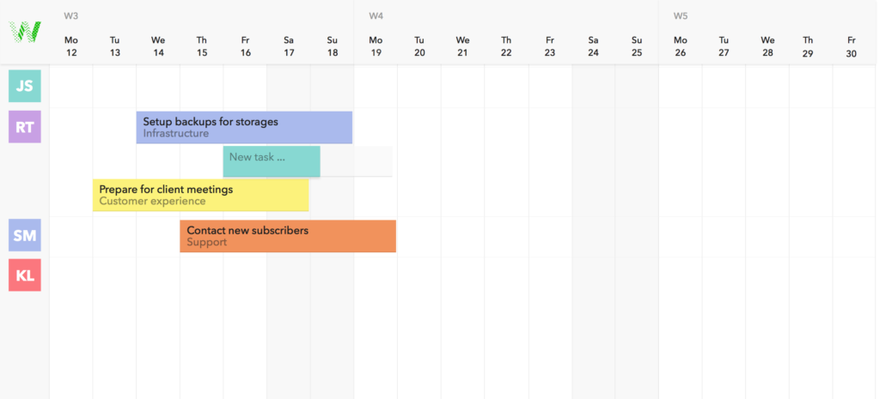**

**Figure 2 – Basic Gantt Chart Diagram**

However, Gantt charts do come with issues. The common errors behind these issues are:

* Providing too much information
* No consideration for version control

It can be tempting to start adding multiple layers to Gantt charts, but this only increases the upkeep and is visually overwhelming. As a project evolves maintenance is required and more often than not there is no backlog showing the history of a project. Harper-Smith and Dery (2012, pp. 141 – 142) writes how having the visual understanding of a projects evolution is priceless.

In recent years drag and drop functionalities have been implemented into most online Gantt chart software. This makes it easier to add tasks, create dependencies and update timeframes according to John (2011). Dependencies have become a staple feature and they are used between tasks that occur chronologically in a waterfall methodology. This means that if a task is delayed then the remaining project pipeline will adapt to accommodate for this writes Valdellon (2014). Dependencies refer to data relationship between tasks and there are four main types. These are finish to start, start to start, finish to finish and start to finish. All of these could exist within a single Gantt chart project reveals Project Insight (n.d). Figure 3 is a diagram showing how these four types of dependencies appear visually.

**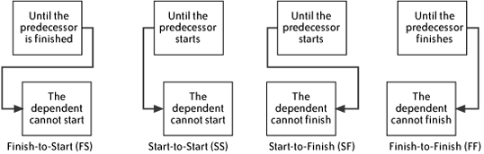**

**Figure 3 – Types of Dependencies**

There is an ongoing debate as to whether or not Gantt charts can fit into an agile workflow. Woo (2014) explains that Gantt charts are still beneficial as they are quick to communicate whether a project is on track. Dependencies are also a crucial feature needed, even in an iterative process.

Within an iterative process there are still layers that make up an iteration or a sprint and these can be visualised in a Gantt chart. However, Sutherland (2006) who invented Scrum in 1993 (a smaller version of the agile methodology) banned the use of Gantt charts. This was because even after the first working day the chart would be outdated and the maintenance of this would be too much. Even after 13 years Jeff Sutherland still frowned upon mixing Gantt charts with an agile / scrum methodology. Croft (2015b) reveals that there has been a lot of competition and rivalry between the two methodologies and which ones are suitable for managing creative teams. Waterfall, agile and scrum methodologies are the main contenders but they all bring advantages and disadvantages. Agile and scrum do not allow for planning of duration and costs, which is why Jeff Sutherland was against the usage of Gantt charts. However, the cost and duration of a project contains key information that should be communicated with clients. By breaking down the iterative sprints into phases this can be clearly documented in a Gantt chart format effectively.

In today’s industry it is rare for there to be single teams working on projects, it is becoming much more of a collaborative process. Naturally this is making managing projects more complex. Especially when there are multiple teams dispersed in different locations. A Gantt chart can help to become a central place for al teams involved, whilst also providing higher level insights for management according to Horvath (2016).

By having a central place for team members it means everyone is on the same page with upcoming milestones and deadlines. Collaborating effectively is key to completing projects on time and in budget. Having a visual representation of tasks helps to put projects into perspective for users. This means that if one member misses a deadline, then the member is aware of the implications on the rest of the current / other projects reports Proof Hub (2016). Croft (2015a) states that when making estimates for the duration of tasks and working within client budgets it is essential to double check with team members. This is because the team members are the ones completing the work, so if there are any issues then this can be addressed earlier on. For effective planning it is important for team members to communicate realistic timeframes in order to show a realistic implementation of the project pipeline. Whilst also allowing the project manager to handle client expectations professionally and effectively writes Meredith, Mantel and Shafer (2016, pp. 272 – 273).

Paula (2016) argues that contingency planning is a really important process in order to identify and deal with problems in a calm and effective manner that have the least impact on the project pipeline. Contingency planning is about knowing what can be done to prevent problems arising and ways to reduce the risk of this happening. Risk management and contingency planning go hand in hand for effective project management states Webster (2014).

Lindenthal (2016) explains that one of the biggest reasons why projects fail, alongside poor management is scope creep. All the small extra tasks that get agreed to along the way add up and without clear insights into the project plan it is difficult to understand the implications. Scope creep often occurs once the project is already underway and clients increase expectations according to Stachowiak (2014).

Aldahleh (2014) reports that Gantt charts are not a suitable method in modern professions. It can be seen as a counter productive method and discourage innovation and creativity. Gantt charts that rely on dependencies showing team members the direct impact on future phases create too much pressure for professionals. The first idea is not also the best idea and presenting deadlines and dependencies could hinder creativity. Within the creative industry projects life span is usually scheduled over a few months, if not more. According to Aho (2013) Gantt charts are not suitable for projects that last over 2 -3 weeks. This is because the maintenance becomes too much work and there are too many conflicting variables. On the other hand, projects spanning a few months can be broken down into weekly sprints if needed. But this approach very much depends on the project manager and the level of detail. Sehlhorst (2007) agrees with Aho (2013) in saying that Gantt charts are only effective for immediate plans and the value decreases when long term scheduling occurs.

The purpose of this project is to create a Gantt chart for creative teams and the 2016 Tech Nation report states that there are now 58,000 digital businesses in the United Kingdom alone. 17% of these businesses are built up of software and app development companies, this makes up for the top sector according to Smirke (2016). Figure 4 provides a clear overview of findings from the 2015 Tech Nation report. The tech sector allows for Britain to have a competitive edge, which transforms the economy and changes day to day living reports Tech City and Nesta (2016). There has also been a rise in the number of small independent companies stepping into the creative field explains The Independent (2011). Whilst this is referred to as a creative boom, it is important to understand that these companies are working together in partnership and thrive together. It is not about stealing and pitching for the same work, it is about establishing a solid creative community writes Blackwell (2015). With this creative industry boom it is easy to establish the need for better project management tools, even for smaller sized teams.

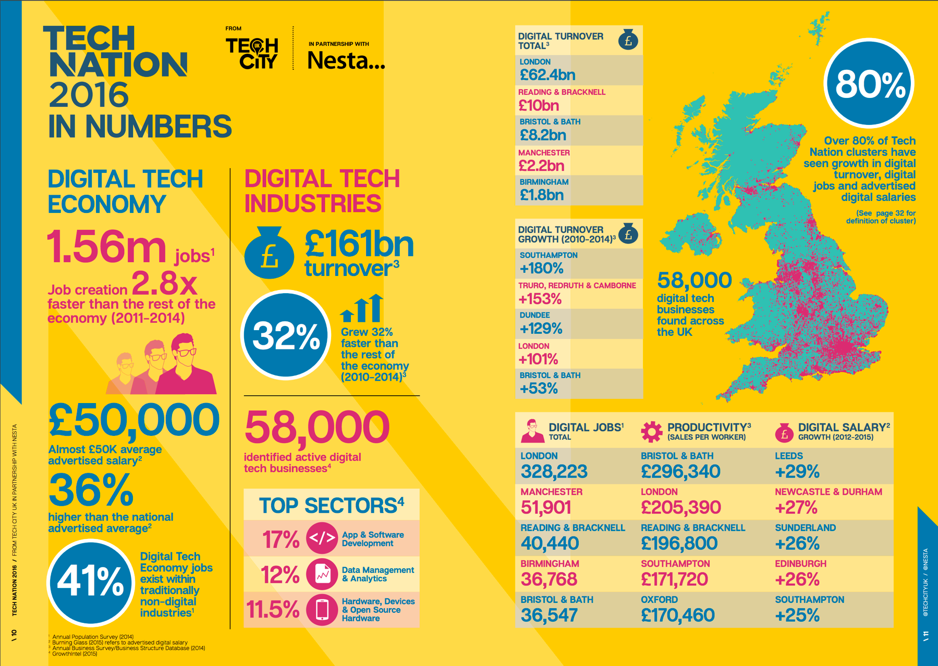

F**igure 4 – 2016 Tech Nation Report**

All of these studies present insights into the state of Gantt charts and how they can fit into different workflows. The 2016 Tech Nation Report reveals that with the growth of the creative industry there is a need for more project management tools that cater specifically for these needs.

\* BURN DOWN CHARTS

**4. Specification**

## **4.1 Purpose**

The main purpose of Project Pipeline is to provide a service for small – medium sized creative teams wanting to manage projects successfully.

## **4.2 Scope of the System**

In order to avoid scope creep, the scope of the project was defined before moving forward in the UX / UI phases.

1. The design of Project Pipeline will be a desktop web app.
2. Costs in carrying out user research, designing the interface and testing should predominantly free. However, if any software costs do arise then The Idea Bureau will cover them.
3. The design will be modern, minimalistic and easy for users to use.
4. Users should be able to carry out a substantial amount of tasks through the prototype. Although there will no be ability to add in real data.

## **4.3 Product Perspective**

There are lots of project management tools available to creative teams in the market. However, after having tried and tested a variety of these tools it was time to create a product that works for users intuitively. The aim of Project Pipeline is to allow users to create and manage projects easily with the ability to add project budgets. Adding budgets will provide users with an insight into if a project is expected to be under / over budget. Users are also able to see a projects history. This means that teams can be better prepared when planning new projects e.g. if a team went over on a design phase then more time could be allocated in the next project for this.

## **4.4 User Interface Requirements**

Creating a fully functioning prototype is going to require having a variety of screens for users to experiment with. A list has been created below of the main screens needed to ensure that all functionalities are captured.

* Home Screen
* Sign Up Screen
* Log In Screen
* Projects
* Create New Project
* Edit Project
* Settings
  + Settings Sub Pages
* Timeline View
* Team Member View
* Daily Digest
  + Today
  + Tomorrow
  + Weekly
* Add A Task
* Card View

## **4.5 Functionality**

There are a number of functionalities that will need to be included within the screens to make them functional for users. The following functionalities will be included within the prototype for Project Pipeline:

|  |  |
| --- | --- |
| **Functionality** | **Why is it needed?** |
| User sign up | Users are required to have the ability to sign up to an account. This will mean that the date created inside projects and team member information will be protected. |
| User log in | Returning users will be required to log in with an email address and password. |
| Creating a project | Users should be able to create different timeline sections for different projects. |
| Editing a project | Once a project has been created, it is important to make sure that users can edit the format of projects in future. |
| Adding a task | The timeline interface should allow users to add new tasks and assign team members. |
| Milestones | Milestones will be created to document important dates inside a project. This will help to make all team members aware of what is happening. |
| Budgeting | Being able to budget projects is one of the main USP’s of Project Pipeline. So allowing users to set daily rates is an essential feature. |
| Team member view | Users should be able to toggle between a project view and team member view. This will allow users to see schedules in different formats. |
| Settings | Users should be able to alter settings for Project Pipeline in one section. This will make it easier to manage accounts etc. |
| Integrating apps | Another USP for this project management tool is the ability to integrate it with apps. This will provide a more fluid workflow. |
| Daily schedule | Users will be provided with a daily schedule in a to-do list format. This means that there is not the need to dive into specific project timelines to find out daily plans. |
| Card view | A card view can be viewed to provide an overview of tasks that are in progress, completed etc. |
| Notifications | Notification emails can be provided daily if users feel the need for this functionality. |

**Table X – User Interface Specifications**

## **4.6 Constraints**

There are several constraints to this which could effect the process and user testing phase. These are:

1. Users may not understand the purpose of a prototype. A prototype means that the user can not input any data and it is purely just clickable to show a user’s journey.
2. Web browsers, specifically out of date ones, may not be able to load the prototype properly. Especially taking into consideration the size of the prototype.

## **4.7 Criteria for Success**

In order to effectively measure the success of this project a criteria for success has been created. A table of this criteria can be found below. If all the criteria are met, then this means that the project has been successful. Another table has been created (Appendix X) to show whether or not the project met the specified criteria.

|  |  |  |
| --- | --- | --- |
| **Has a clickable prototype been created using InVision?** | Yes | No |
| **Does a style guide exist? (colour, typography)** | Yes | No |
| **Is there the ability to add tasks?** | Yes | No |
| **Can tasks have dependencies?** | Yes | No |
| **Can projects have milestones?** | Yes | No |
| **Have budget constraints been considered?** | Yes | No |
| **Can apps be integrated?** | Yes | No |

**Table X – Criteria For Success**

**5. Methodology**

Fellner (2014) reveals that methodologies help to carry out projects comprehensively. If the right methodology is being used, then the process should feel intuitive and accurate. Not using a methodology for projects reduces the success rate. This is down to a lack of structure and project control according to Borysowich (2010). With a variety of different methodologies, it was essential to carry out a comparison (Appendix X and X) before deciding which to move forward with.

After carrying out a comparison between Agile, Waterfall and Spiral it has been decided that an Agile approach would be used to complete this project successfully. Figure X is a visual diagram of how the Agile methodology works.

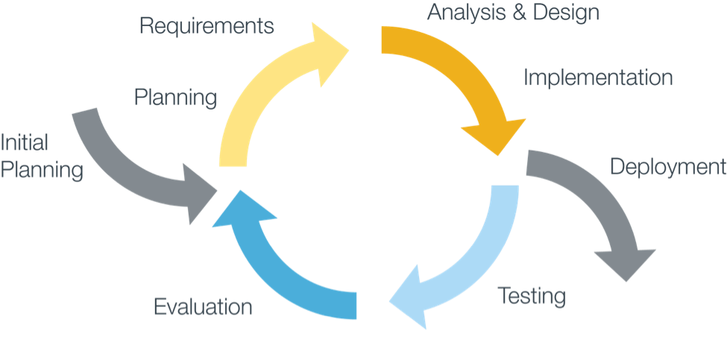

**Figure X – Agile Methodology**

The term Agile for designers can be slightly odd to comprehend as when the methodology came around in 2001 it was primarily aimed at software developers. Joel (2015) explains that despite this Agile can be a very effective method for the design process. It allows for large scale problems to be broken down according to Brooks (2014). As this method is an iterative process it removes the pressure of getting the design right first time. This also allows for user testing and UI changes to be considered and then tested again.

On the other hand, Lillington (2015) argues that working to a fast pace and in iterative sprints the overall quality of the design could suffer. Designing websites and apps takes time and research and this is something that the Waterfall approach allows for. The benefits of gaining user feedback earlier on in the design process outweighs Lillington’s argument. Having the ability to design and roll out new features and functionalities is a lot easier with an iterative workflow.

It was vital that this project stayed on track and within the schedule created, otherwise the final deadline would be in jeopardy. Clum (2013) states that this methodology has a strong emphasis on designing and implementing products and services on-time and in-budget. This methodology also ties in with the process followed at The Idea Bureau, which means that a professional workflow is being adhered to.

Since the project review schedule was created, which can be found in Appendix X. Certain timings have changed and this is due to having to manage another assignment alongside this. Although this meant that a new Gantt chart had to be created, the final deadline was still achieved. If anything it has given more time to create a polished interactive prototype and more thorough user research.

Originally the user research and design phase was meant to be completed by… but it has been pushed forward until … .

* Talk about how all files were version controlled using GitHub

Prior to diving into the project a list of risks was identified and displayed in a risk register. This can be found in Appendix X. Overall throughout the duration of this project there has not been any significant issues with the risks previously identified. Users were sourced easily for the user interviews and this was done through asking project managers / designers / developers on Twitter. There were no issues with scope creep, Sketch bugs or website content.

The only two risks that did occur were inaccurate estimates and not being able to get into the usability lab. However, there was plenty of time left at the end of the project so all of the work still got completed. Due to work commitments with The Idea Bureau and running slightly behind schedule it meant that there was not time to travel to Southampton to use the usability lab. Whilst doing this would have provided some useful insights (heat maps and gaze plots) effective user testing has still taken place.

# **6. Ethics**

As discovered at the beginning of this project there was undoubtedly going to be ethical issues to consider. This project required the need to be in contact with potential users of Project Pipeline through the use of surveys and interviews. Due to this an ethics form needed submitting to the university (Appendix X). This form was accepted hassle free and it meant that carrying out these user interviews was possible whilst also conforming to the university ethics regulations.

The research collected from the participants has been kept anonymous and has not been shared outside The Idea Bureau or university. As stated in the ethics form the participants involved were not children or vulnerable making the user research phase of this project successful.

# **7. Planning**

## **7.1 User Research**

Having an understanding of users when designing user interfaces is essential. There are two types of data that can be collected and these are quantitative and qualitative. Veal (2016) states that inexperienced designers often skip the user research phase and rely on biased opinions to create designs. This is dangerous and can impact clients’ business or service.

For this project a combination of quantitative and qualitative research has been carried out. Using a combination of these methods helped to gain a solid foundation to move forward into the design phase of this project. According to Thelwell (2015) surveys are a great way to collect large amounts of data. Surveys also help to gain a better understanding of the end user and Gray (2014) reveals that an intuitive experience starts with a great survey.

The survey created was made up of eight questions and presented and shared on Typeform. Typeform is an online survey platform that allows users to create customisable surveys that provide in-depth analytics on research findings reveals Funke (2016). The data collected through this tool is all anonymous. This survey was about finding out about user’s habits with existing project management tools, what features should be included in a new tool and if there was room in the market for a new tool. The survey got 25 responses from a combination of project managers and team members working in small – medium sized teams. Results show that 80% of participants felt that there was a gap in the market and the main features required by users were:

* Dependencies
* Assign tasks
* Organisation cards
* Overview of schedules

A full breakdown of the results can be found in Appendix X.

The second part of the user research phase was to carry out five user interviews. Nielsen (2000) reports that interviewing only five participants is needed to gain the most valuable information. Anything beyond this is seen as a waste of time and resources. Figure 5 is a graph supporting Nielsen’s research on this.



**Figure 5 – Usability Testing Statistics Nielsen Norman**

Since it has been established that the two user types for the project are project managers and team members a variety of these users have been interviewed. This means that both user perspectives have been carefully considered. These interviews have helped to understand the frustrations and pain points of existing tools as well as what works. Transcripts of these interviews can be found in Appendix X.

All of the research gained in this phase of the project has heavily influenced the design of the clickable prototype. Without these research findings the prototype would have been built based on personal experiences with these tools. Taking into consideration a wider audience has definitely helped to create a professional workflow with a detailed end product.

## **7.2 Personas**

Personas are a tried and tested part of the UX process as they have been in use since the mid 90’s reveals Goltz (2014a). Usability Gov (2013) explains that personas are about creating realistic representations of different user types. These personas should be informed by user research collected. The more in depth research carried out the better quality personas.

Based on the user research that was collected for this product, two personas have been created for each user type (team member and project manager). These personas have been used as a base for the user journeys. By factoring in personas it makes the process more realistic and relatable both for the client and the designer working on the project. These personas can be found in Appendix X. Meyer and Wachter – Boettcher (2016, pp. 7 – 10) stress that taking into consideration user’s stress cases is important as this is when the application is tested the most. A small case study on why this is required can be seen in Appendix X.

## **7.3 User Journey and Empathy Mapping**

Typically, user journey’s follow on from the persona phase of the UX process. According to Adaptive Path (n.d.) the process of mapping out a user’s journey is a strategic process that helps to capture and communicate users interactions with the product. Doing this helps to iron out complexities and reduces the likelihood of creating a bad user experience. The user journey can be seen below in figures X,X and X.

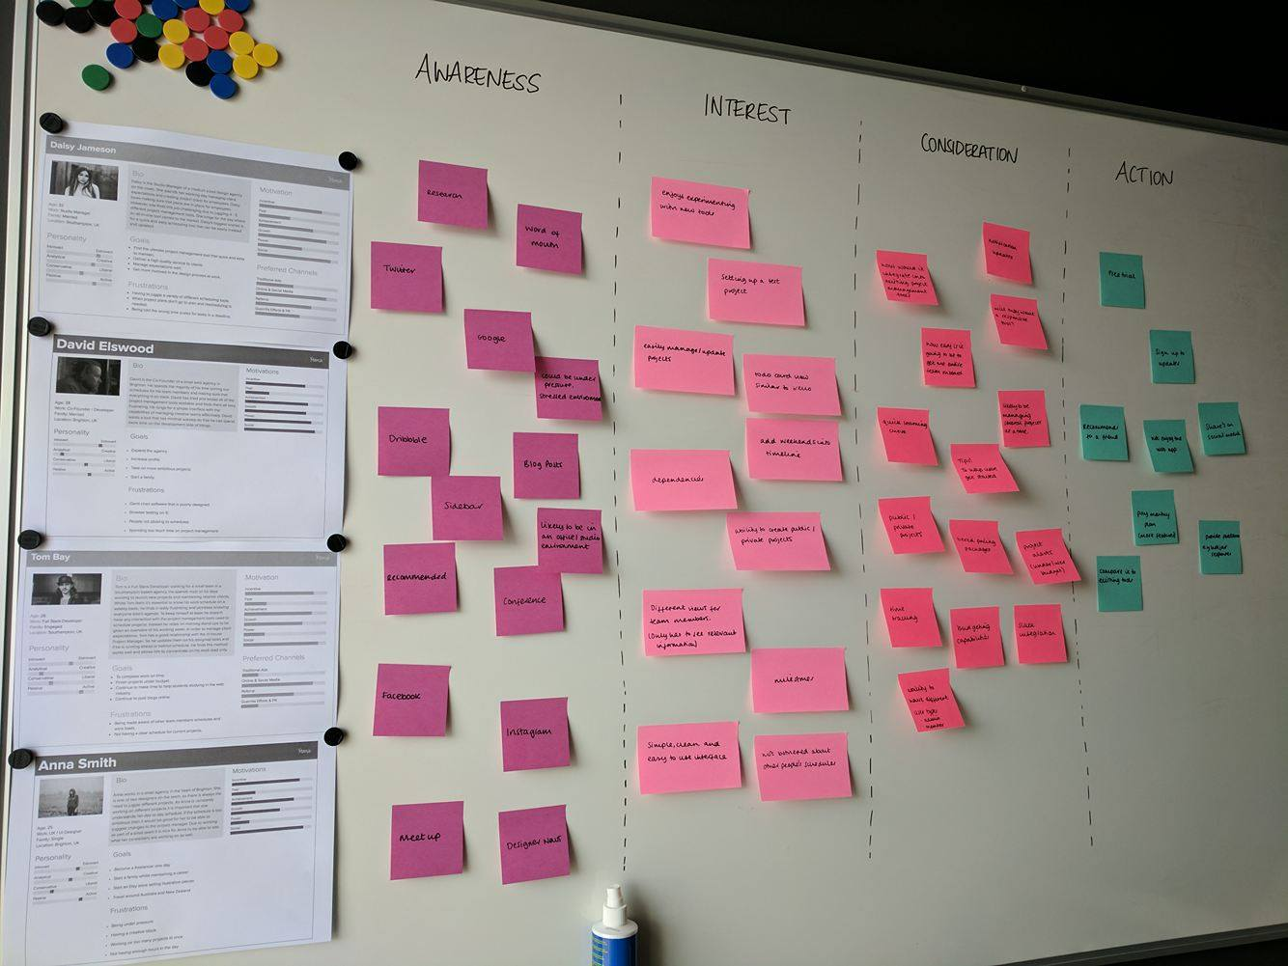

**Figure X – User Journey Overview**

**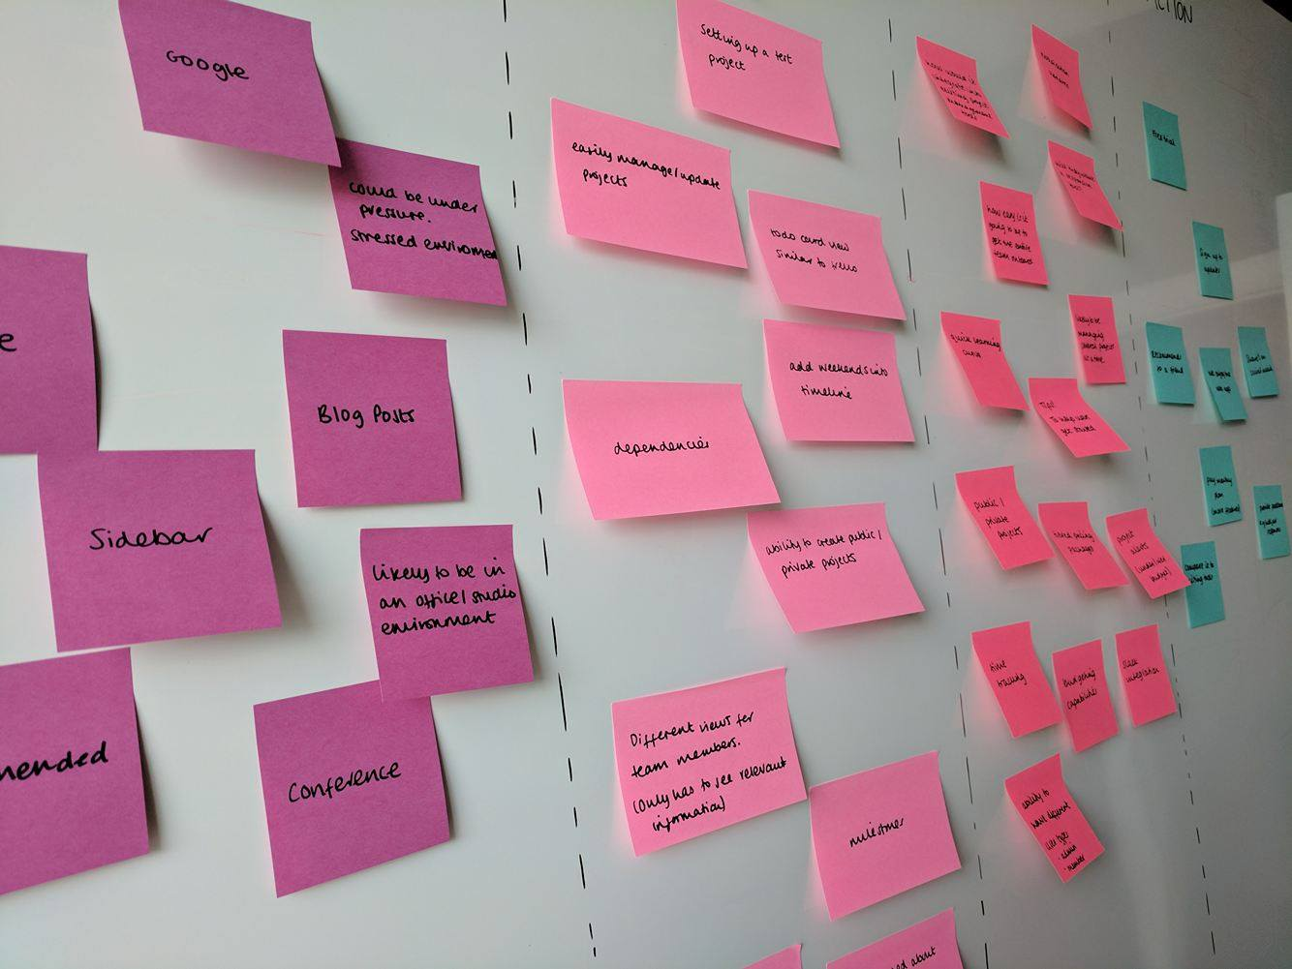**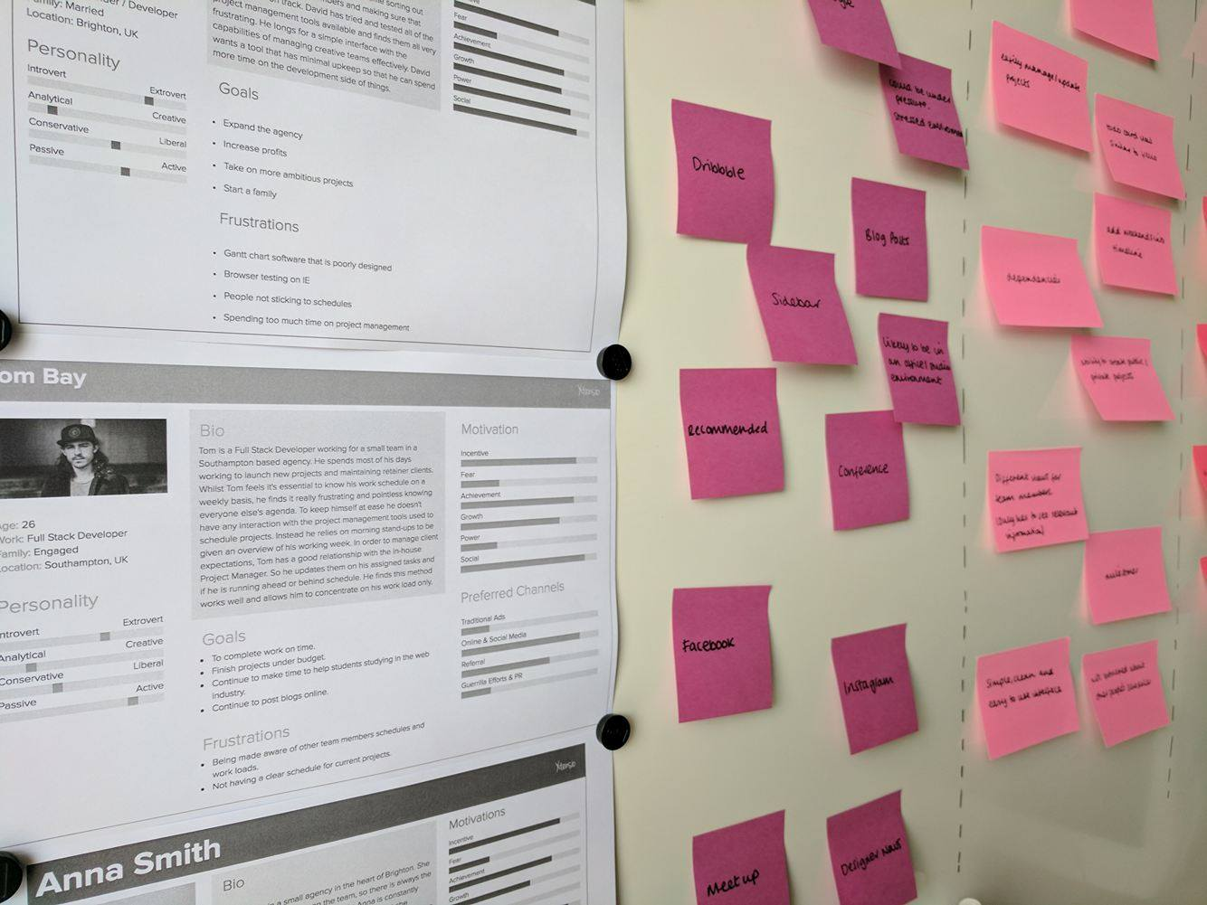**Figure X and X – User Journey Close Ups**

To create the user journey above the four personas previously created were printed out. This meant that the journeys could be mapped against the two different user types, admin and team members. The user journey was then broken down into four sections: awareness, interest, consideration and action. These four sections covered users becoming aware of the product, what might be of interest to them, considerations to be made and what would be the users end action.

The user journey revealed insightful insights into what users may expect when visiting Project Pipeline and also how users may be feeling. Getting users on board with a new product is not easy and understanding this really helped to move forward in the design process. Creating a product that was familiar with users was essential in providing a good experience. This lead promptly onto the next phase of the planning process which was to carry out a competitor’s analysis.

## 

## **7.4 Competitor Analysis**

- 3drops meeting

## **7.5 Mood Boards**

A mood board was created using InVision boards as a way of storing and collecting design inspiration for this project. InVision boards allow for colour swatches and typography details to be stored alongside screenshots of web pages. This board has been added to throughout the duration of this project as a way of defining a design style. Figure X provides an insight into what this board looks like. However, it can also be accessed by following the following URL:

[**www.hudhjgnfmg**](http://www.hudhjgnfmg)

// Image of InVision board

## **7.6 Site Map**

Site maps are a hierarchical diagram that visually show the structure of a website. This is an important part of any design process as it is a way of ensuring that content is where users expect it to be. Defining a site map after the UX phase helps to identify any areas of concern earlier on reveals Mears (2013b). Site maps help to reduce and fix the number of poorly linked internal pages. If the navigation structure of a website is strong then this will improve the overall user experience of the website according to Bigby (2016).

The site map for this project has been designed using a tool called Timblee. Timblee is a free web service that allows users to create high level site maps for websites. This was an easy and hassle free way of creating a site map for Project Pipeline. From this it is easy to see how users would interact with the site and how tasks would be achieved. Appendix A is a diagram of the site map for Project Pipeline.

## **7.7 Wireframes**

After all of the UX tasks had been completed it was time to move into the design phase. This began with creating low fidelity wireframes of the pages that were going to exist in Project Pipeline. Having the site map mapped out meant that planning for these pages was easy. According to Latus (2016) before starting the wireframe phase a list of the products main features and functionalities should be created. With this in mind hierarchy can be established between components. The best way to achieve these low fidelity wireframes was through pen and paper. This meant that all the ideas were throw away as there was not much investment in them at this stage. It is essential to avoid becoming attached to the first idea. The low fidelity wireframes for this project can be found in Appendix X.

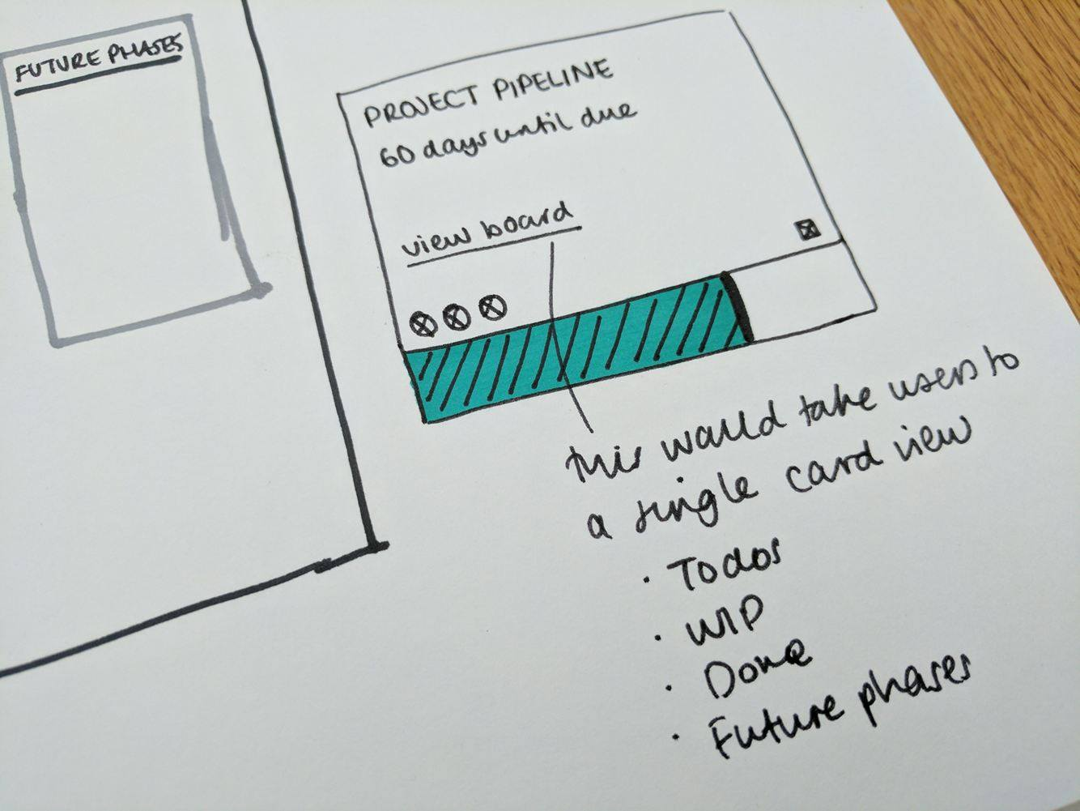It was important to get feedback on these designs. Doing this at an early stage saved a lot of time later on in the design process. A lot of thought went into how to make users aware of project alerts / budget warnings easily. This required experimentation with project card views. Figure X shows how this was thought out in the early stages.

**Figure X – Low Fidelity Project Alert / Budget Warnings**

When the low fidelity wireframes had been achieved it was time to progress them to a medium fidelity. For this Sketch was used to create simple layouts that had more solid layout considerations. There are a variety of tools that could be used for medium fidelity wireframes and a comparison of these can be found in Appendix X. The important thing to remember when creating these wireframes in Sketch was to not get too invested in spacing and typography. Using a basic and stripped back tool would have avoided this altogether. However, for this design process using minimal software tools was essential in having a smooth and reliable process. This was a really part of the design phase as it was reassuring to know how the prototype was going to work and how the complicated design was going to fit in a single view port. It also helped to gain a better understanding of the information architecture. The medium fidelity wireframes can be found in Appendix X.

# **8. Design**

## **8.1 Branding**

Creating and establishing a powerful brand is all part of gaining the trust of users. It is important to ensure that users are aware of the purpose of Project Pipeline when visiting the website. This applies for both new and returning users.

Beginning with rough sketches was the ideal way of coming up with different ideas for the brand. It also meant that these ideas were throw away and there was no significant attachment, similar to the wireframe phase. Figure X provides an insight into the rough ideas at the beginning stage. 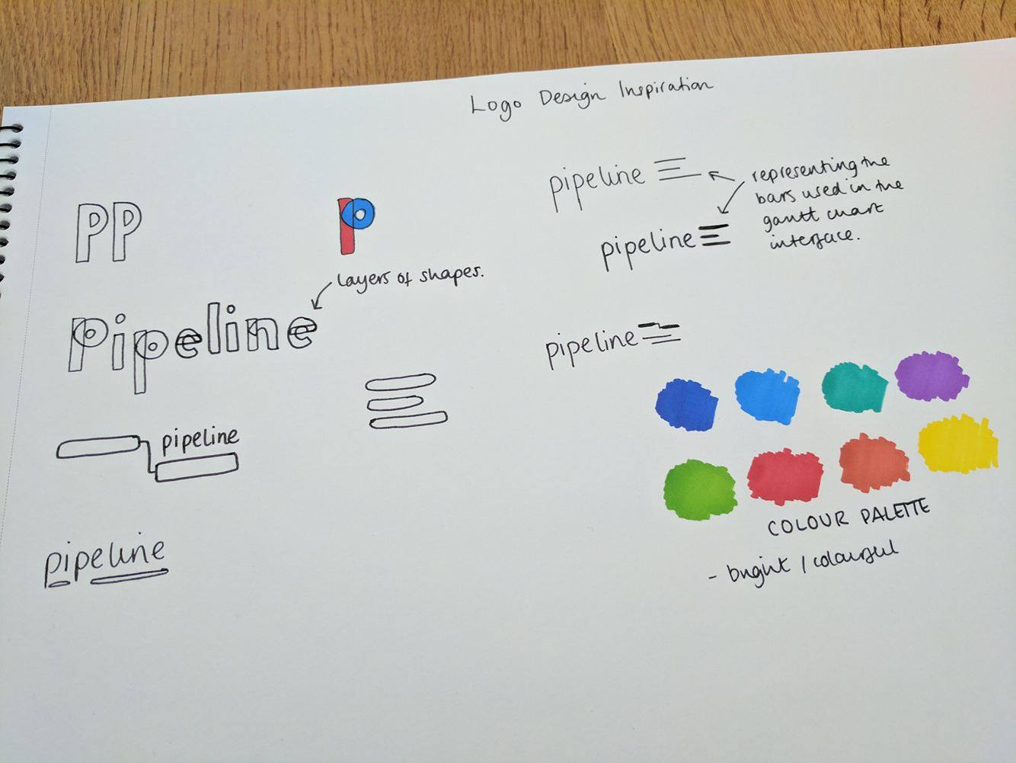

**Figure X – Logo Drawings**

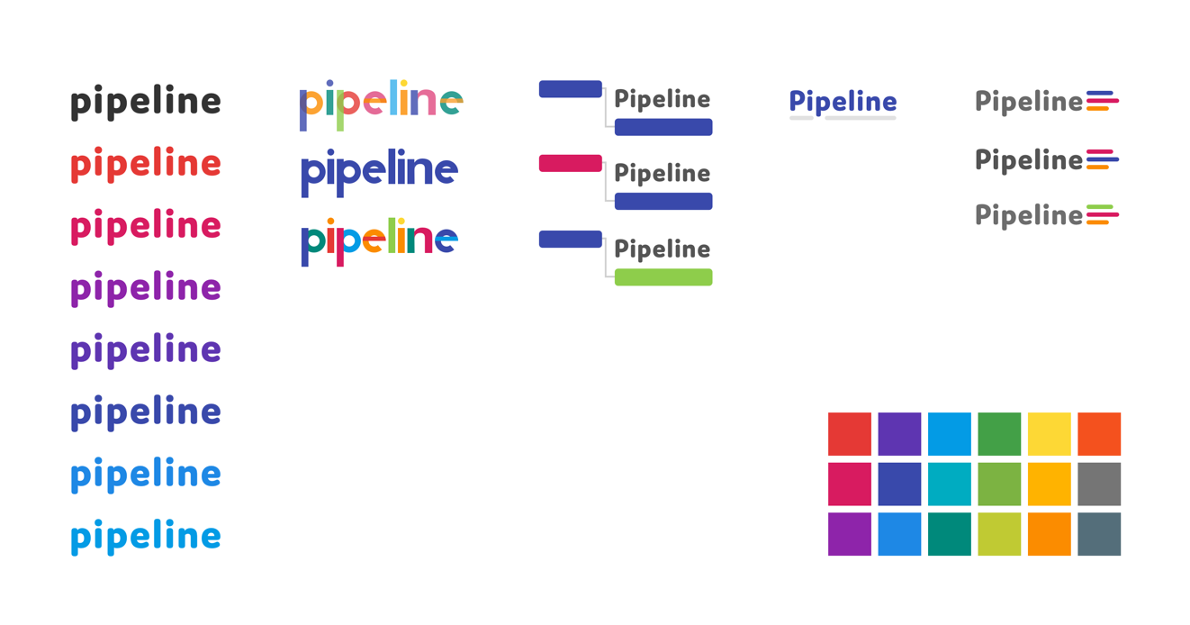Following on from this low fidelity phase experimentation began in Sketch. This meant taking several of the rough ideas and taking it further. This resulted in experimenting with colours and typography options. By creating the logo in Sketch it meant that it was vector driven resulting in SVG file types. An SVG file type allows the logo to be resized freely without losing quality. Figure X captures the logo experimentation that happened in Sketch.

**Figure X – Logo Experimentation in Sketch**

A lot of time was spent going through Adobe Typekit in order to find the appropriate font to use for the logo. In the end the chosen font was Domus used in the font weight extra bold. The design of this font fits very closely with the design of the interface.

This font has been accompanied with 3 lines that relate to the pipeline used in the timeline interface of this web app. The logo can be used with the font and lines or just the three lines. Figure X clearly shows how the logo can be used in different formats.

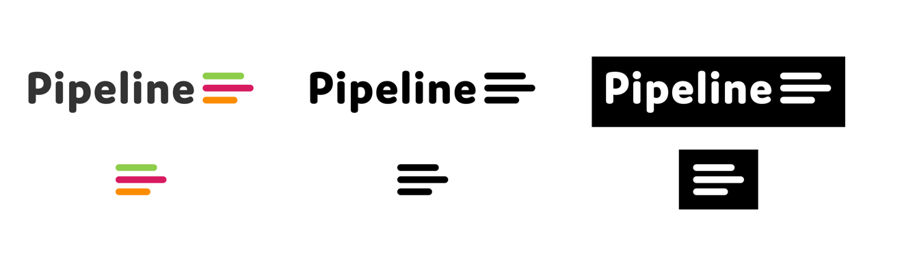**Figure X – Logo Usage**

## 

## **8.2 Design**

Once all of the wireframing had been done it was time to move into high fidelity mock-ups. This required using industry standard software to create a high end final output. A comparison of the latest industry standard software can be found in Appendix X.

It was decided that Sketch was going to be used to create the UI for Project Pipeline. Sketch is a simple and easy to use design programme with a clean interface. The minimal interface means that there are no unnecessary tools on show, which can often make users feel overwhelmed. Sketch has a vector driven environment so it means that all components are easy to scale and resized according to Andrew (2016). Avocode (2017) reveals that there are now more designers using Sketch than Photoshop. This is mainly because of the constant updates that are released with Sketch. Figure X shows the statistics of Photoshop vs Sketch users.

**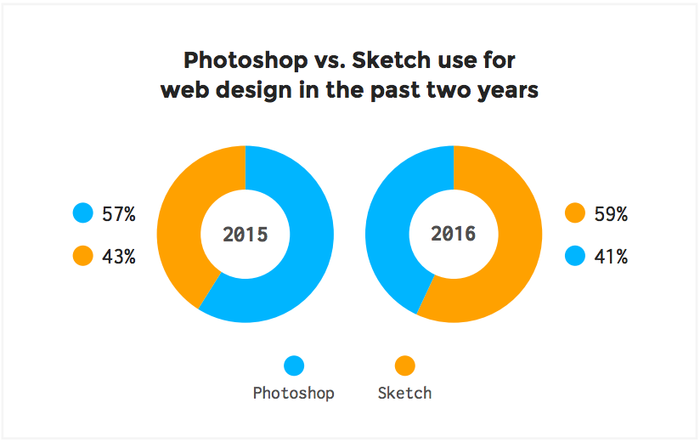**

**Figure X – Logo Experimentation in Sketch**

Sketch is incredibly powerful because of all the plugins that can be used with the software. A list of the plugins and a description can be found in Appendix X.

When first creating a new Sketch file it was really important to make sure that artboards were organised. As there were a lot of screens it meant that being able to easily navigate was vital. Pages have been created inside the Sketch file to indicate different features. Figure X shows how this was achieved.

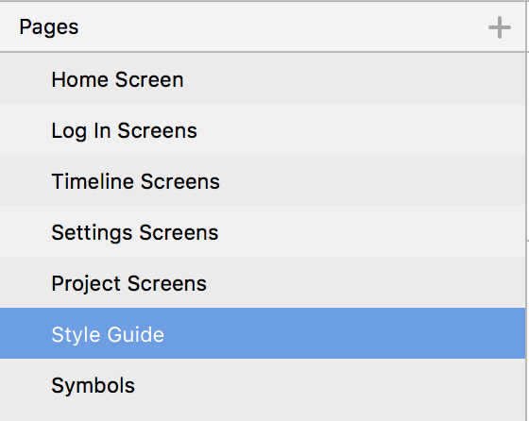

**Figure X – Sketch Page Names**

It was also important to make sure that all layers were named appropriately and symbols were used when required. Sketch is really powerful for allowing users to create nested symbols for repeated styles. This ensures that there is design consistency.

When the structure of the file was set up right it was time to start experimenting with colour palettes and typography options. The design of this project management tool was made to be minimal and colourful. Research into Google Material Design colours helped to choose a bright and consistent colour palette. The main colours used in the design can be found below in Figure X.

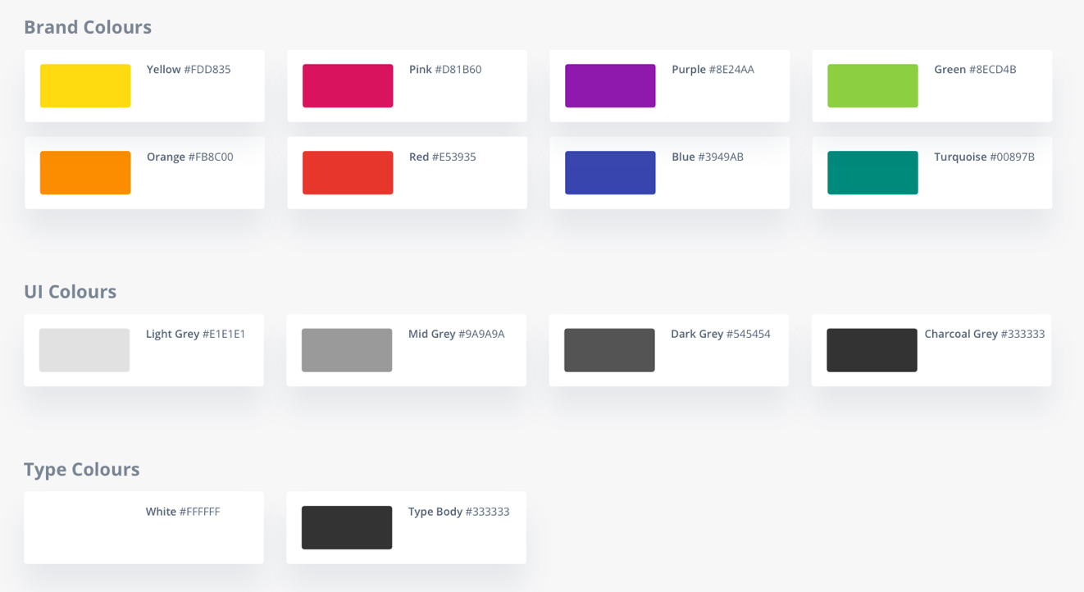**Figure X – Project Pipeline Colour Swatches**

The fonts used in the design have been downloaded from Adobe Typekit. A great amount of time went into sourcing fonts that were right for the design. When it came to selecting font sizes the modular scale was followed. This allows for type sizes to work well and be meaningful. The modular scale refers to line height and type face sizes report Brown (2011). In order to calculate the font sizes the modular scale website is going to be used. The final fonts chosen work really well and more details on this can be found in the style guide in Appendix X.

**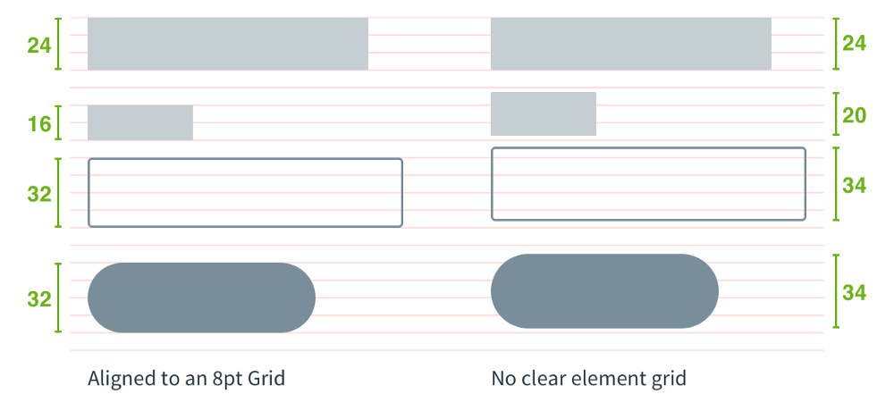**The next step was to decide on what grid the designs were going to fit to. After reading in to Bryn Jackson’s articles on the 8px grid system it was decided to work to this. Introducing the 8px grid system meant that there was greater consistency. Figure X shows a comparison of how components lie on and 8px grid vs no clear grid.

**Figure X – 8pt Grid**

There have been a lot of articles recently talking about a component driven workflow in Sketch. This is something that has been adhered to in the design process. It is based on Brad Frost’s atomic design principles and more information on this can be found in Appendix X.

## **8.3 Design Features**

After talking to users about what features and functionalities were needed for Project Pipeline to be successful, it was important to ensure that these were available in the prototype. There were five main features that are explained in detail below. However, a list of all the features can be found in Appendix X. For the five main features HTA’s have been created to indicate how a user would go about using Project Pipeline’s interface. Hornsby (2010) reveals that a hierarchical tasks analysis provides details on the tasks user would need to undertake in order to achieve a goal. Breaking the main features down in this way makes it easier to understand how screens link together effectively.

### **8.3.1 Creating A Project**

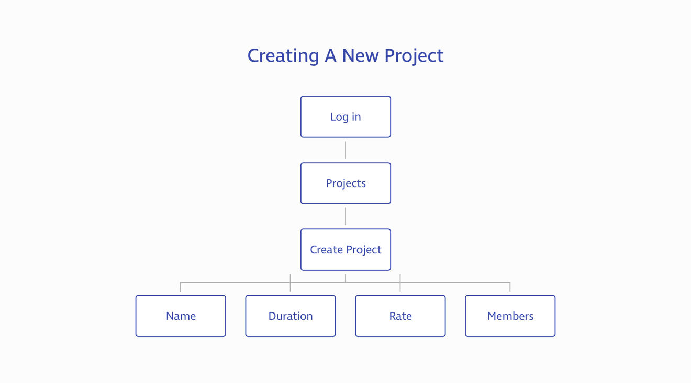Having the ability to create a project is one of the main features of the app. Without this the app would not fulfil user needs. The main purpose of this app is to be minimalistic and simple. So ensuring that users can carry out tasks in the minimum amount of steps was necessary. Figure X shows the steps users would take in creating a project. After logging in to Project Pipeline it only takes two clicks and entering some data to set up a project. The data that would need entering by the user is the name of the project, the duration (start and end date), the daily rate and members involved.

**Figure X – HTA Creating A New Project**

### **8.3.2 Editing A Project**

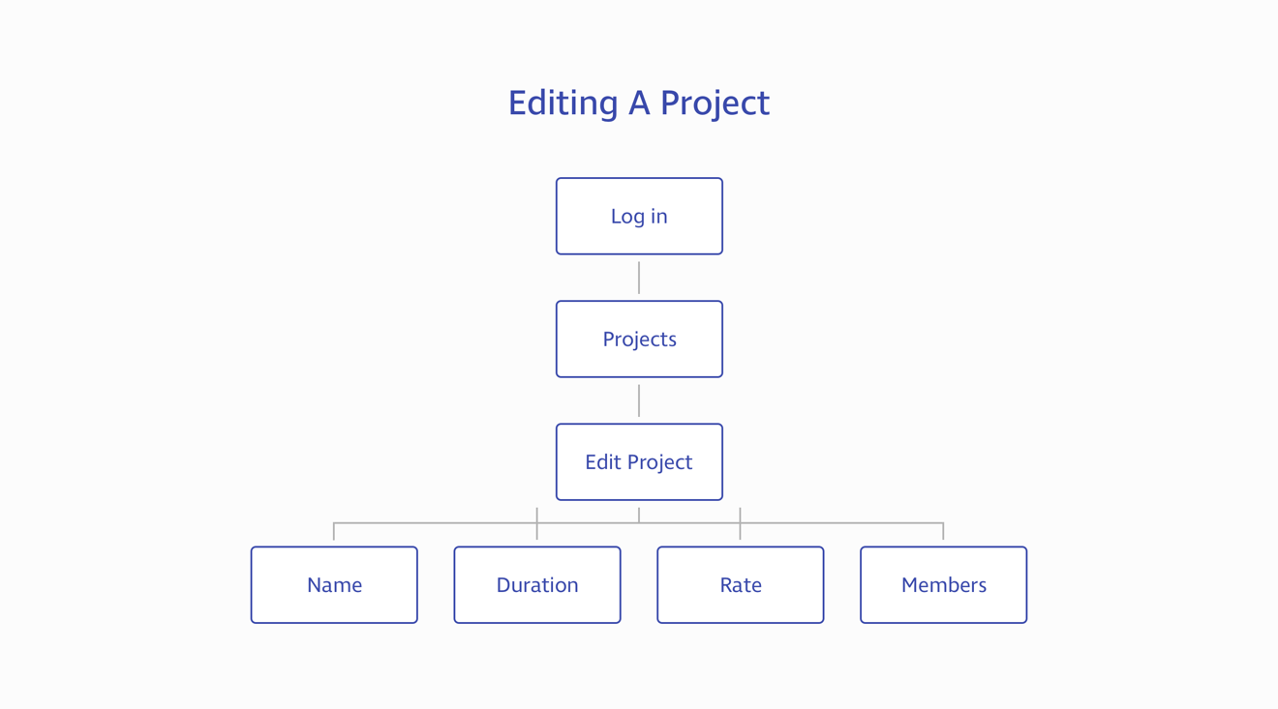After creating and working on a project there is likely to be a time where the project needs editing. Editing a project will allow users to edit the name, duration, daily rate and members. There is also the ability to delete the project in this view. It takes the same amount of steps to edit a project as it does to create a new one. This means that it is quick and easy to alter and update projects when needed. Figure X shows how users would go about editing a project.

**Figure X – HTA Editing A Project**

### 

### **8.3.3 Adding A Task**

After creating a project one of the next steps a user may want to take is adding a task. Adding tasks will bulk up the project pipeline and provide users with data on budget and looming deadlines. Users are required to be inside the specific project to add a task and there are also some form fields to fill out. These are the duration of the task and the members involved in the completion. Whilst it has been hard to convey this in the prototype, tasks can be rearranged simply by dragging and dropping individual tasks. The number of steps required to complete this goal is three after logging in and a breakdown 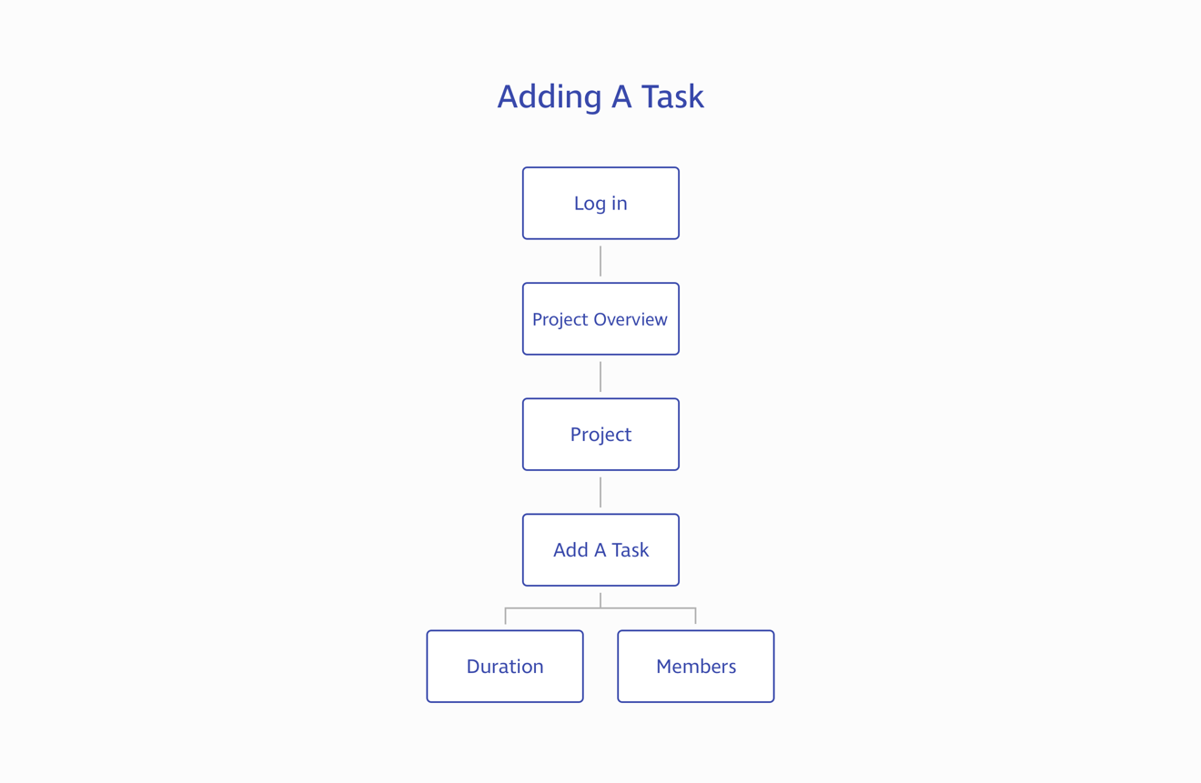of this can be seen in Figure X.

**Figure X – HTA Adding A Task**

### **8.3.4 Viewing Schedule**

One of the USPs of Project Pipeline is its ability to provide users within an insight into individual upcoming schedules. The interface allows users to see schedules for that specific day, the following day or a weekly overview. This is a beneficial feature when just wanting to see a high level overview of tasks. It means that users would not have to look in project specific schedules. Users are provided with a notification daily to be made aware of tasks. Accessing this only requires clicking on the avatar when logged in and then toggling between the three different options. See Figure X for a breakdown of the steps required in viewing a schedule.

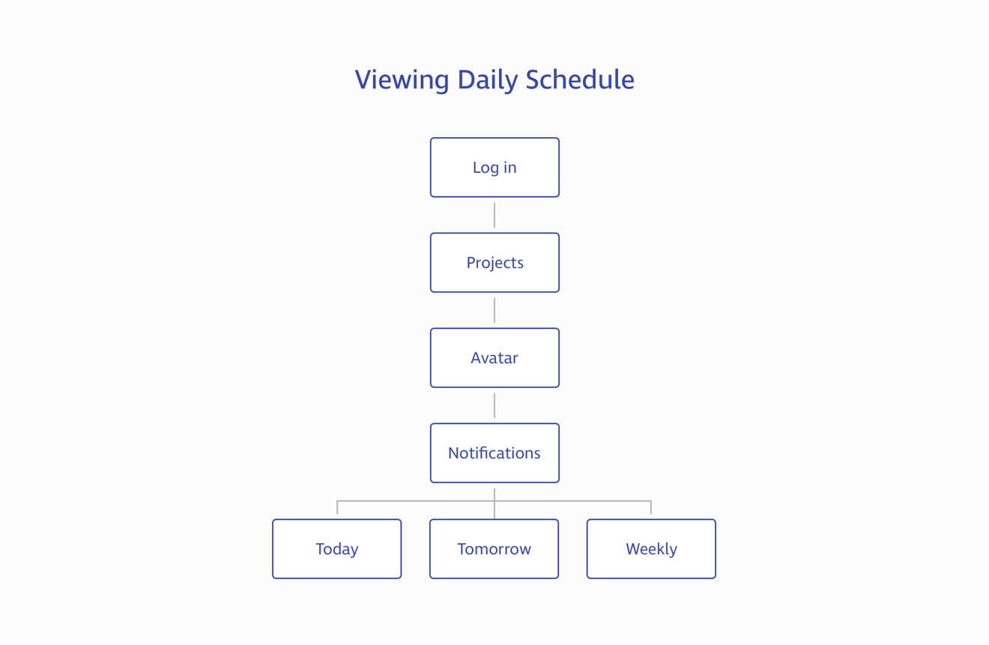**Figure X – View Daily Schedule**

### **8.3.5 Setting Up App Integration**

Another USP for Project Pipeline is being able to integrate it with a variety of apps. Whilst at the moment this is limited to three apps there are plans to push the boundaries and add more options for users. Currently users can integrate Project Pipeline with Slack, Harvest and Basecamp. In order to do this user’s are required to carry out four steps after logging in. The integrations set up lives in the settings part of the app as this seemed like the most logical place to exist. Creating this feature was a request that appeared in the user interviews carried out. Figure X shows a breakdown of the tasks required to complete this goal.

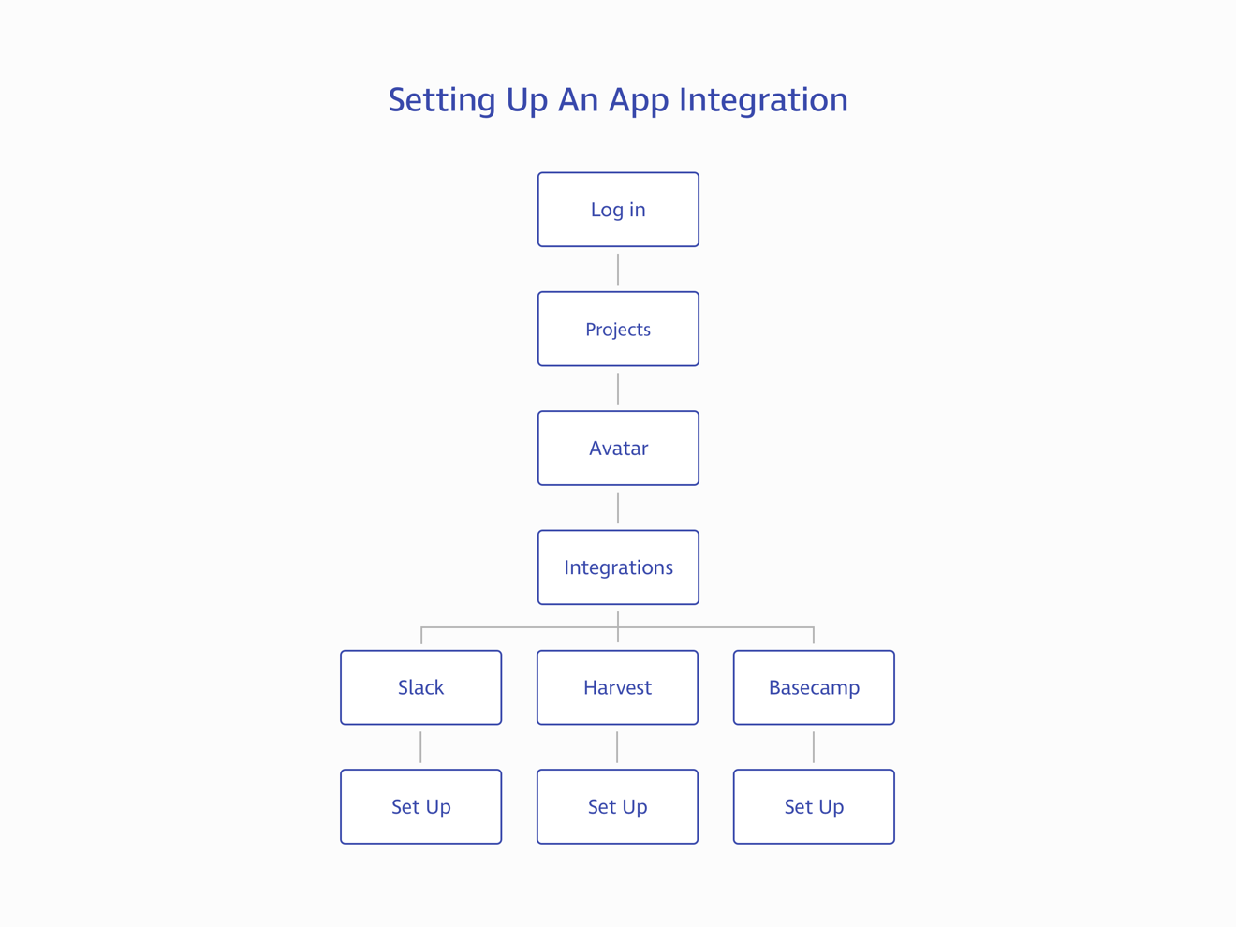**Figure X – HTA Adding A Task**

# **9. Prototyping**

Prototyping allows for designers to better communicate concepts and ideas with the wider team and clients. This means that everyone involved within this process can provide feedback and suggestions on improvements. These feedback comments can then be refactored into the design before the development phase begins according to Sandu (2016). Mejia (2016) explains that there are a variety of prototyping tools available to users. The purpose of these tools is to bring ideas to life and convey concepts clearly. When deciding on what tool to use it comes down to personal preference reveals Mockplus (2016). A comparison of these tools can be found in Appendix X.

InVision was the prototyping tool used for this project and it worked really well in creating a clickable prototype. This is a simple tool that allows designers to create interactions between artboards. There are also commenting features, which allow feedback to be recorded easily states Order Group (2015). In order to get the artboards from Sketch into InVision the Craft plugin was used. This provides one click syncing and this made it really quick and easy to import the large quantity of artboards. When creating the prototype there were a lot of clickable hotspots that needed repeating on all pages. This was easy to achieve in InVision using Hotspot templates and saved a lot of time when putting together the prototype. Figure X shows how hotspots have been created in InVision to link all the screens together.

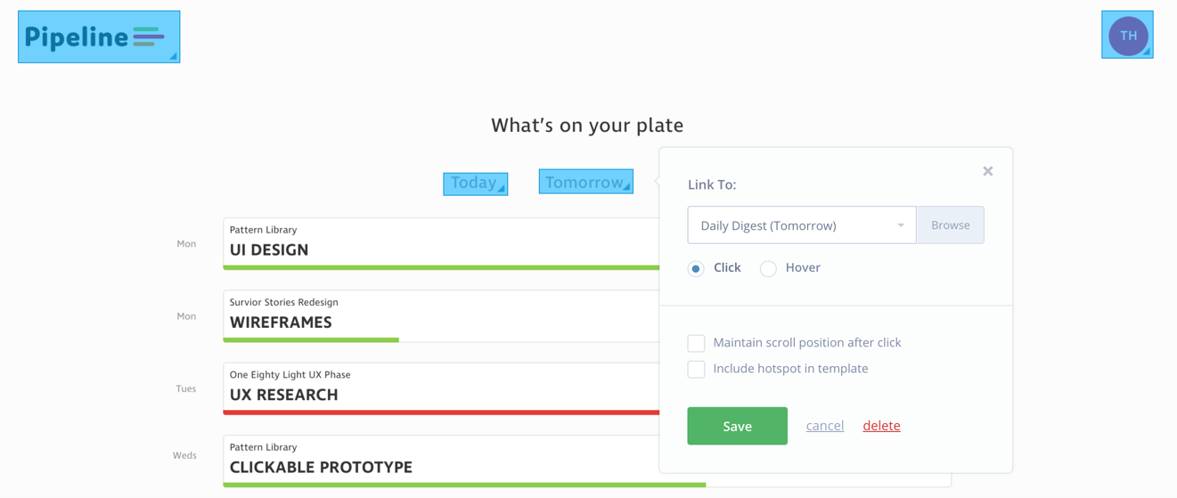**Figure X – InVision Hotspots**

Once the prototype was completed a shareable URL was created so that the prototype could be tested with users. Having previous experience with using InVision for user testing made this process a lot smoother. The completed prototype can be accessed following the following URL:

## **https://invis.io/32BLMEEB4#/231320655\_Home\_Screen**

## 

# **10. Testing**

Once the prototype had been created the next step was to test it on typical users that would be interacting with the web app. This was a really important phase and would dictate the next steps for this project. Unfortunately, due to time and location constraints it was not possible to book a space in the Usability Lab at the university. It would have been really beneficial to use the Tobii Studio to get eye tracking results of users interacting with Project Pipeline.

Instead users were contacted personally to interact with the prototype and answer a few questions which were created through Typeform. This meant that users would be in comfortable and less stressful surroundings, which could provide more realistic results. The survey asked users for personal opinions on the design of the interface as well as asking users to carry out a few tasks to better understand the navigation structure. A breakdown of the full survey can be found in (Appendix X). Due to popular demand of project managers / designers / developers wanting to try out Project Pipeline ten users answered the questions in this survey. Whilst Nielsen Norman recommends only five users, gathering this data was free and easy to collect. All thoughts and opinions from users would help to benefit the progression of this product for The Idea Bureau.

A five-minute video of a user interacting with the prototype was also recorded. This helped to get an insight into the users thought process when completing tasks set. Figure X shows the user interacting with the prototype. Quicktime was used to record to user and the users screen. This meant that the emotion of the user could be recorded as well as the mouse clicks which was really insightful.

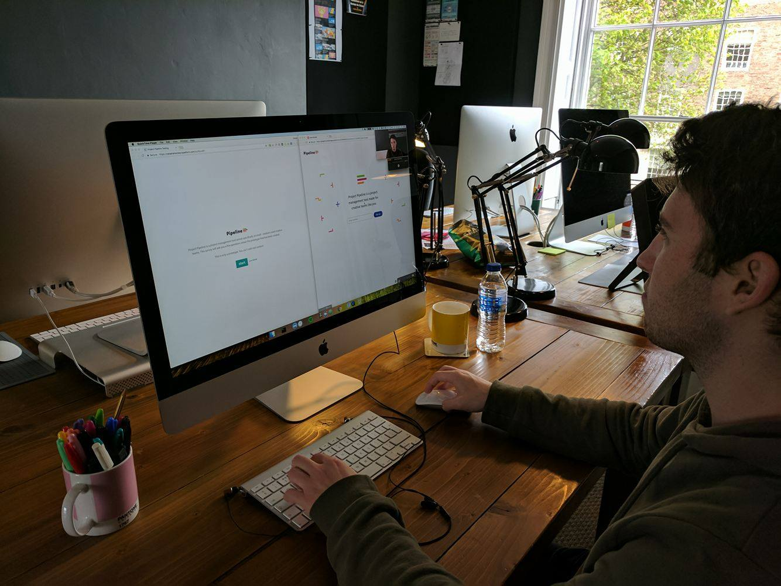

**Figure X – User Interacting With Project Pipeline**

A link to this video can be found below:

[**https://youtu.be/vpg9Ju2qq6A**](https://youtu.be/vpg9Ju2qq6A)

# **11. Results**

The results from the survey (Appendix X) provide great insights into how users felt about the design and interaction of Project Pipeline. Overall the response from users was really positive and some great design improvements were suggested. The response from the user testing video was also positive and the way in which the user interacted with the prototype to complete tasks was as expected.

## **11.1 First Impressions**

Users first impressions of Project Pipeline were all complimenting the design of the interface. Comments were made on how clean, uncluttered and minimal the design looked. This was really reassuring as this was the design aesthetic Project Pipeline was meant to follow. A user even commented saying how small – medium sized businesses would benefit from a product like this. And another user stated how straight away they understood it was a project management tool. Creating a new yet familiar project management tool was one of the main objectives for the design of this product.

## **11.2 Navigation**

Within the survey there were two questions aimed at the navigation of the prototype. Users were asked to add a new project and open an existing project. 100% of the users who tested the prototype were able to carry out these two tasks. It is reassuring to know that the time spent working on the site map for the interface has paid off.

Users were also asked to add a task to a prototype. All users also found this easy, however one user did mention about changing the hierarchy of the content. Instead of having the ‘Add a task’ button at the bottom of the list of tasks that maybe instead it could be at the top. This would mean that users would not have to scroll down a list to add a new task. The reason that this has been designed the way it has is because the interface is following a Waterfall methodology (although as discussed in the literature review, an Agile workflow can still work) meaning that tasks should appear in a chronological order. If the add a task was at the top of the interface, then this would not work well at all.

The user testing video revealed that the user found it easy to navigate around the prototype and could easily complete the tasks in the survey. It also showed that the user was able to navigate into areas which were not asked in the survey meaning that the additional functionalities were found such as: app integrations, notifications and card view.

## **11.3 Design Improvements**

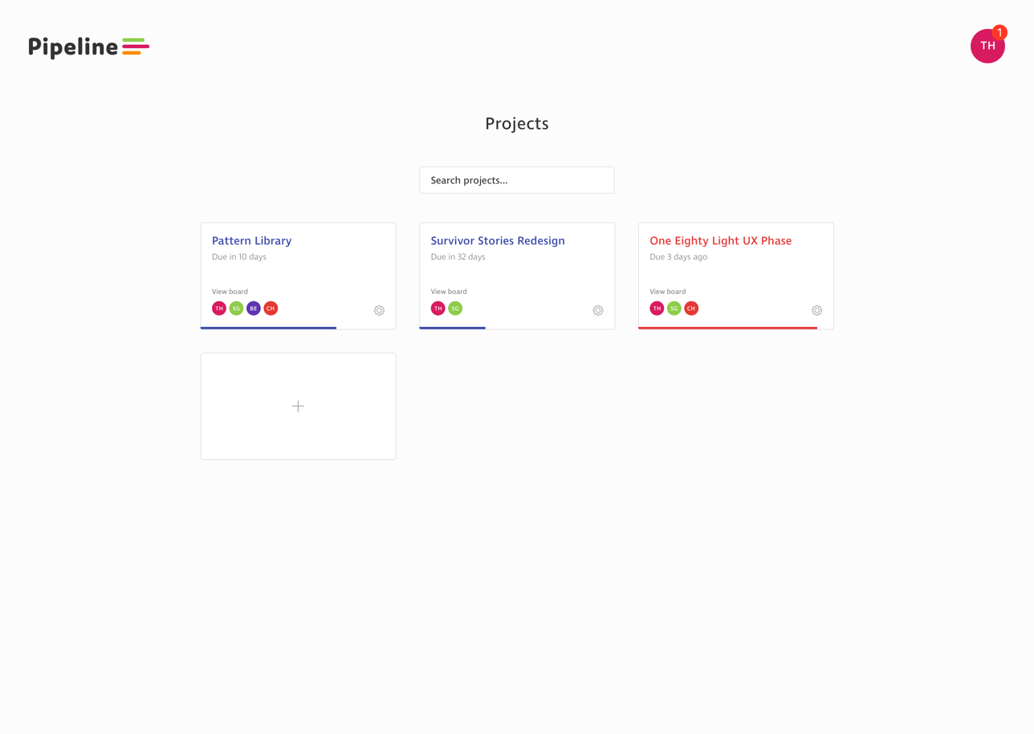Several design improvements were documented in the survey, which has been really helpful in finding ways to progress the web app further. One suggestion was to include a search option in the projects interface. This will allow teams will large amounts of projects to easily and quickly navigate to the specific project. This feature has been implemented and the design for this can be seen in Figure X.

**Figure X – Project Screen With Search Functionality**

Another feature that was requested was the ability to toggle weekends on and off in the settings. This gives more flexibility to users who may want to schedule work in over the weekends or just prefer a view with this in mind. A simple toggle functionality has been added to the settings screen. This can be seen in Figure X.

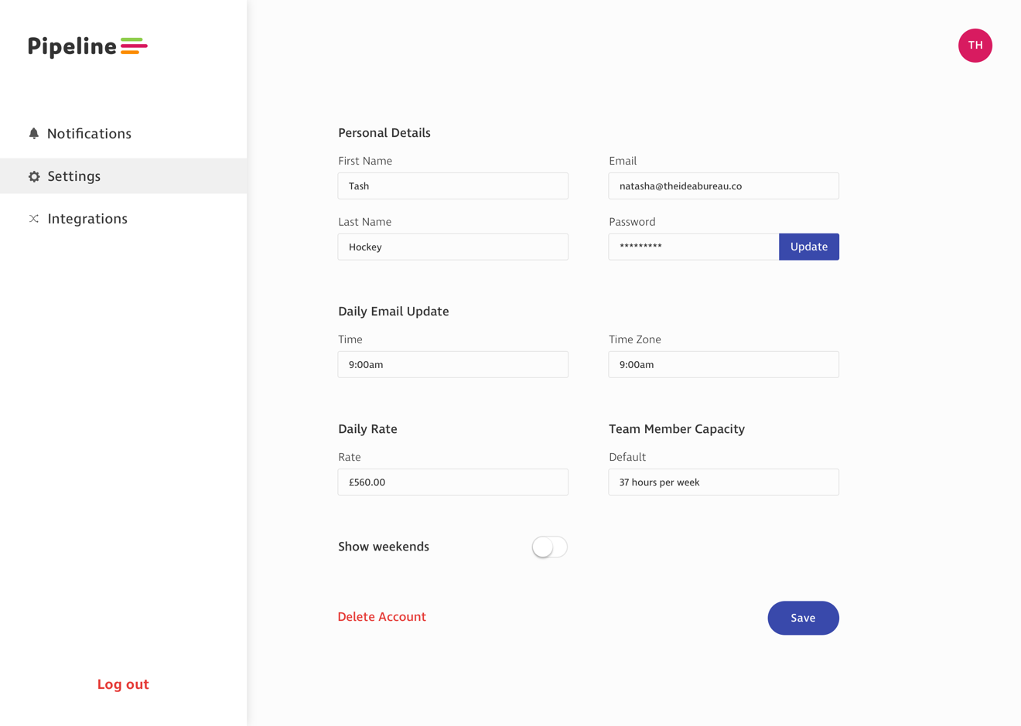

**Figure X – Settings Weekends Toggle**

Overall the feedback received through user testing has been positive and there have been some design changes suggested to improve the product. It would be great to make some more design changes that were suggested and then test the prototype again.

# **12. Evaluation and Conclusions**

This section will evaluate both the process and products of your project based on your previously developed criteria. Note that the products of your project include not just the principle artefact that you have developed but also design and other documentation associated with the development process. It is also appropriate to discuss the results of any external validation of your artefacts in this section. The evaluation of the process should consider all elements of your project methodology as well as project management issues.

* How did the process go?
* What could be improved next time?
* Was the project successful?
* Did I meet the criteria for success?
* Is the final product at a high enough standard?
* What were TIB thoughts on the final product?
* What did users think of the product?
* Would this tool be successful?

# **13. Recommendations for Further Work**

Overall the process for this project has been successful and the finished prototype meets the criteria for success. But as with any project there are always improvements that can be made in the future. Without carrying out the user testing phase it would have been impossible to gage how users felt about the current state of Project Pipeline. As this project is in collaboration with The Idea Bureau this project is far from finished. There are still some design improvements to be made which would be rolled out after the implementation of the current prototype begins. This project has helped to create a solid foundation.

## **13.1 Implementation**

The current designs have been added to InVision with the Craft plugin using Sketch. This means that all the designs are accessible in the Inspect feature of InVision. The developers at The Idea Bureau already have access to the designs and assets, along with a style guide that will help to begin implementation. As all of the design files have been version controlled through GitHub it means that the whole team at The Idea Bureau have access to these files. This means that if the team need any extra information that Inspect can not provide then this is easily accessible.

## **13.2 Design Tweaks**

Whilst some design tweaks that were mentioned in the user testing have already been implemented, there are still more instances to be considered.

### **13.2.1 Budgeting Alerts**

More work needs to be done around budgeting projects. Whilst users can currently input a daily rate and duration of the project, which calculates whether or not a project is going to run over or under budget this could be considered further. It would be good to make this a feature that can be edited in more detail, especially for projects that have more complex project budgets. The Idea Bureau do a lot of work with charities and the project budgets for this are a lot more complicated than a normal project. It all depends on when the charities receive the donations that pay for the design and development of online platforms. So designing a system that could handle this would be incredibly useful.

### **13.2.1 Typography**

In the user testing one user commented on the typography of Project Pipeline could be improved. The typography was apparently too quiet and needed some stronger font weights from the font family. Including a variation of font weights could improve the hierarchy of content and this is something that is going to be looked into moving forward. The font sizes work well and these will not be changing as they follow the modular scale.

### **13.2.1 History View**

One of the main USPs of Project Pipeline was creating a project management tool that allowed users to see the history of a project. Usually if a project overruns then the timeline is just updated accordingly. Project Pipeline is meant to show this change and allow users to see how this has changed. Whilst this has been achieved in the timeline view it would be good to have a section where the history of a project can be seen in an individual interface. This would provide details and who made the change and the date it was made. Doing this should help to plan for projects better moving forward.

## **13.3 Further Testing**

After making updates to UI interfaces it is important to keep testing the product. Small changes could have a significant impact on the user experience and who better find this out from than the users. In future it would be beneficial to use the university Usability Lab to get some heat maps and gaze plots on the app. However, there are lots of online tools that can help to achieve this level of detail. Usability Hub is an app that will be considered for testing in the future.

## **13.4 Design Accompanying Mobile App**

When continuing with further work on this an accompany mobile app could be designed and implemented. This would provide users with an overview of schedules and the availability of team members. During the user research phase for this project this was a point that came up. However, users said that it would not be an essential component to create it would be a luxury. This is why it has not been designed within this project schedule. It was more important to make sure that the desktop interface worked effectively and was to a high standard. Now that a design system has been created for this product, creating a mobile app would not be too much work as the colours, typography and base grids already exist. There would just need to be more user research, planning, designing and testing into how users would expect this mobile app to work.

## **13.5 Branding Considerations**

The branding of Project Pipeline has been carefully considered. However, if there was more time then the usage of this logo and other assets would be better documented. Creating a brand guidelines document would be really beneficial to this project. It would make people working on the project aware of the ways in which the logo / typography should be used. A template for this has been created in Sketch (Appendix X). Before creating this document, it would be really important to ensure that the logo is pixel perfect and works on both the mobile and desktop apps that will be created.

## **13.6 Marketing**

Marketing Project Pipeline is going to be essential in getting people to sign up to the beta version of this product. Without this it will be hard to build up a community of people interested in the progression of Project Pipeline. This will be done through showing sneak peeks of the design on Dribbble, setting up a Twitter account for the product, building up a mailing list, writing blog posts and using other social media to promote it. This should lead to a well marketed product resulting in people trying out and signing up for the product.

# **14. Appendices**

## **Appendix X – Waterfall Methodology**

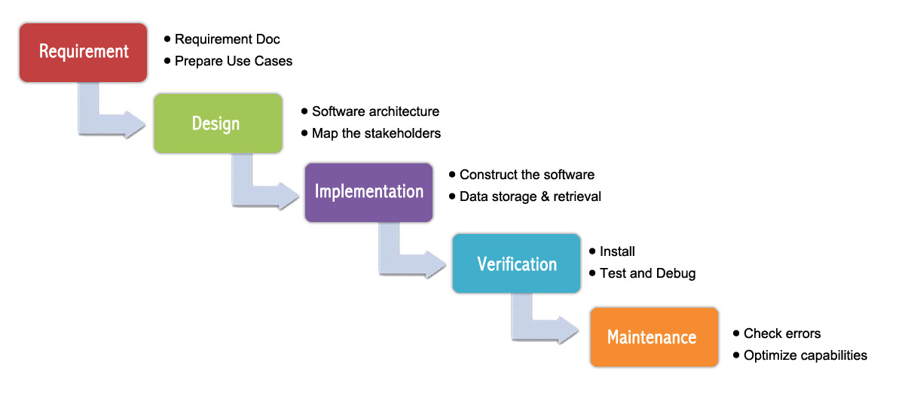

|  |  |
| --- | --- |
| **Description** | |
| A classic approach to software development projects is the Waterfall methodology. This approach is made up of distinctive goals for each milestone in a project1. When completing a phase, it is not possible to revisit that phase later on in the project2. However, to prevent being unsatisfied with the outcome of each phase QA checks happen before moving forward3. | |
| **Advantages** | **Disadvantages** |
| * With this methodology there is high managerial control. This is needed to reduce the risk of error and not being able to solve this4 * It is easy to measure the progress of a project5 * Waterfall methodology is considered a secure approach to projects6 | * This methodology does not allow for revisions to be made easily7 * There is a higher risk of not meeting client expectations as the final product is delivered at the end of the project with no feedback throughout8 * The testing of products following this methodology only happens at the end of a project9 |

2, 6 & 9 BABICH, N., 2016. *Waterfall vs agile* [viewed 27 February 2017]. Available from: https://medium.com/@101/waterfall-vs-agile-9da25daf18e8#.4yx8knw2l

1, 4 & 7 LOTZ, M., 2013. *Waterfall vs. Agile: Which methodology is right for your project?* [viewed 27 February 2017]. Available from: http://www.seguetech.com/waterfall-vs-agile-methodology/

3, 5 & 8 ROUSE, M., 2007. *What is waterfall model? - definition from WhatIs.com* [viewed 27 February 2017]. Available from: http://searchsoftwarequality.techtarget.com/definition/waterfall-model

## **Appendix X – Spiral Methodology**

**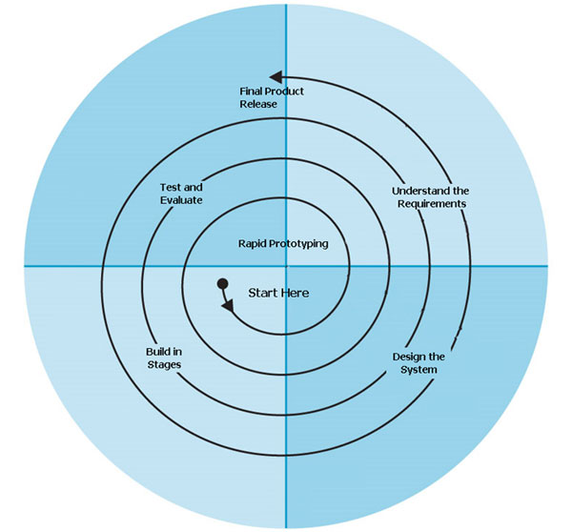**

|  |  |
| --- | --- |
| **Description** | |
| The Spiral methodology is a combination of both the Waterfall and an iterative process1. This method is a realistic approach targeted primarily at large scale projects. It caters for the natural evolution of projects2. The iterative part of this methodology works well for projects that are continually evolving3. | |
| **Advantages** | **Disadvantages** |
| * Spiral methodology concentrates on monitoring project risks continuously4 * Due to high project control and risk management the development process is faster5 * Control of the project is done to a high level6 * Always time for feedback on the project which can be considered immediately7 | * Spiral is considered a waste of time and money on smaller scale projects8 * The duration and costs of projects is hard to manage9 * There is a lot of documentation for this methodology due to the constant spiral of phases that occur10 |

1 & 7 GURU 99, 2017. *What is spiral model? When to use? Advantages & disadvantages* [viewed 27 February 2017]. Available from: http://www.guru99.com/what-is-spiral-model-when-to-use-advantages-disadvantages.html

2, 4, 8 & 9 SOFTWARE TESTING BOOKS, 2016. *What is spiral model? Advantages and disadvantages of spiral model*[viewed 27 February 2017]. Available from: http://softwaretestingbooks.com/what-is-spiral-model

3, 5 ,6 & 10 SOFTWARE TESTING HELP, 2016. *Spiral model - what is SDLC spiral model? — software testing help* [viewed 27 February 2017]. Available from: http://www.softwaretestinghelp.com/spiral-model-what-is-sdlc-spiral-model/

## **Appendix X – Criteria for Success**

|  |  |  |
| --- | --- | --- |
| **Has a clickable prototype been created using InVision?** | **Yes** | No |
| **Does a style guide exist? (colour, typography)** | **Yes** | No |
| **Is there the ability to add tasks?** | **Yes** | No |
| **Can tasks have dependencies?** | **Yes** | No |
| **Can projects have milestones?** | **Yes** | No |
| **Have budget constraints been considered?** | **Yes** | No |
| **Can apps be integrated?** | **Yes** | No |

## **Appendix X – Ethics Form**

## **../Dropbox%20(Personal)/Screenshots/Screenshot%202017-05-06%2009.19.37.png**

**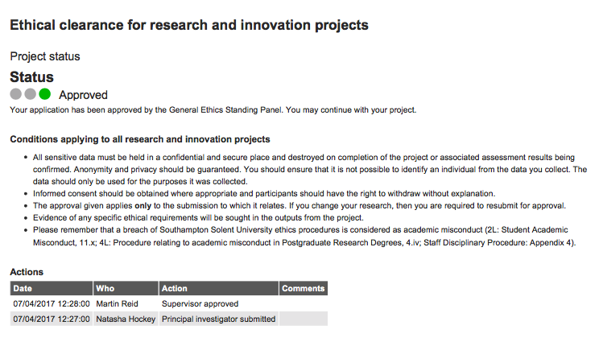**

## ../../Screenshots/Question%203.png../../Screenshots/Question%202.png../../Screenshots/Question%201.png**Appendix X – Survey Results**

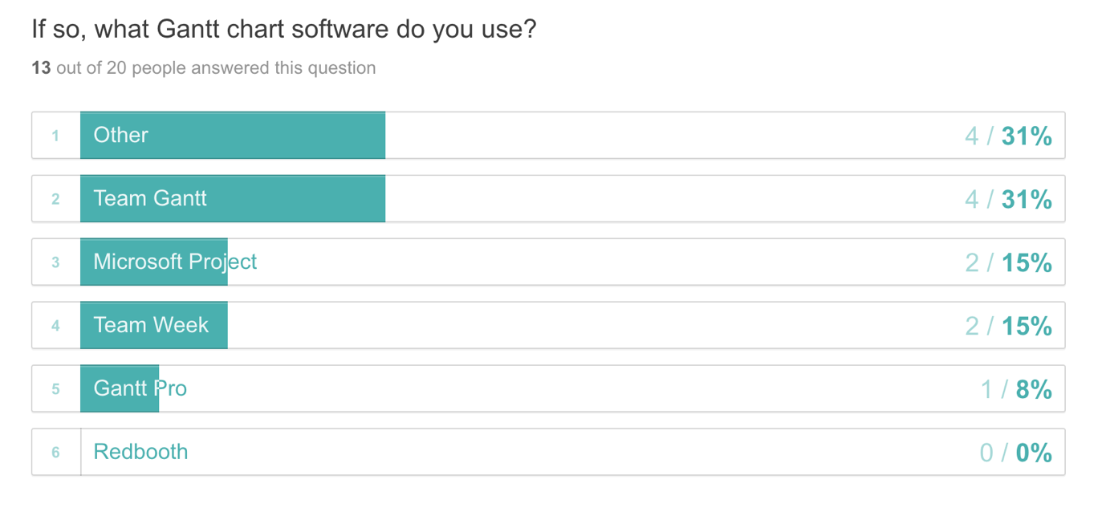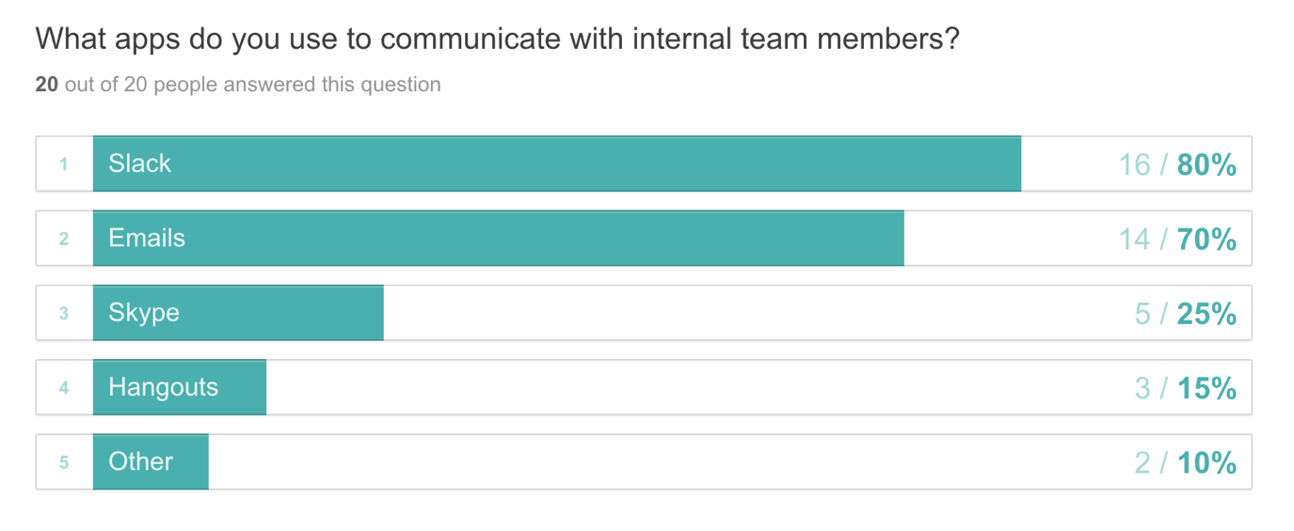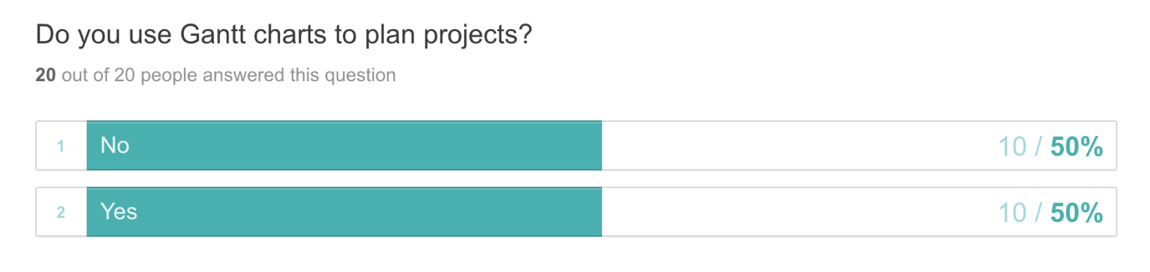

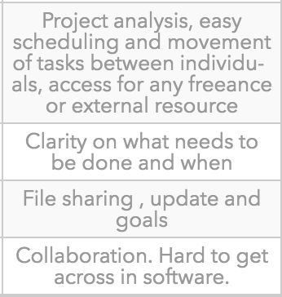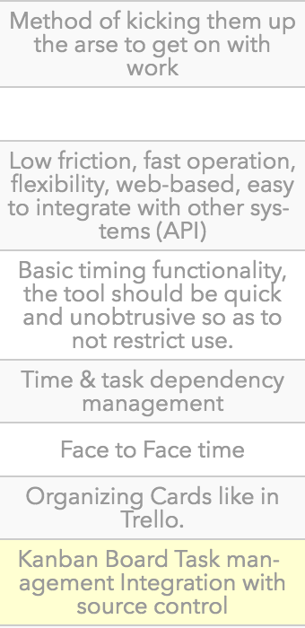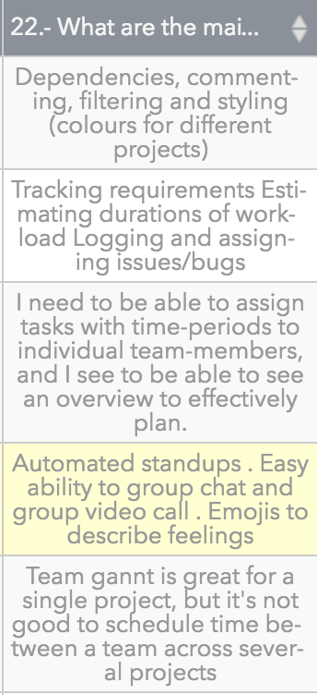

What are the main features / functionalities you require to successfully project manage a creative team?

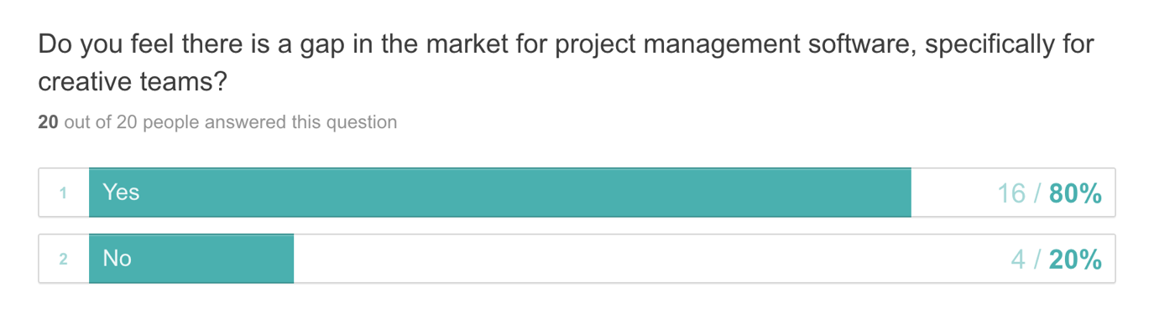

## **Appendix X – User Interviews**

**User Interview – Male, Front End Developer**

**Me:** So how do you feel about having to follow a project plan?

**Interviewee:** Umm, yeah, I make sure I know what I’m doing before the day or the week. So I think project plans are very important just as your daily schedule.

**Me:** Cool, and what do you think makes it a good experience or a bad experience?

**Interviewee:** So that’s when everything is thought through and you have a got a lot of things planned out in advanced. And so you have a clear cause of action.

**Me:** Cool, and do you feel that having a project management tool that works responsively is necessary, and if so why?

**Interviewee:** Yeah completely, it’s got to work on all screen sizes because you might check it on your phone in the morning or your watch when you’re out and about. Or you might pop it up on your iPad or the big screen.

**Me:** And do you think that being able to integrate apps with the tool will be useful? And what apps do you think would be valuable.

**Interviewee:** Yeah, um if it could integrate with services that people use I mean definitely. It’s got to work with things like calendars, Google calendars is a great one. And maybe stuff like emails and messaging services like Slack. Then you could get daily updates and things which is perfect.

**Me:** Cool, and what tool do you currently use for your projects?

**Interviewee:** At the moment we’re using Teamweek, which is cool. That at the moment integrates with Slack and emails and things as well.

**Me:** And what features do you like and dislike about the tool?

**Interviewee:** It’s nice and easy to use. It’s got a couple of different views, so you can go down and see what your schedule is or more of an overview or like a month view. So you can check out different projects and time ranges.

**Me:** Yeah, but you can’t have dependencies can you? So I guess that’s something its lacking?

**Interviewee:** Yeah Teamweek is very focused on a person kind of view. So it’s not a typical Gantt kind of thing.

**Me:** Are there any features that you feel should be a part of a new project management tool that’s being designed, specifically for creative teams?

**Interviewee:** Specifically, for creative teams?

**Me:** That would be like small to medium sized teams as well

**Interviewee:** Yeah, I think a good thing there is applying details such as time tracking because that’s very important in I’d say the smaller industry at the moment, so that you can relay that back to clients. Other than time-tracking, I’d say just integrating with the services that teams use to communicate. That’s about it really for me.

**User Interview – Male, Full Stack Developer**

**Me:** How do you feel about having to follow a project plan? Do you find they become quickly outdated?

**Interviewee:** When you say ‘follow a project plan’ do you means as a developer or someone managing a project?

**Me:** As a developer

**Interviewee:** It’s super useful to have one, especially for bigger projects. We always have some form of plan for a project, even if it’s just a conversation in the office (for smaller jobs). They remove some of the stress of having to deliver a project on time as it’s often broken down ahead of time with sensible deadlines. As long as I hit those, I don’t need to worry about the impact of other projects on scheduling.

**Me:** Yeah, that makes sense. Have you had any experiences where a projects plan has gone really bad and impacted significantly on other projects in the pipeline?

**Interviewee:** Yes. That’s normally due to underestimating how long something will take and not the fault of the project plan directly. We had a project run 2x longer than it should have. Was difficult delivery all of the other projects we promised.

**Me:** Do you feel that having a project management tool that works responsively is necessary?

**Interviewee:** Responsively as in media queries or automatically pushed projects back?

**Me:** As in media queries. So being able to access project schedules on mobile / tablet devices.

**Interviewee:** I would say there is a use-case for it. Whether it needs exactly the same functionality it a different question. I don’t do this, but it might be that Joe or Susan are with a client and they ask “When can we expect this done by?”. Being able to look at the schedule on your phone or iPad may be useful. Realistically, we would probably just get back to them later. But we should be able to view at least some of the information on mobile in my opinion.

**Me:** Yes, so I’ve got the idea of having full functionality to create / edit project schedules on desktop and laptop devices, but only provide overviews of schedules on tablet / mobile. So it’s great to hear what you think on that. The next question is about having the ability to integrate apps with a project management tool. This could be anything from time tracking software to Slack. Do you think this is beneficial and what apps do you think would be essential?

**Interviewee:** It’s a bonus being able to do those things. I’d probably avoid time tracking tools as I think they will be unrepresentative of how much work has been done or is left to do. Especially as estimates are never 100% accurate. For example, on a current project I’ve spent 155 hours of 210 hours. The project management tool then thinks “Oh, we are 74% complete” but realistically I have another 70 hours left on it. We find it easier putting in high level progress percentages, which is given from the developer. So in this case, I’d say we are 60% done. Slack could be a good integration. Maybe ping a message to a project specific channel with messages like “X deadline in 14 days or X task completed ahead of schedule”.

**Me:** Cool, what tools do you currently use to manage your projects? And what do you like / dislike about them?

**Interviewee:** That is a question for Susan, as she actually does a lot of that now. We don’t have access to it, because I don’t think we need access to it.

**Me:** Okay cool, that’s interesting. So you don’t even see an overview of a project timeline or anything? How do you know your schedule?

**Interviewee:** Nope! My brain doesn’t need to be filled with that information as it doesn’t gain anything. I can’t do anything else as a developer. My job is to deliver work on time. I shouldn’t have to know about all the projects we have on, including ones that I am not involved in. We have a catch up in the office where Susan outlines what she would like people to work on. If things start to get behind, then she can see the impact of that and manage client expectations. A typical conversation is “Adam, you’re on project X for 2.5 days and project Y for 2.5 days. Joe we need A, B and C done this week. Do them in any order that suits you but we need them done. Tom, you’re doing designs this week for X client.”

**Me:** That makes sense! I hate knowing the ins and outs of every project. Especially when you aren’t involved at all.

**Interviewee:** Yeah, one person needs to. And that person also needs to know what expectations have been set with the clients.

**Me:** Last question. Are there any features that you think should be part of a project management tool specifically for creative teams?

**Interviewee:** Do the actual work for them too? Again might be a question for Susan as she uses it more. But being able to set hours-per-day (per resource). We work 7.5 hours a day. But we might have someone else on the team who works half a day (like an intern). Maybe being able to list the skills required to complete a task in a project. Might make it easier to assign resource to it for a bigger team.

**User Interview – Male, Project Manager**

**Me:** So how do you feel about having to organize and follow project plans?

**Interviewee:** Organising and following project plans are essential to ensuring a projects success, without a plan the project would essentially be a nebulas amount of work that needs to be completed but there’s no expectations of when or how it’ll be done.

**Me:** What makes this a good or bad experience?

**Interviewee:** Undoubtedly the software that you use will result in a good or bad experience, using no software and relying on scraps of paper is almost definitely going to end badly. Good software on the other hand can speed up the process and give clarity to all involved in the project. That said it does rely on all involved in the project to be onboard with the software, otherwise it’s just another point of failure.

**Me:** Do you feel having a project tool that works on tablet and mobile devices is necessary? If so, why?

**Interviewee:** Definitely from a from high-level, I’d want to be able to look at tasks or add notes on a mobile or tablet device. Otherwise these small tasks will need to wait until I’m at a desk or force me into pinch, zoom and drag hell assuming the tool isn’t mobile friendly.

**Me:** Would you find value in being able to integrate apps into a project management tool useful? And if so, what apps would be valuable?

**Interviewee:** Absolutely. Where possible we’d like the tool to integrate with all the other software we use to communicate as a team. For us the most important integrations would be Slack and FreeAgent.

**Me:** What current tools are you using for your project plans?

**Interviewee:** Right now we use Teamwork, previously we used Trello but moved away from it because it became a big soup of projects with no real clarity as to what needed to be done per project without forcing you to dive into a particular project.

**Me:** What features do you like and dislike about these tools?

**Interviewee:** As of yesterday Teamwork released Boards within projects which gives us the same flow as Trello. This is really important to us as we are now able to visualize progress to a client without producing old school Gantt charts (which it will produce for your as well). We love this tool and can’t think of any functionality we dislike.

**Me:** Are there any features you feel should be part of a new project management tool that’s specifically for small – medium sized creative teams?

**Interviewee:** Aside from the integrations mentioned above Teamwork does everything we need it to do for us right now.

**User Interview – Female, Project Manager**

**Me:** So the first question is about how do you feel about having to plan projects for a team and what makes it a good or bad experience?

**Interviewee:** Good things is that you know what’s happening in the near future and who is working on what and when. You can see what projects are on track and on budget. It also helps to plan future work and update clients on the progress of their project. Bad things would be when you hit a couple of problems and a project overruns. Or when a team member is unwell, you then need to find solutions and rework the schedule. This can be stressful.

**Me:** Cool. Do you think that having a project management tool that works on mobile and tablet devices would be useful? It may not have the same functionality as the desktop site but just provide an overview of schedules.

**Interviewee:** Yes definitely. Especially when having a meeting with a client and you’re out of the office. Can answer any scheduling queries there anre then.

**Me:** Would being able to integrate aps into the project management tool be useful? This could be anything from time tracking to Slack.

**Interviewee:** Yes, I think so. Slack especially. What I’d love is an all in one tool. Instead of having 4 – 5 different applications that you have to pay for and jump between.

**Me:**  Yeah definitely! Makes it all easier to maintain. What current tools are you using? And what do you like / dislike about them?

**Interviewee:** So I currently use Slack, Flow, Pipedrive, Hub Planner, Toggl and Team Gantt. Slack is used to talk to the team and send links etc. I like that its quick to communicate and share files and I dislike threads. These sometimes hide content, which means I miss it. Flow is what I use for my to do list. I can set reminders for future dates and make sure I finish my checklist for the current day. I like that it allows me brain dump all my jobs I need to do for the day. I can set recurring weekly / monthly / annual to do’s so I never forget tasks. This tool is only really suitable for small reminders. Sometimes I need notes with the task, but limited by the word count. Pipedrive is where sales leads and records of meeting notes or important points from calls. A CRM that has all contact details and project updates. So if I’m away Joe can see where we are with each project and last contact etc. I like that it is easy to find projects and update their statuses. I dislike that sometimes it’s hard to find previous emails attached to a client. It can take a while to find what I need to reference. Hub Planner is used to schedule all the work and assign to each team member. It’s great to see an overview of what projects we’re working on and when. I can also easily move things around. Allows me to see if we have capacity to take on another project. I dislike that there is a limit on how much detail you can add to the phases. Hence why Team Gantt is needed to break these down further. Toggl is what we use for time management. It allows me to see how much time has been spent and keep an eye on budgets. I like how I can see detailed reports for each project and their various tasks. Although the summary report is lacking and usually wrong. I always have to go to the detail report to get the correct data. And we also use Team Gantt for Gantt charts with milestones and detailed proposed timelines for each element of a project. I like how it allows you to break down all phases into tasks and add dependencies based on previous tasks. You can put percentages on each one for their completion status. The design is outdated and horrible to use though.

**Me:** This is really helpful. The last question is what features do you feel should be part of a new project management tool that’s aimed at small – medium sized creative teams?

**Interviewee:** What I’d love is an all in one piece of software that does the following. Be an easy, flexible planner for ongoing projects, provide an overview that shows what projects are booked in and scheduled. This should then offer a more detailed plan (Gantt chart) for the project. Having channels for each project that allows for quick file sharing / chats to the team. A to do list would also be good so that you can add to any date and recur if necessary. Being able to integrate with the CRM to see client details and all correspondence. The ability to manage time like Toggl. This would show what time has been logged against each project. So, not much! I hope that helps and let me know if you find a solution.

**User Interview – Male, Project Manager and Designer**

**Me:** How do you feel about having to organise and maintain project schedules?

**Interviewee:** I feel great. It’s a core part of a running a team. It’s not an easy task, especically in client services.

**Me:** Awesome, what makes this a good or bad experience?

**Interviewee:** The tools play a huge part in this. The user experience, including performance of the tools we use make such a big difference.

**Me:** Do you feel that having a project management tool that works on mobile and tablet devices is necessary? And if so, why?

**Interviewee:** Yes! Schedules change all the time and we need the tools to be able to adapt whenever we need to. It’s not essential that a planning tool doesn’t work on mobile but it can help.

**Me:** Would you find value in being able to integrate apps into a project management tool useful? And if so, what apps would be valuable?

**Interviewee:** Yes! I’d love this! I’d love to be able to integrate with our staff holiday app (timetastic). Also Basecamp (our PM / Project Comms app) and also Slack (our team internal chat tool).

**Me:** Cool. What current tool(s) do you use to plan projects?

**Interviewee:** Apple Calendar, Teamweek and Basecamp.

**Me:** What features do you like and dislike about these tools?

**Interviewee:** Teamweek is okay but would prefer something which can provide greater integration, bigger picture views and an understanding on billing and missed plans.

**Me:** Are there any features you feel should be part of a new project management tool that’s specifically for small – medium sized teams.

**Interviewee:** Project filtering is important. Understanding a difference between planned commitments and also TBC commitments. That would be sweet.

## **Appendix X – Personas**

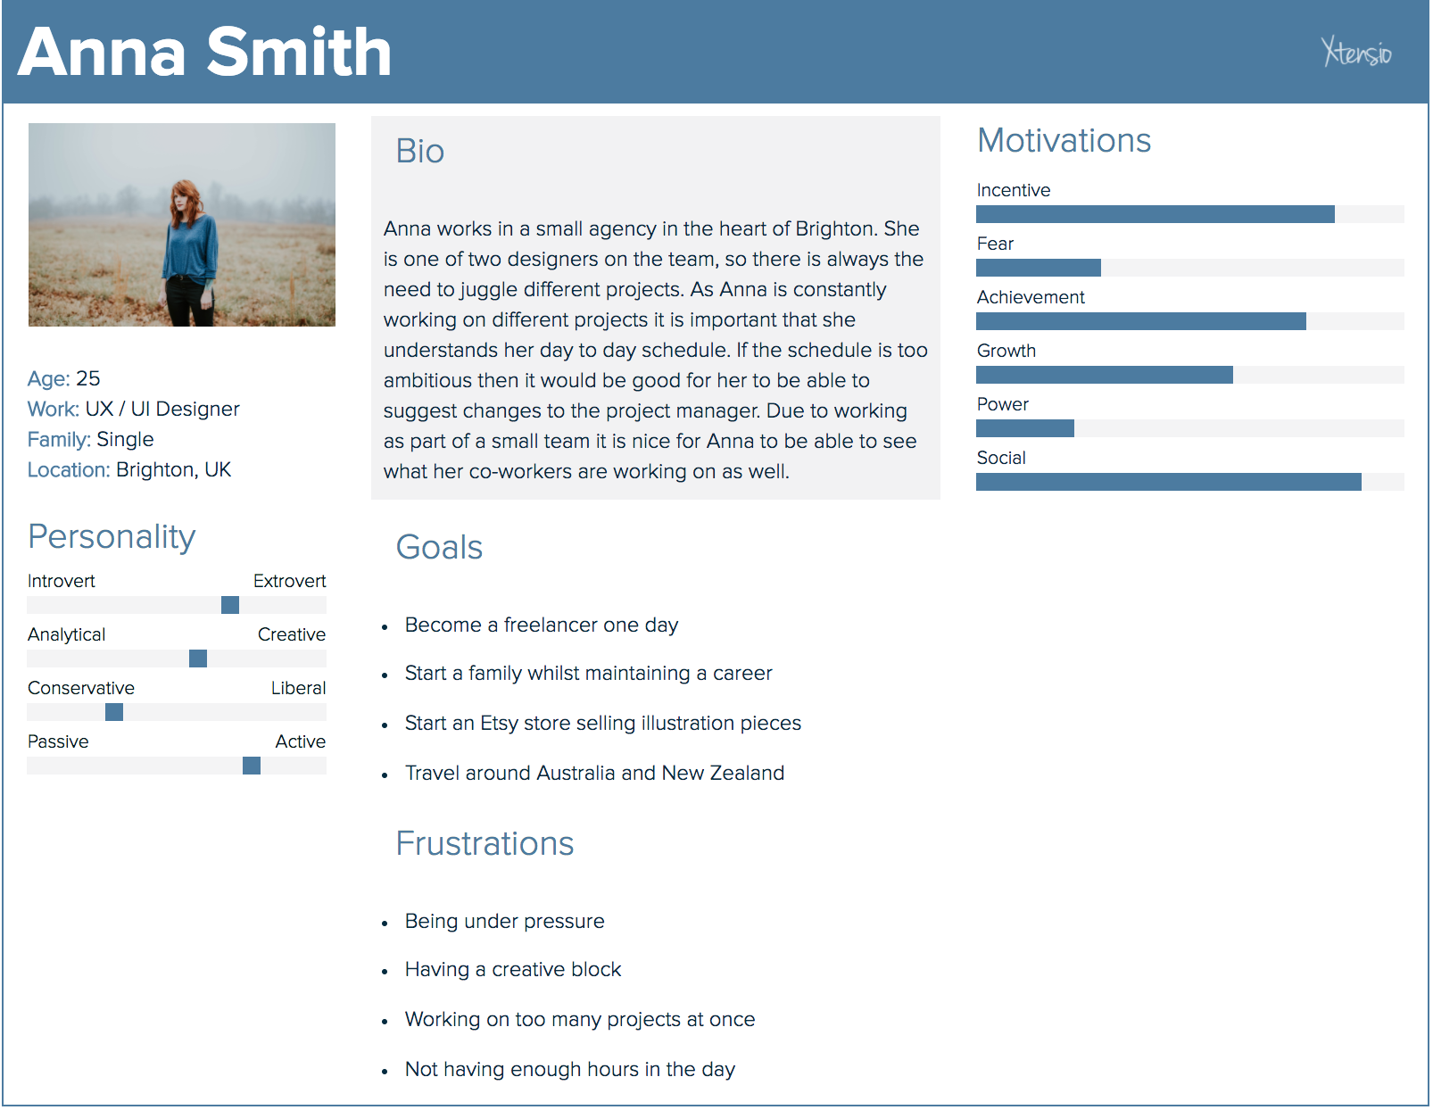

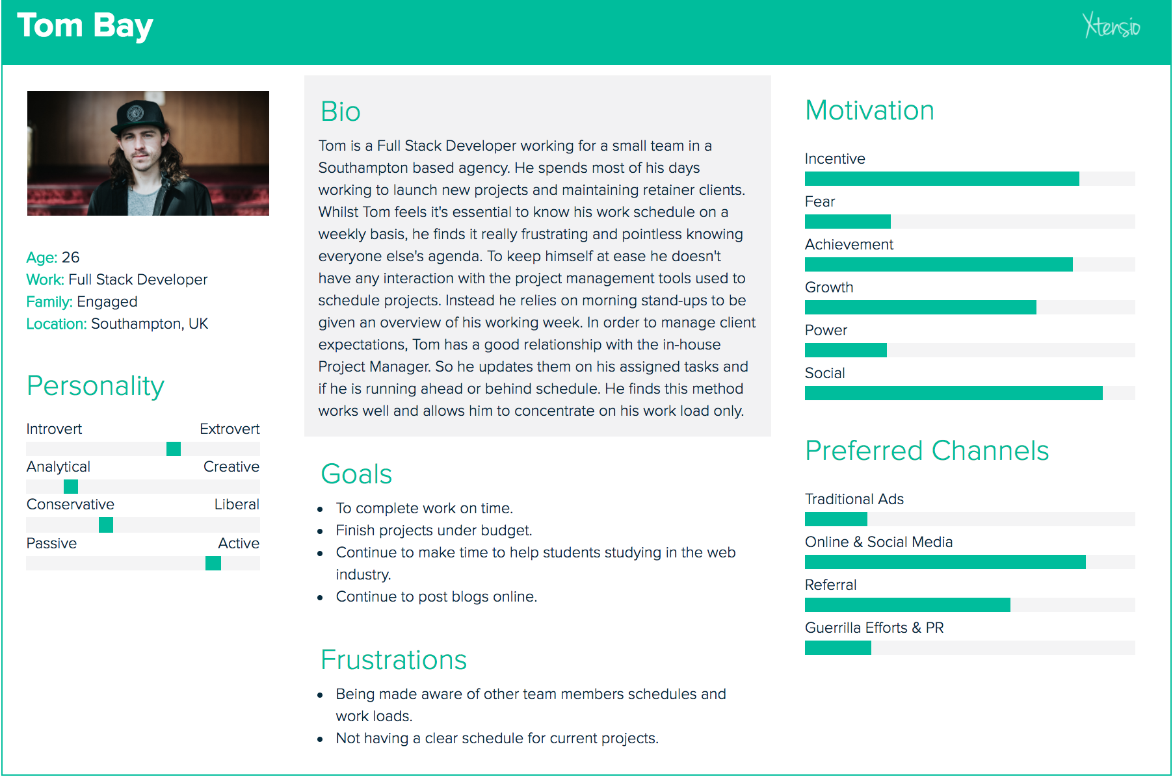

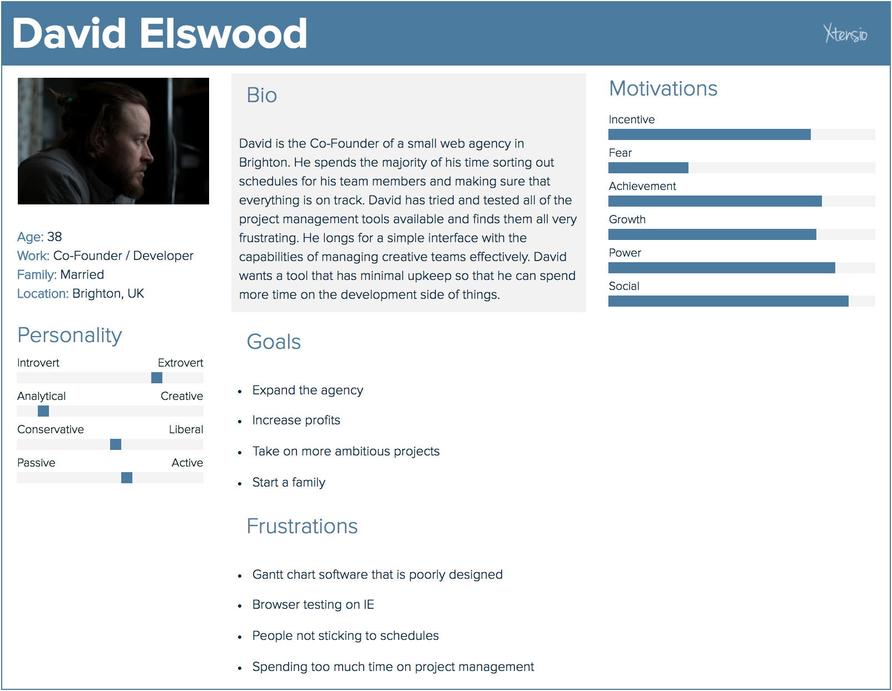

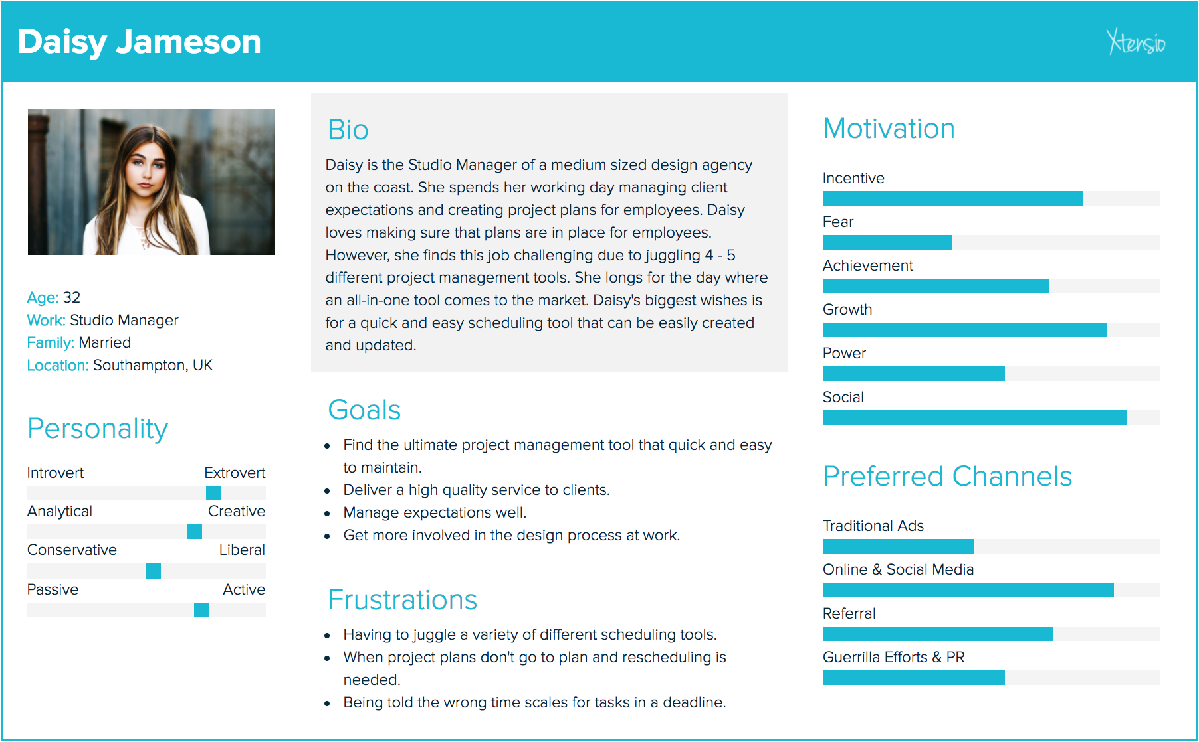

## **Appendix X – Site Map**

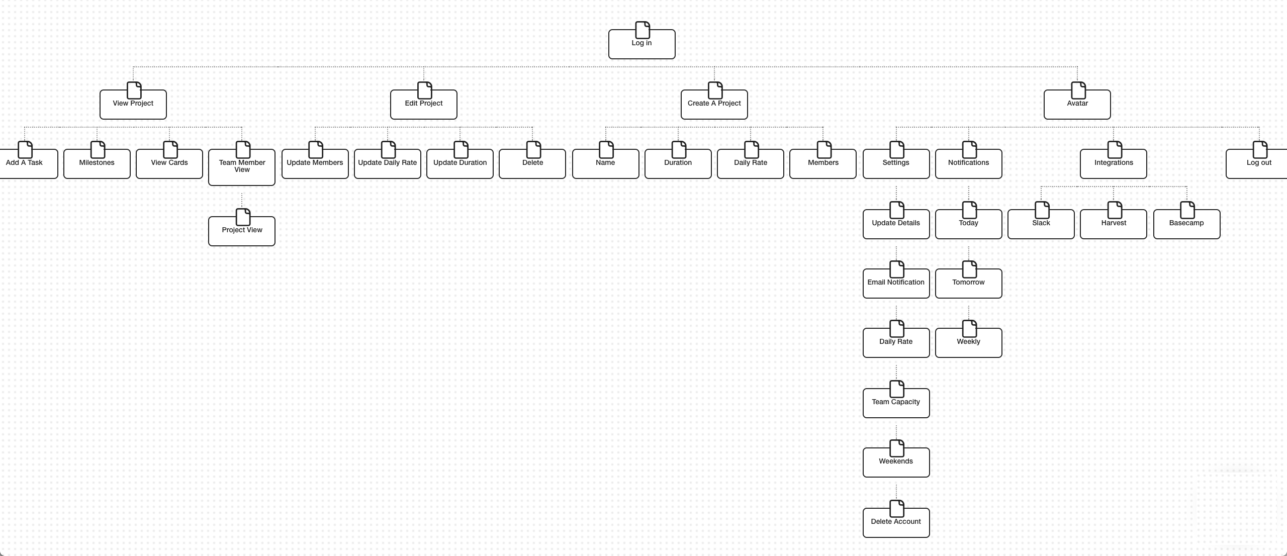

Appendices

* UX Case Study
* **Waterfall Methodology**
* **Spiral Methodology**
* **Competitors Analysis**
* **Competitors Analysis**
* **Competitors Analysis**
* **Personas**
* **Site Map**
* **Design Features**
* **Low Fi Wireframes**
* **Medium Fi Wireframes**
* **High Fidelity Wireframe**
* **Style Guide**
* **Survey Results**
* **User Interview Transcripts**
* Comparison of Prototyping Tools
* Comparison of Medium Fidelity Prototyping Tools
* **Sketch Plugins**
* Atomic Design Overview
* User Interview Survey Questions
* User Interview Survey Results

## **Appendix X – Competitor’s Analysis Teamweek**

|  |  |
| --- | --- |
| **Strengths** | **Weaknesses** |
| * Teamweek is a collaborative tool * Ability to add tasks * Free software * Everything lives in a single interface * Ability to view by teams or groups * Admin and team member user profiles * Shareable URL to timeline view * Integrates with Slack, GitHub and iCal * Personal app integrations can be set up * View by agenda, week, month and 3 months * Add flexible working hours for individual team members * Add milestones | * There is no way to add dependencies between tasks * Limited colour options to add to tasks * No ability to view by individual team member |
| **Opportunities** | **Threats** |
| * There is the opportunity to introduce payment plans * Could include more features on bigger screens * Responsive considerations * Commenting features could be introduced | * New competitors could enter the market * A software product that offers dependencies and other features that are not available in Teamweek |

## **Appendix X – Competitor’s Analysis Team Gantt**

|  |  |
| --- | --- |
| **Strengths** | **Weaknesses** |
| * Collaborative tool * Ability to assign tasks * Can create dependencies between tasks * Users are able to comment on tasks * 30 day free trial * Users can print to PDF overview of timelines * Documents can be attached * Time tracking functionality * Refine by days, progress status and users * Groups of tasks can be created * Easy to rearrange and alter task timings / durations | * Separate Gantt charts are need for different projects * Users only get one project in the free plan * Limited colour palette available to add to tasks |
| **Opportunities** | **Threats** |
| * When separate Gantt charts are used for projects it could be beneficial to have an overview of all projects * Ability to extend trial for users if the user is not sure on investing in a monthly payment * Include more features on bigger screens * Responsive considerations | * Pricing of accounts could be too high and so it could be cheaper to use another tool * A product that provides an all in one view of project timings * New competitors enter the market * A more modern and minimal design could be considered |

## **Appendix X – Competitor’s Analysis Roadmap**

|  |  |
| --- | --- |
| **Strengths** | **Weaknesses** |
| * Roadmap is a collaborative tool * Users can assign tasks * 30 day free trial exists * In beta release so new updates are rolling out frequently * Ability to see actual vs estimates of project forecasts * Users can see the history of a project * Year view of all projects can be viewed * Admin and team member profiles * Users can add milestones to projects * Integrates with Slack | * There is no way to add dependencies between tasks * Users can not rearrange tasks so if they are input in the incorrect order there is nothing that can be done easily * No responsive consideration * No option to group tasks * Charging users even though the product still lacks core functionality * UX of the software is not the best * Icons used do not always reflect the action that occurs * Users have to right click on the timeline to change the colour of tasks. This is not how it is typically done |
| **Opportunities** | **Threats** |
| * Improve the navigation to support users being able to easily jump between projects and teams * Responsive considerations * Allow the yearly overview to be broken down into 3 / 6 / 9 month views | * Users may want to stick to tried and tested trusted companies who are already established * New competitors enter the market * Charging even though it is still in beta |

## **Appendix X – Meeting with 3drops**

**Location:** Taunton

**Date:** 21/02/2017

**Time:** 4pm

**Attendees:**

1. Natasha Hockey – Designer at The Idea Bureau
2. Shane Griffiths – Co-founder / Designer at The Idea Bureau
3. Farzad Ban – Founder / Creative Director at 3drops
4. Marcus Brynolf Pedersen – Project Manager at 3drops

**Agenda:**

* Discuss Roadmap
  + Current / new features
  + Who works on it?
  + How long has it been worked on?
  + What is planned for the future?

**Notes:**

* 3drops have been working on the progression of Roadmap for over a year now
* In the beta version there are currently 1500 members
* Roadmap opens up to the public in a month’s time
* There is currently 1 full-time developer and 2 part-time designers working on the production / maintenance of Roadmap
* The paying beta members are already covering the expenses of the employees

Future Features

* Dependencies
* Daily time spent on between different projects
* Ability to jump between projects
* Time tracking
* Time off / showing weekends
* Milestones
* Creating two user profiles
  + Agencies and product users
* Responsive features

## ../Downloads/18362806_1375089329253610_1682465524_o.jpg../Downloads/18338990_1375089332586943_1964336267_o.jpg**Appendix X – Low Fidelity Wireframes**

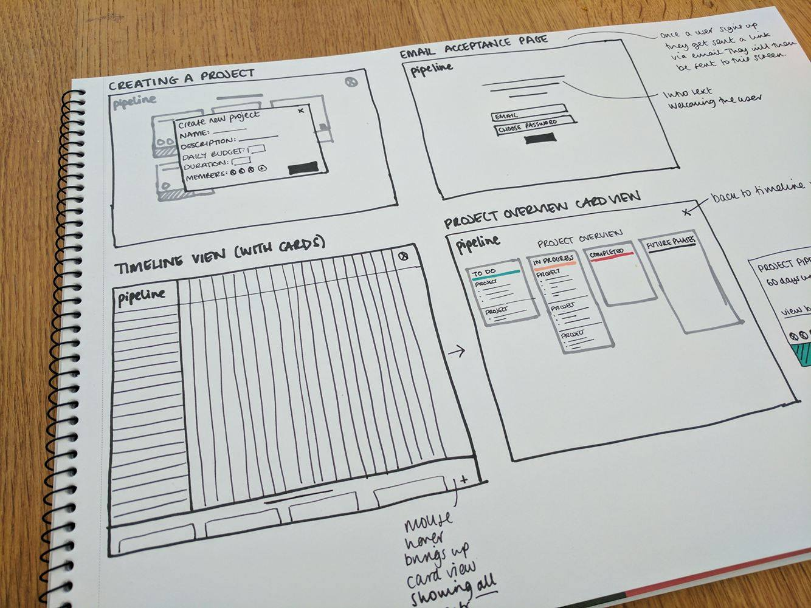

**Appendix X – Medium Fidelity Wireframes**

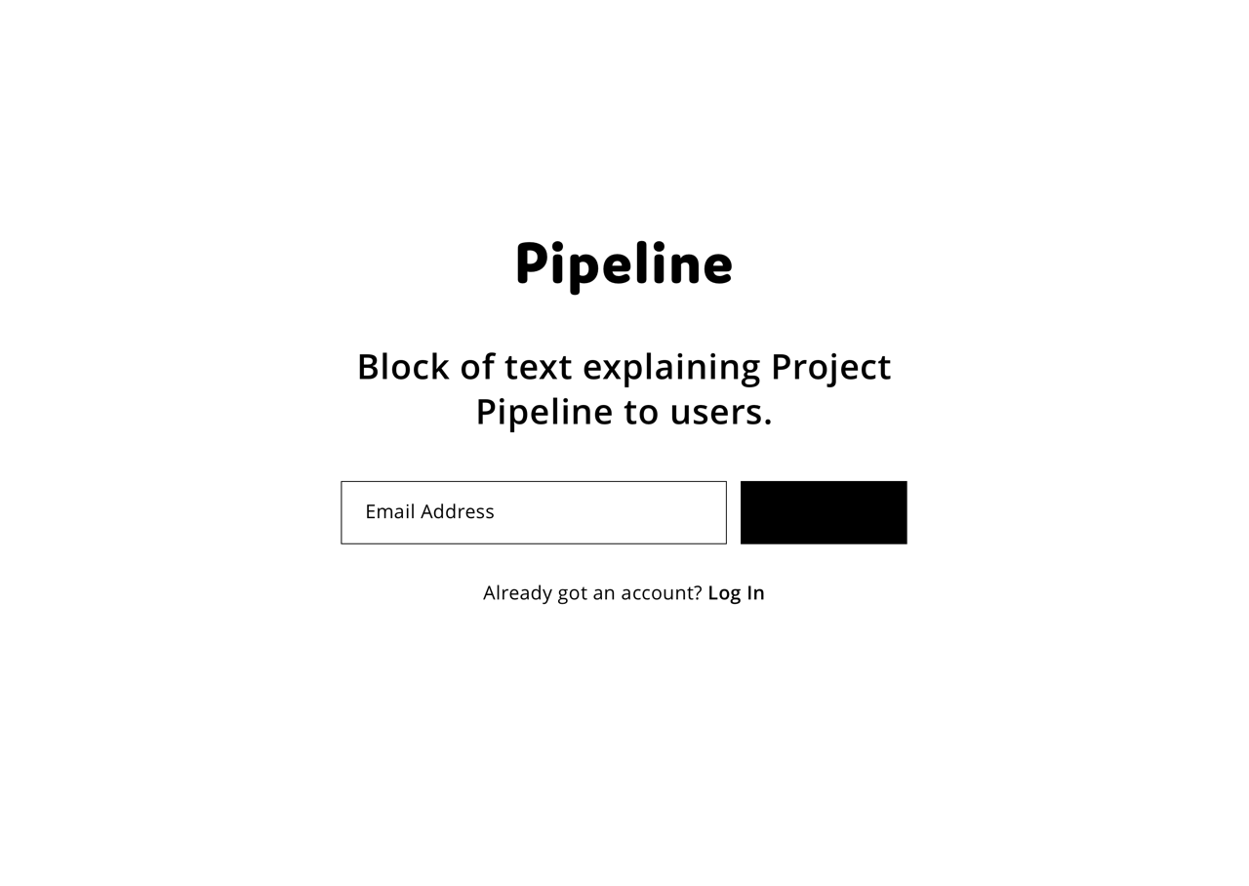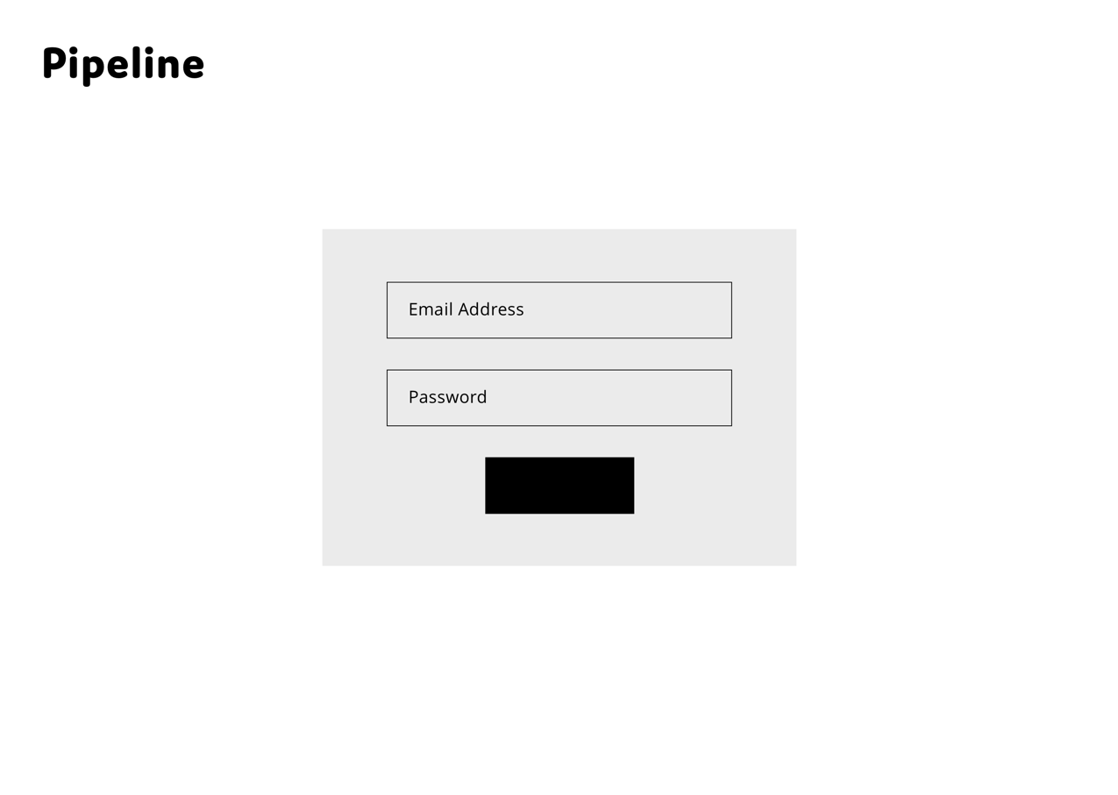

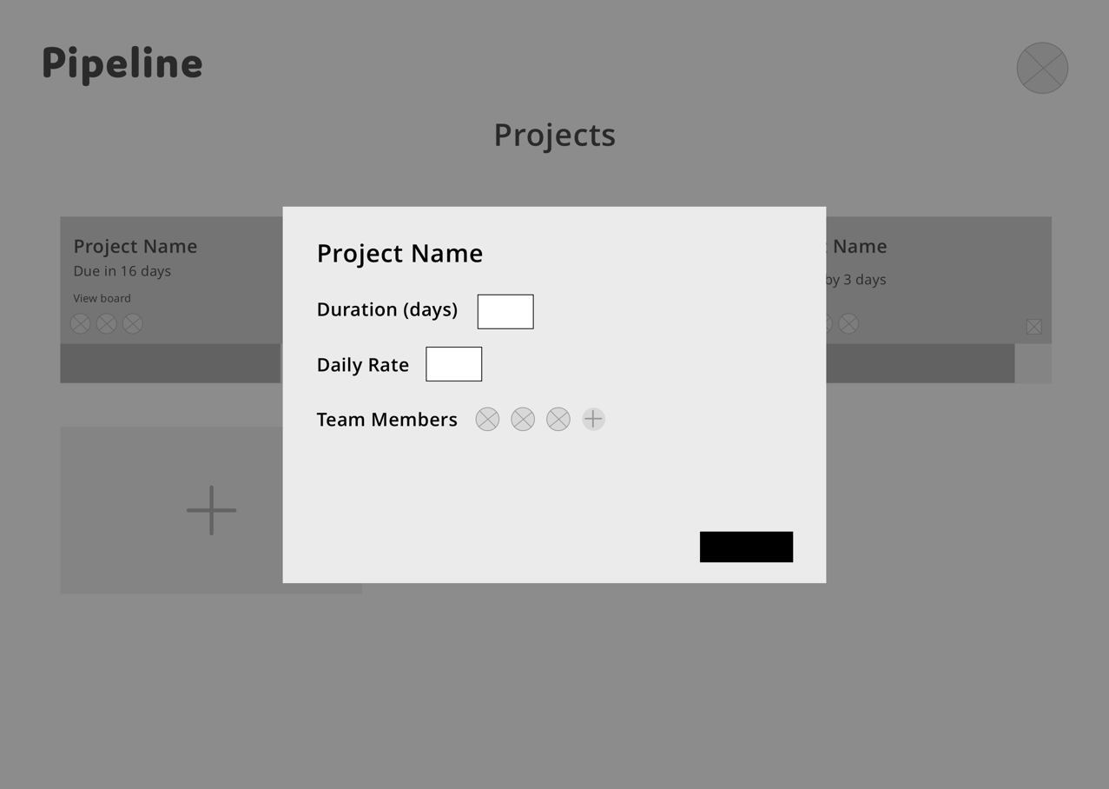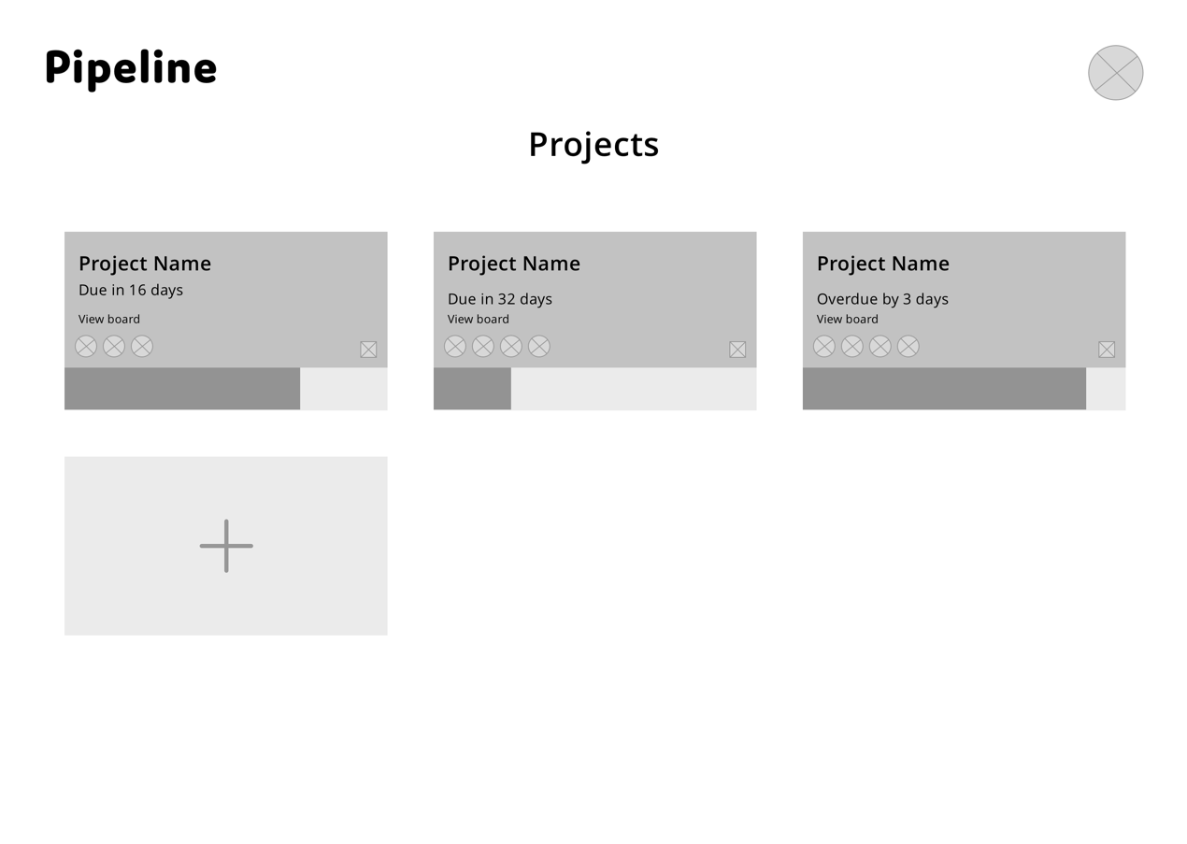

**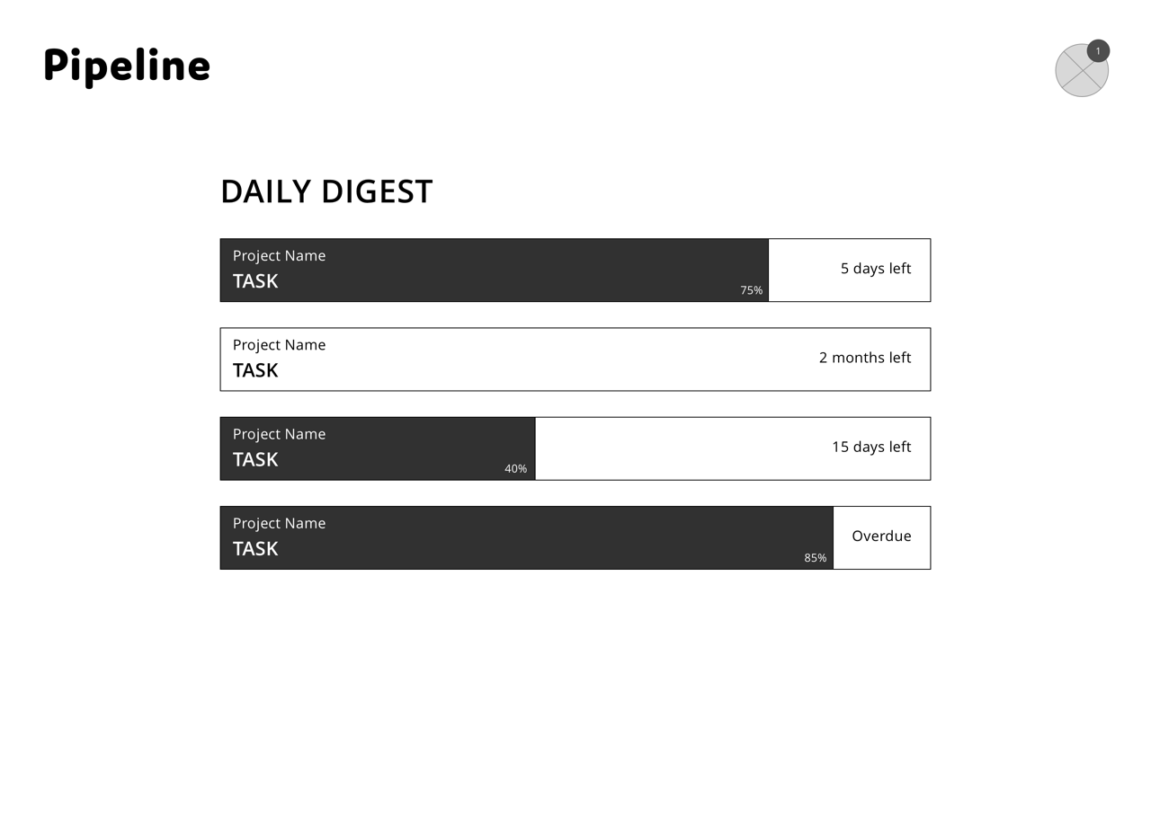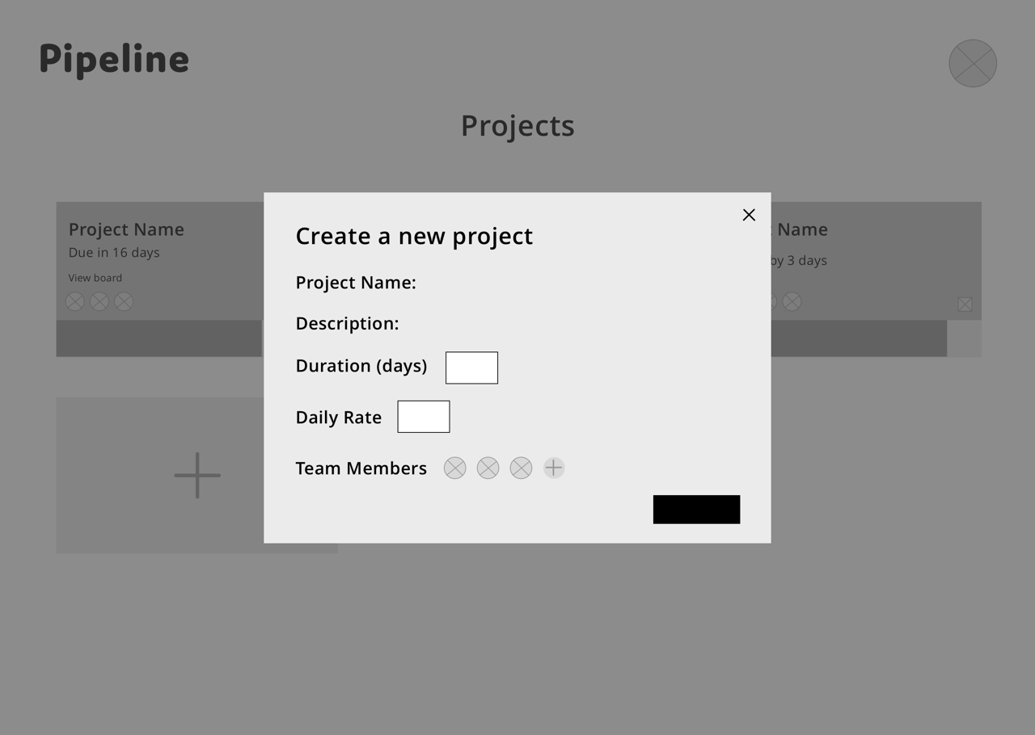**

**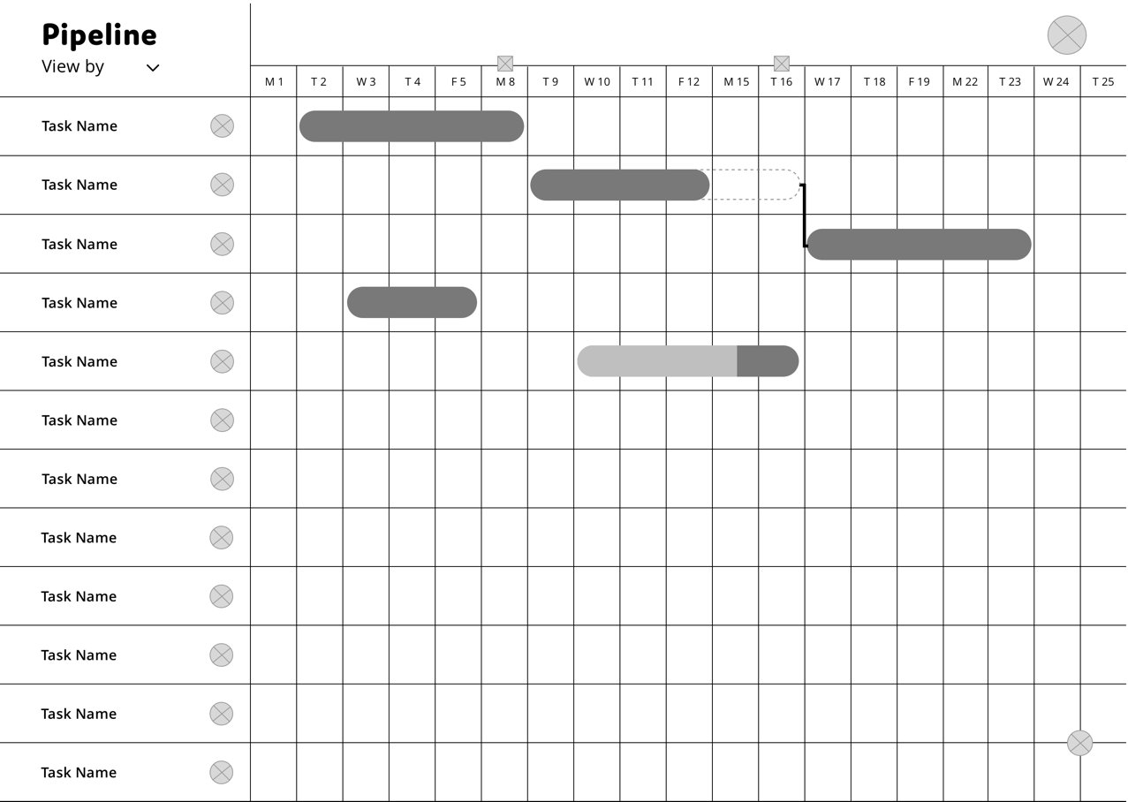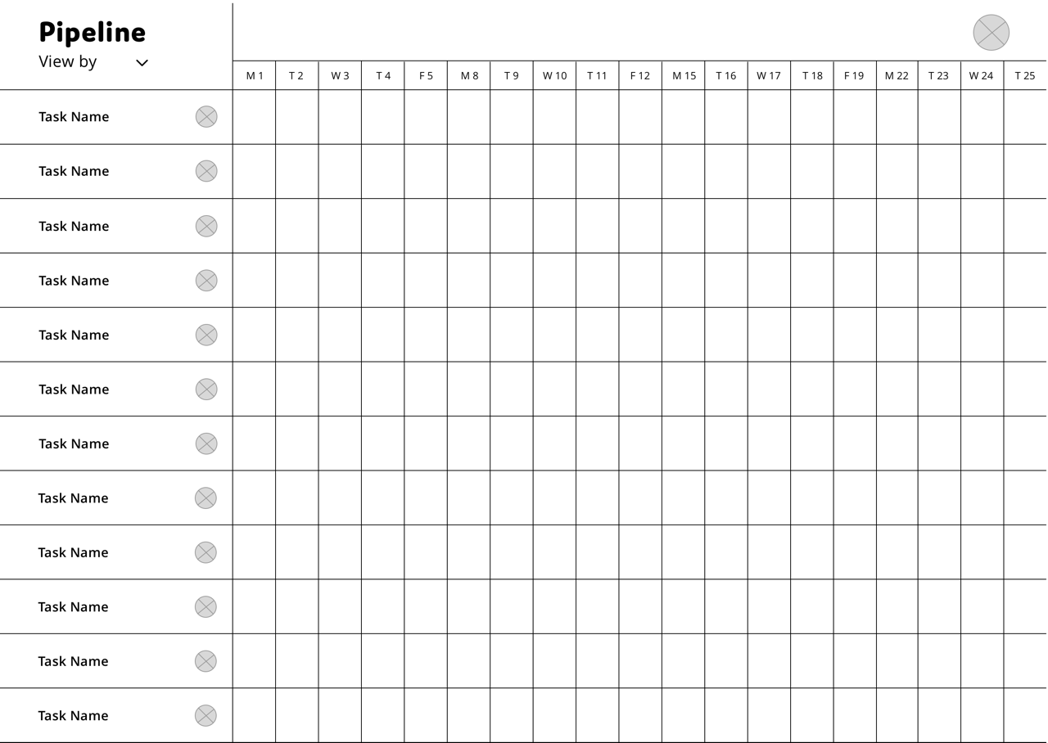**

**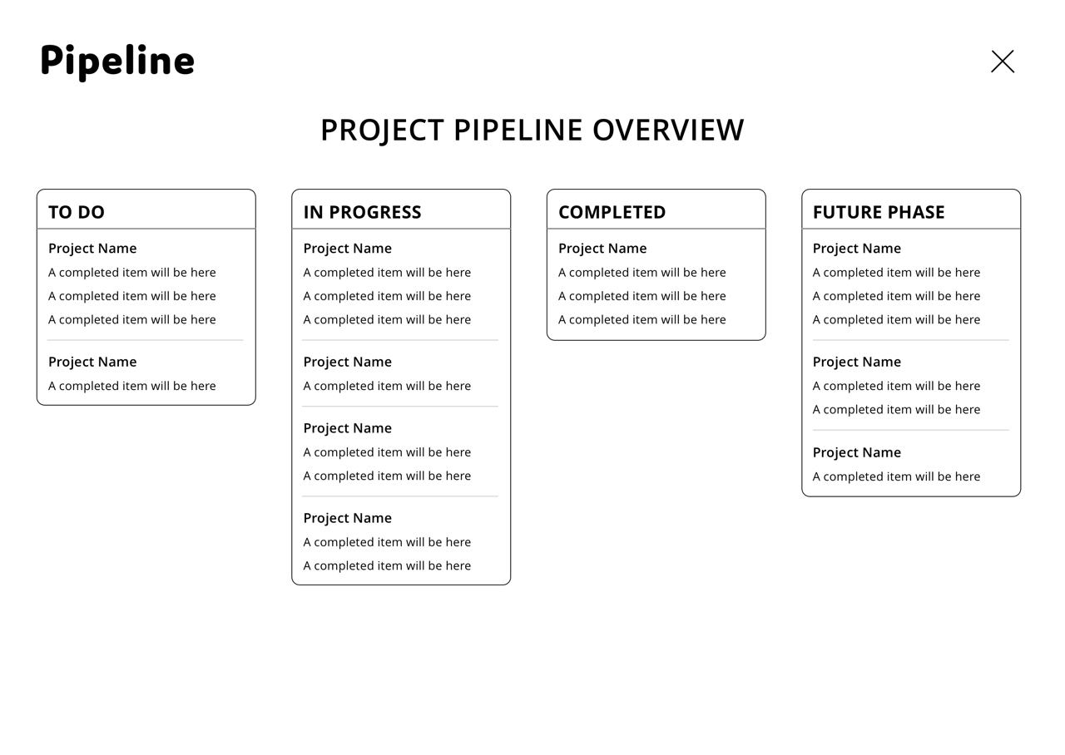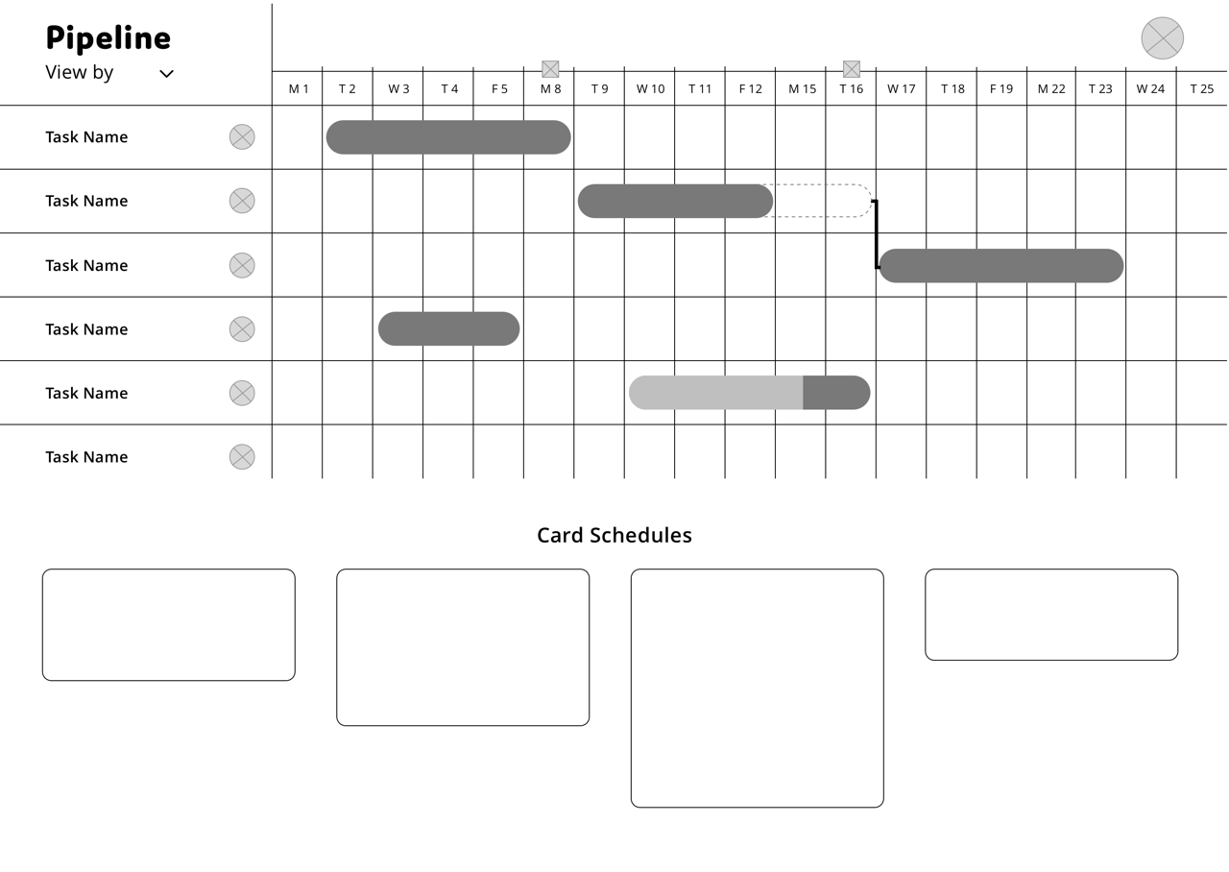**

**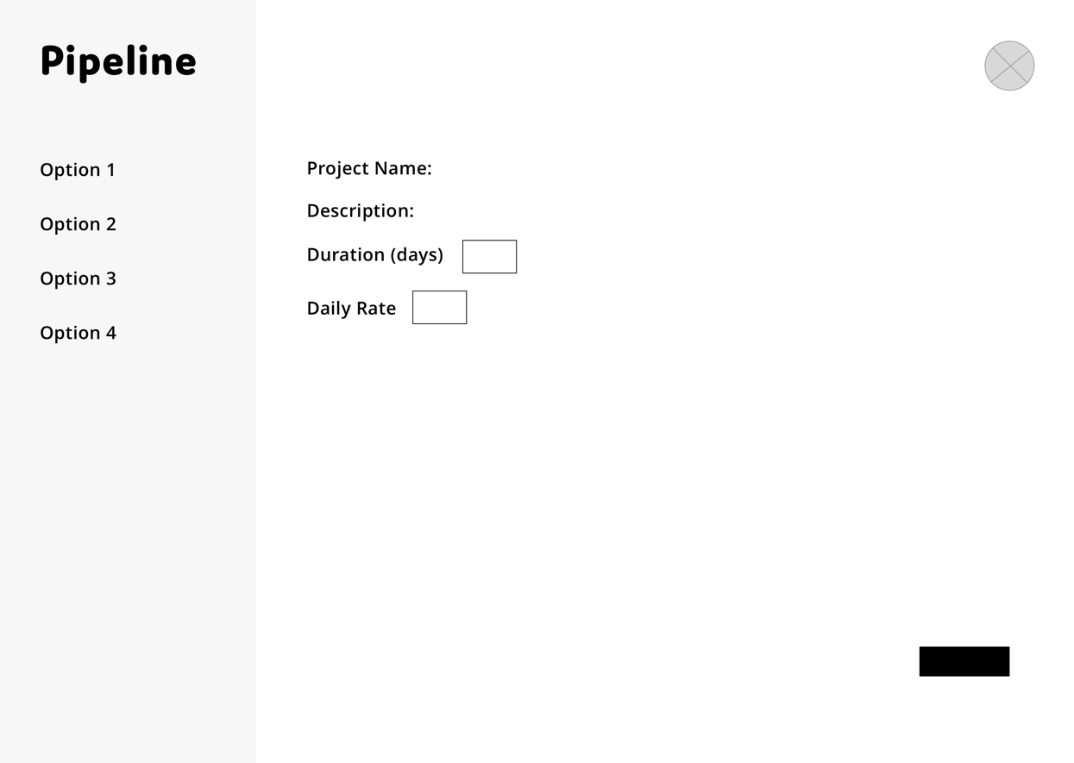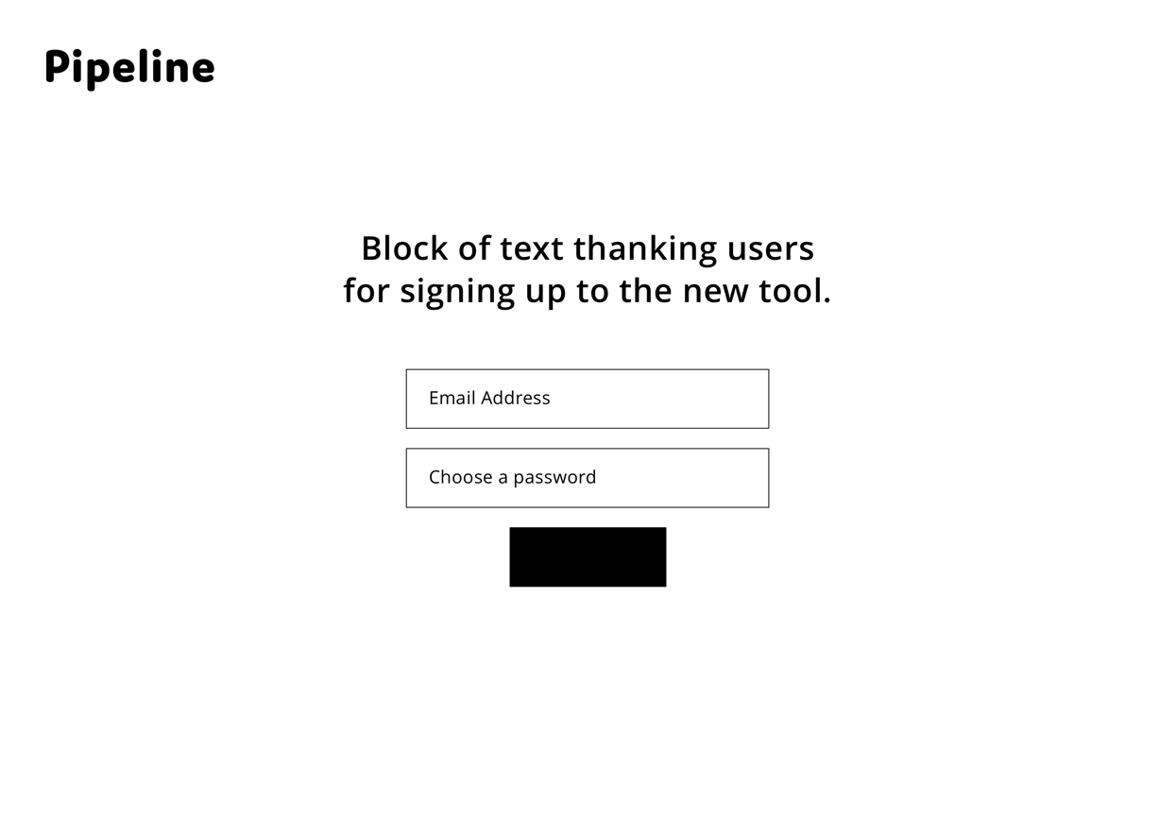**

## ../Dropbox%20(Personal)/Dissertation/dissertation/designs/high%20fidelity%20designs/Email%20Link%20Screen.png**../Dropbox%20(Personal)/Dissertation/dissertation/designs/high%20fidelity%20designs/Home%20Screen.pngAppendix X – High Fidelity Designs**

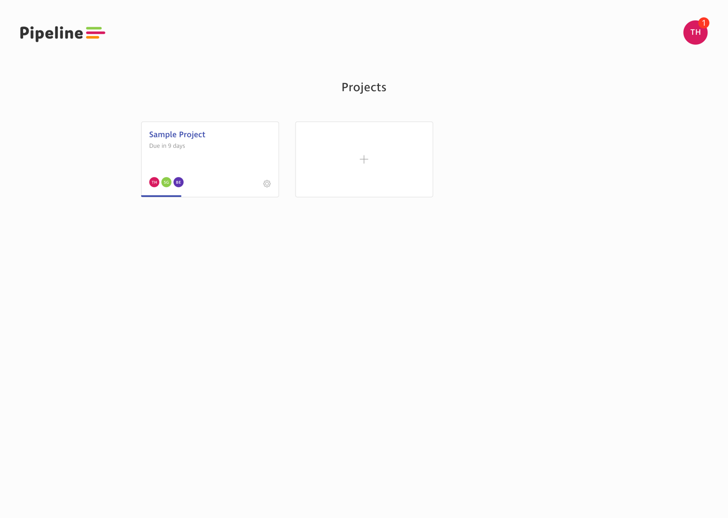**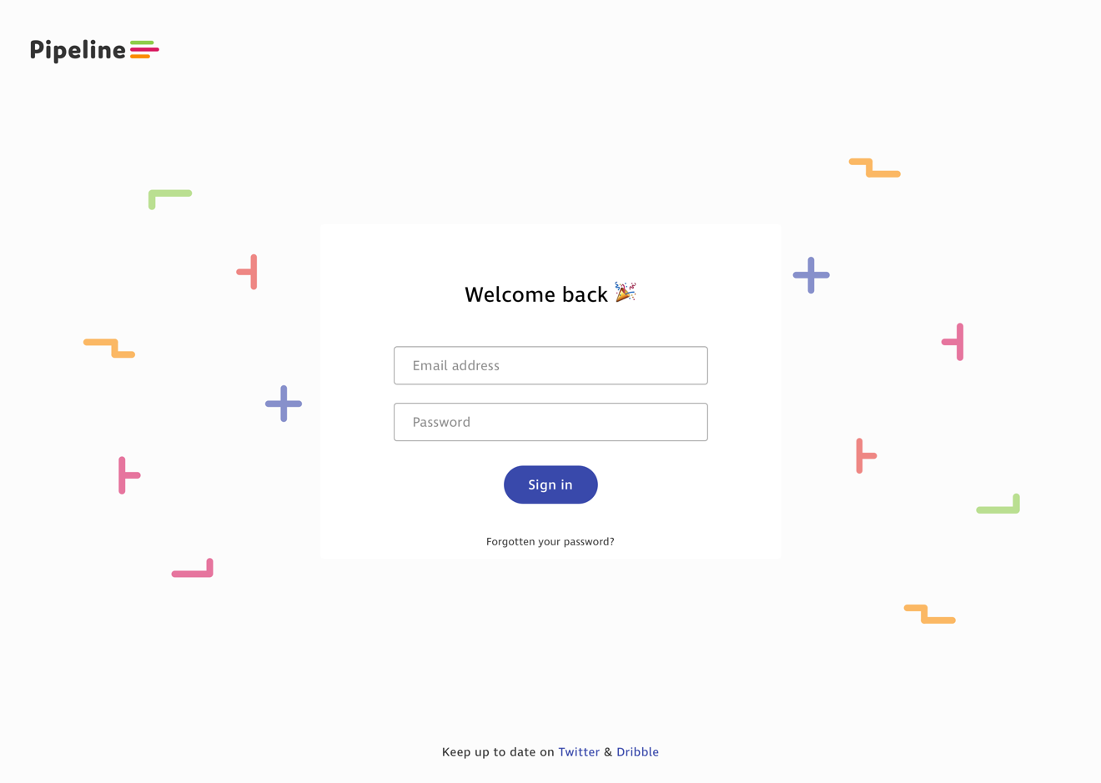**

**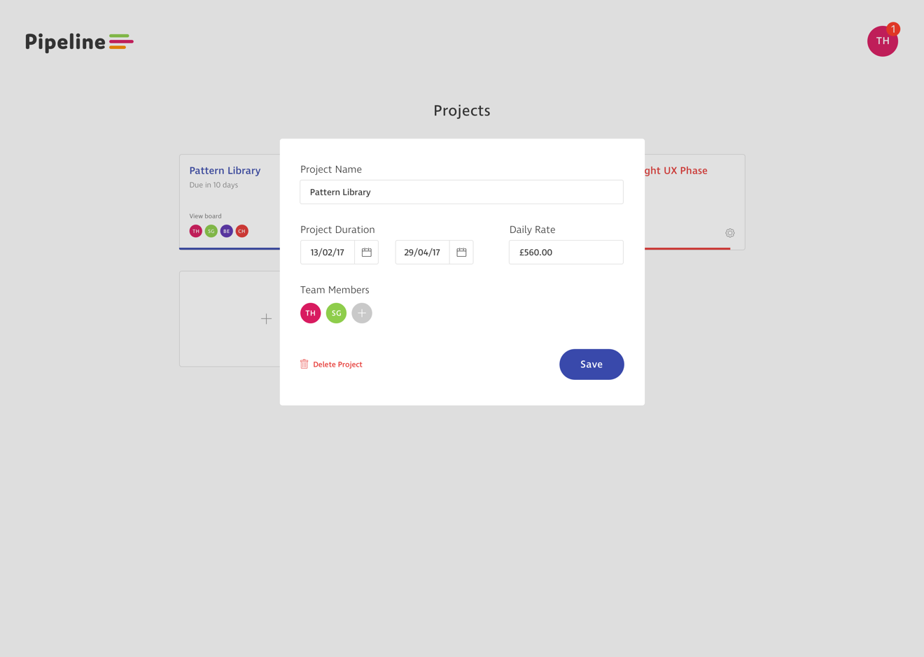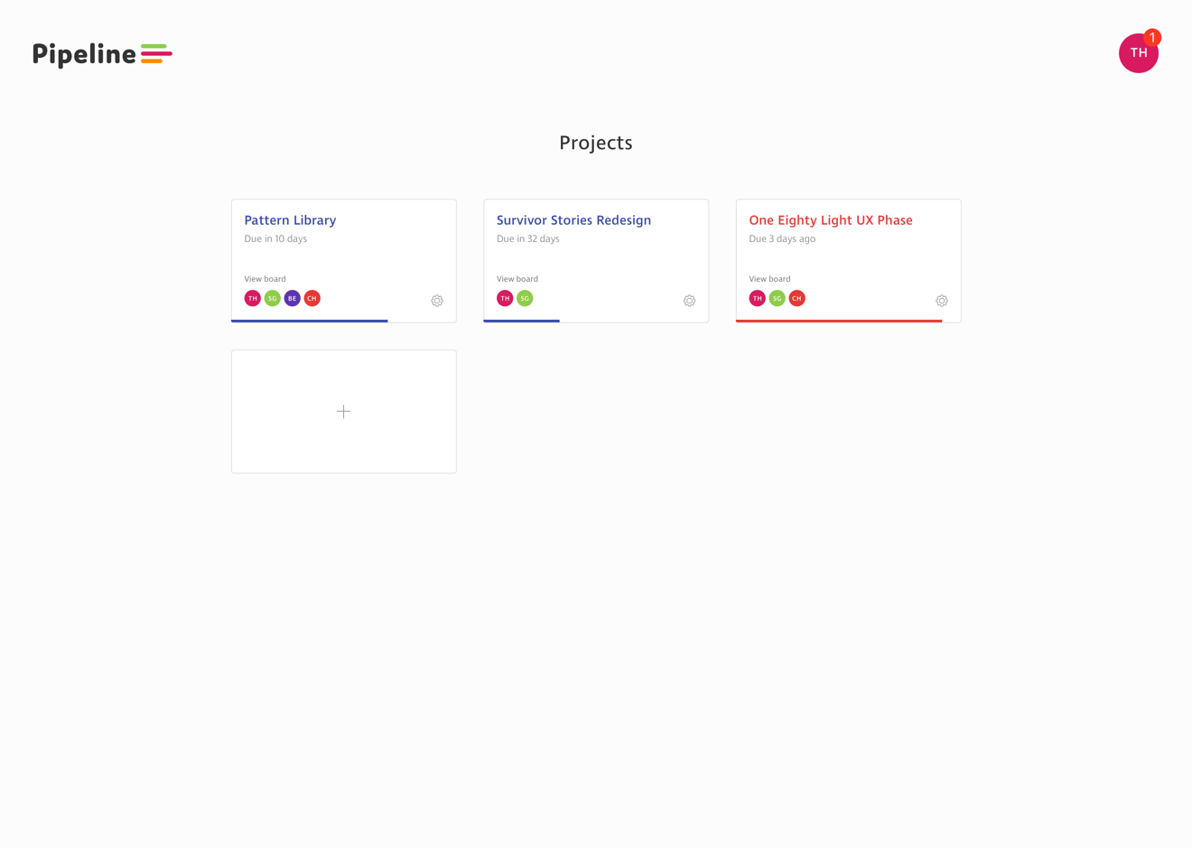**

**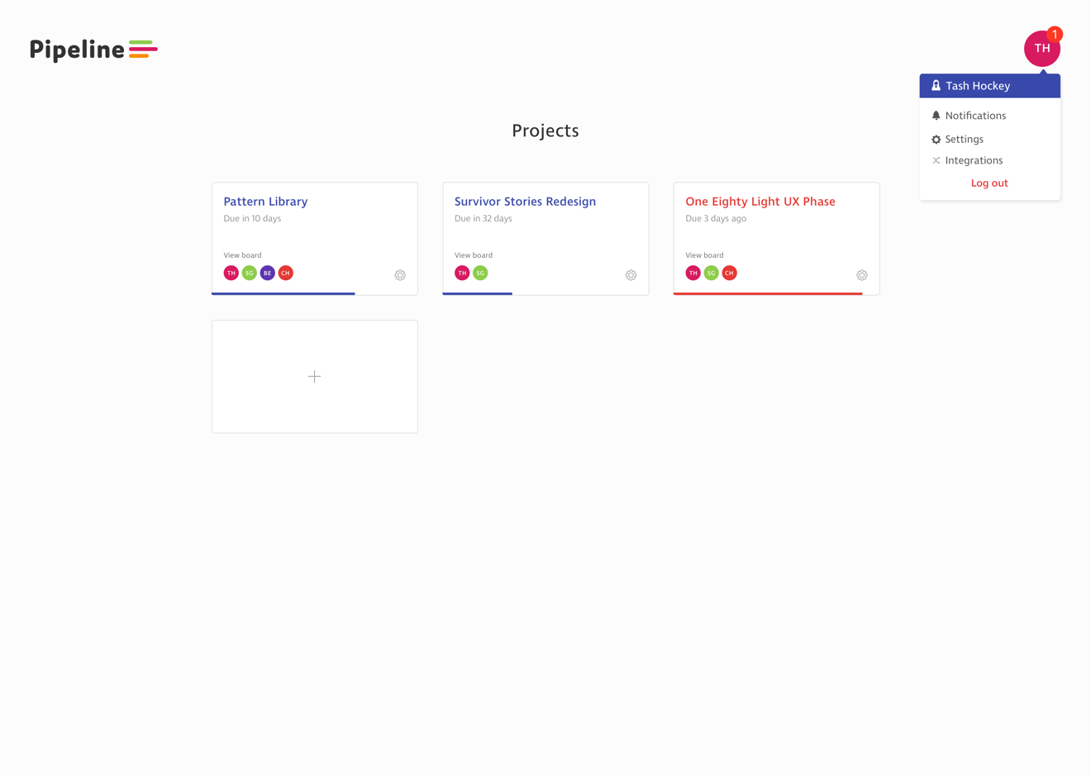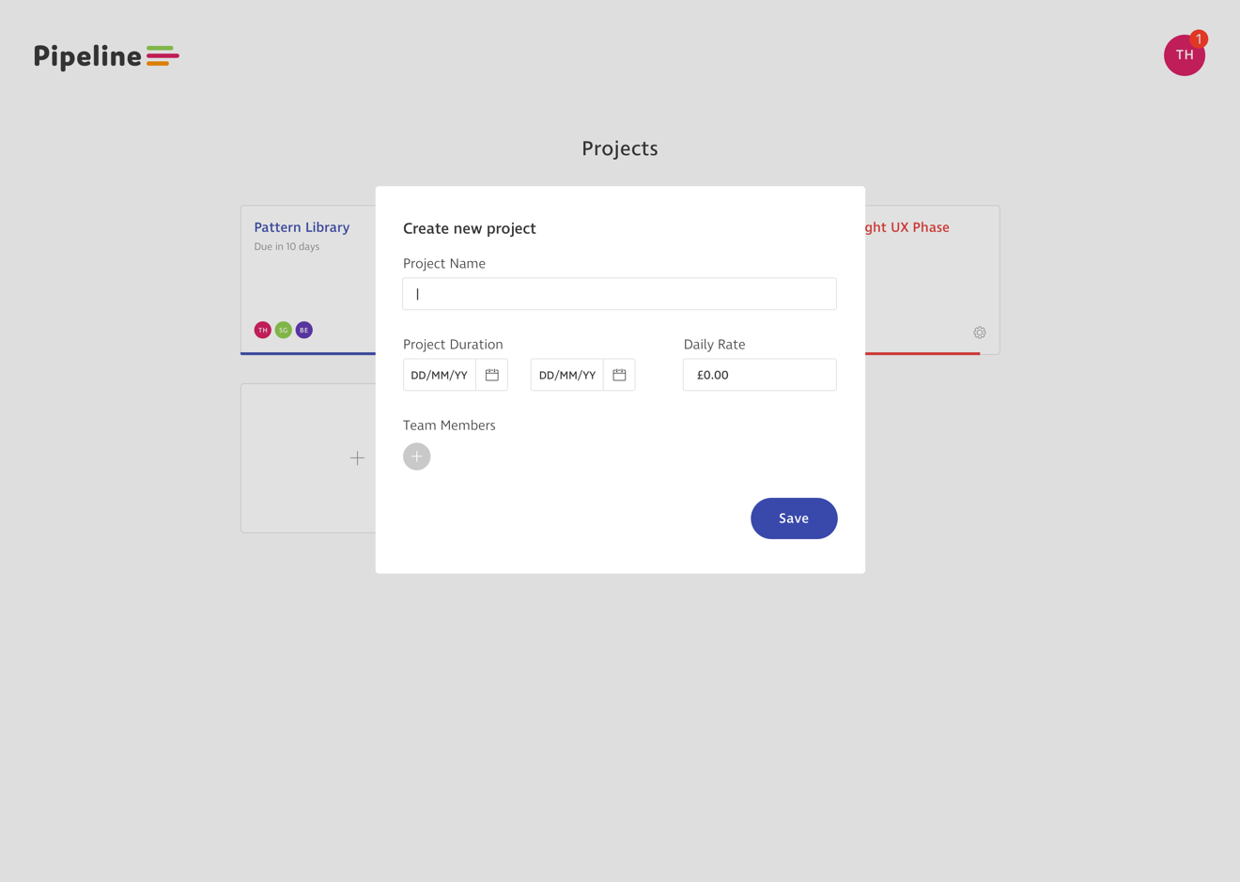**

**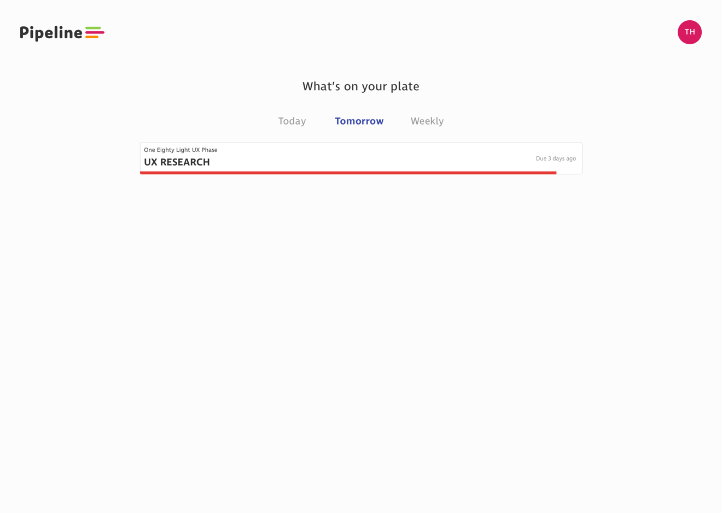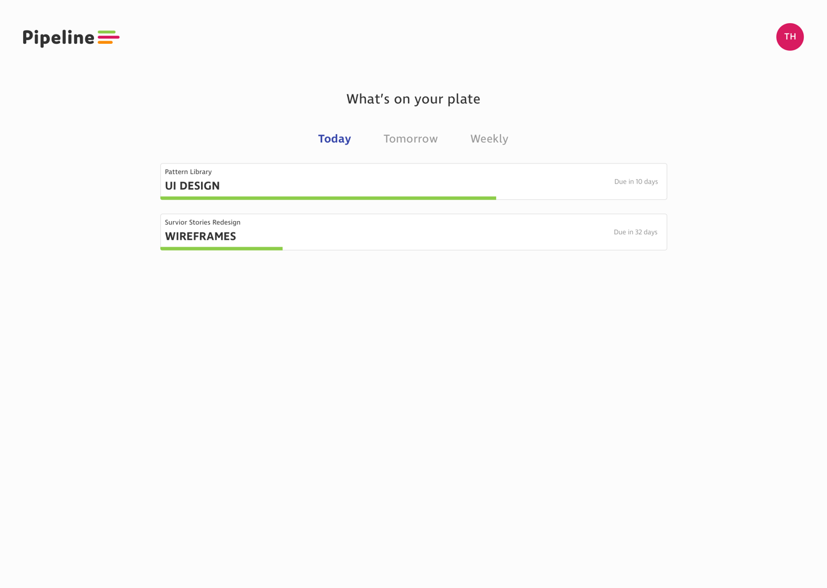**

**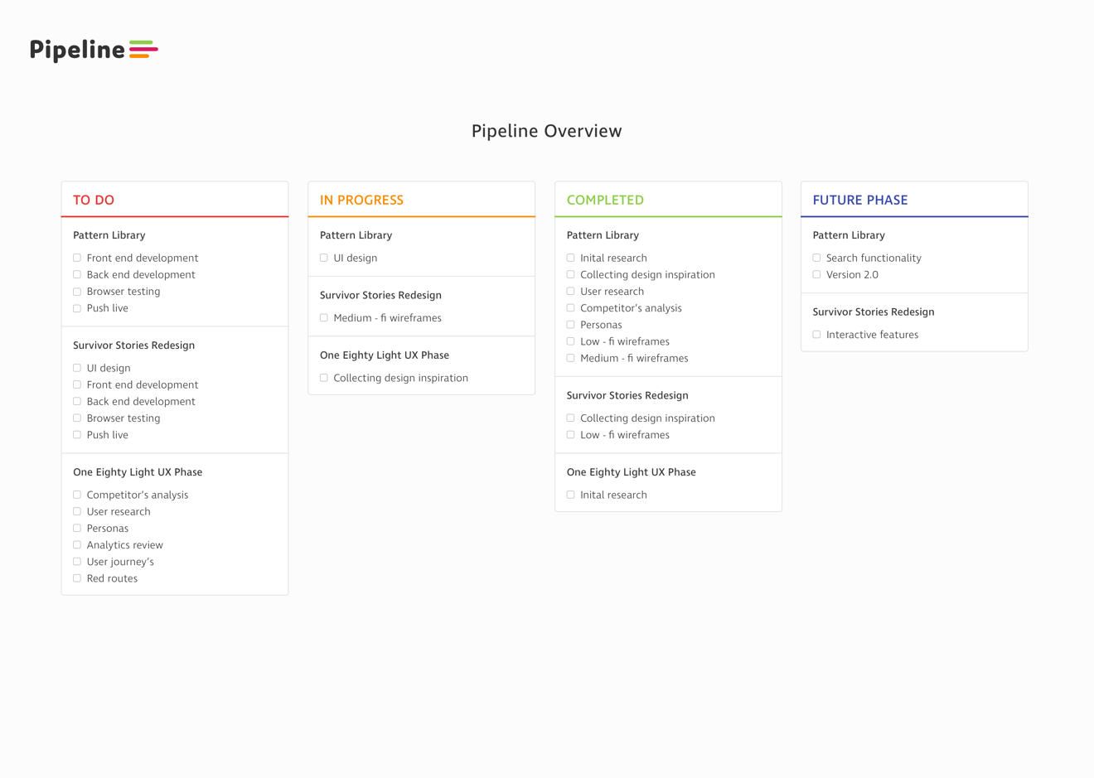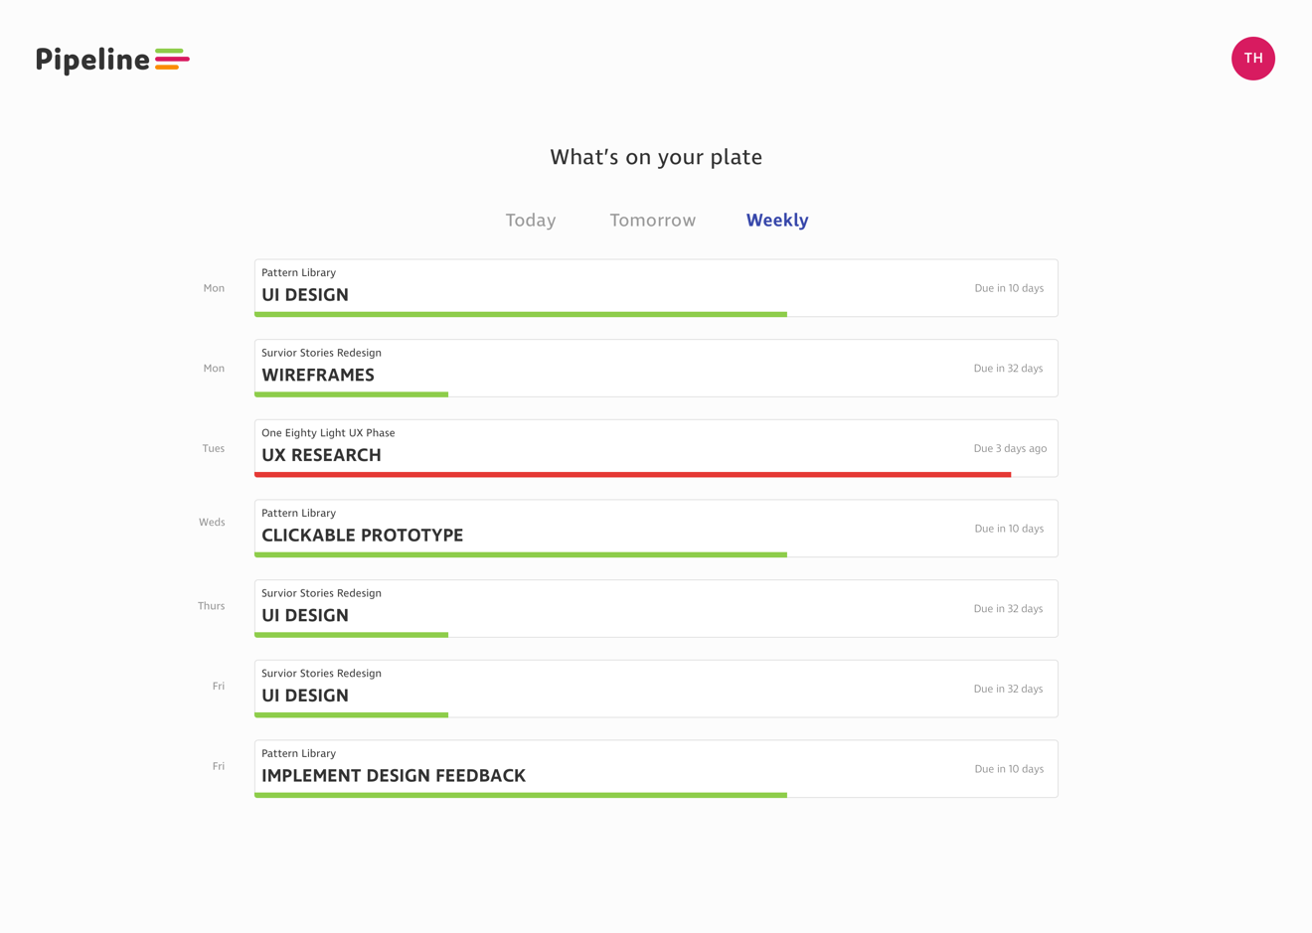**

**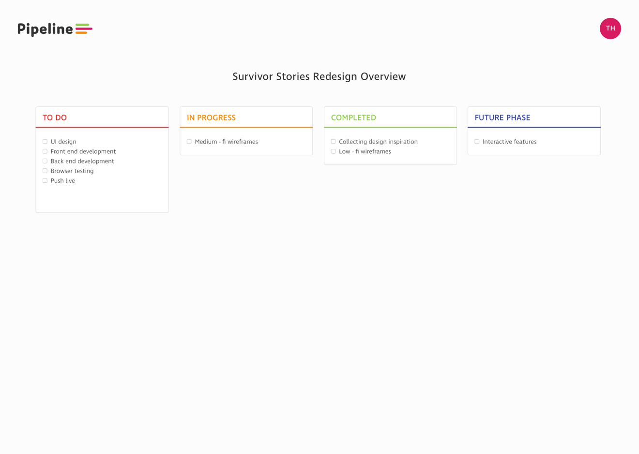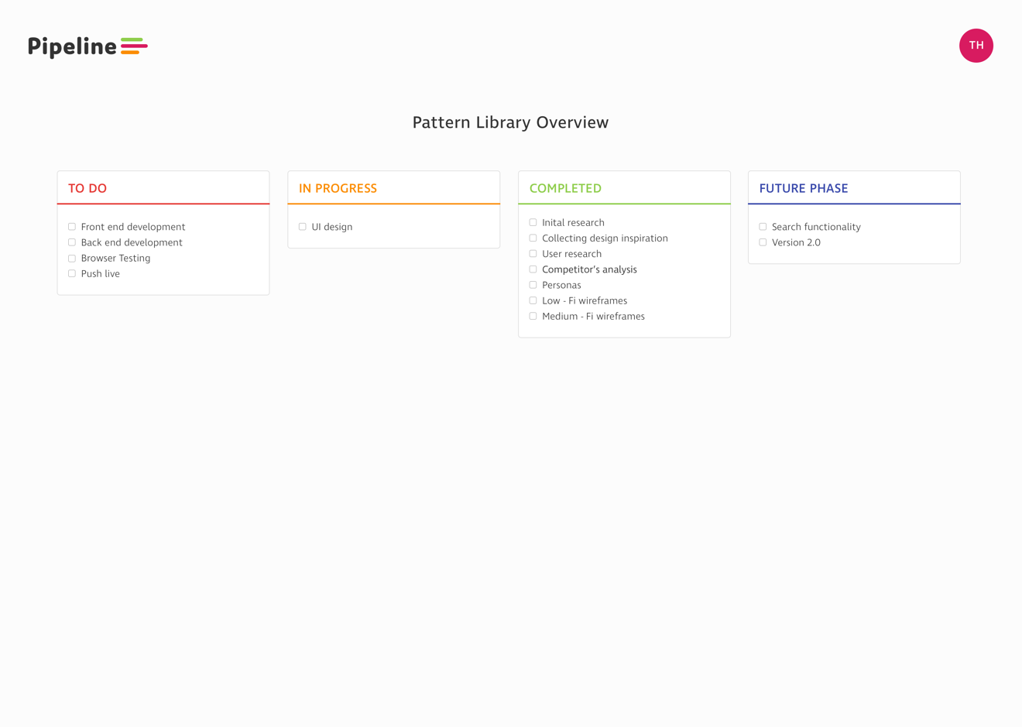**

**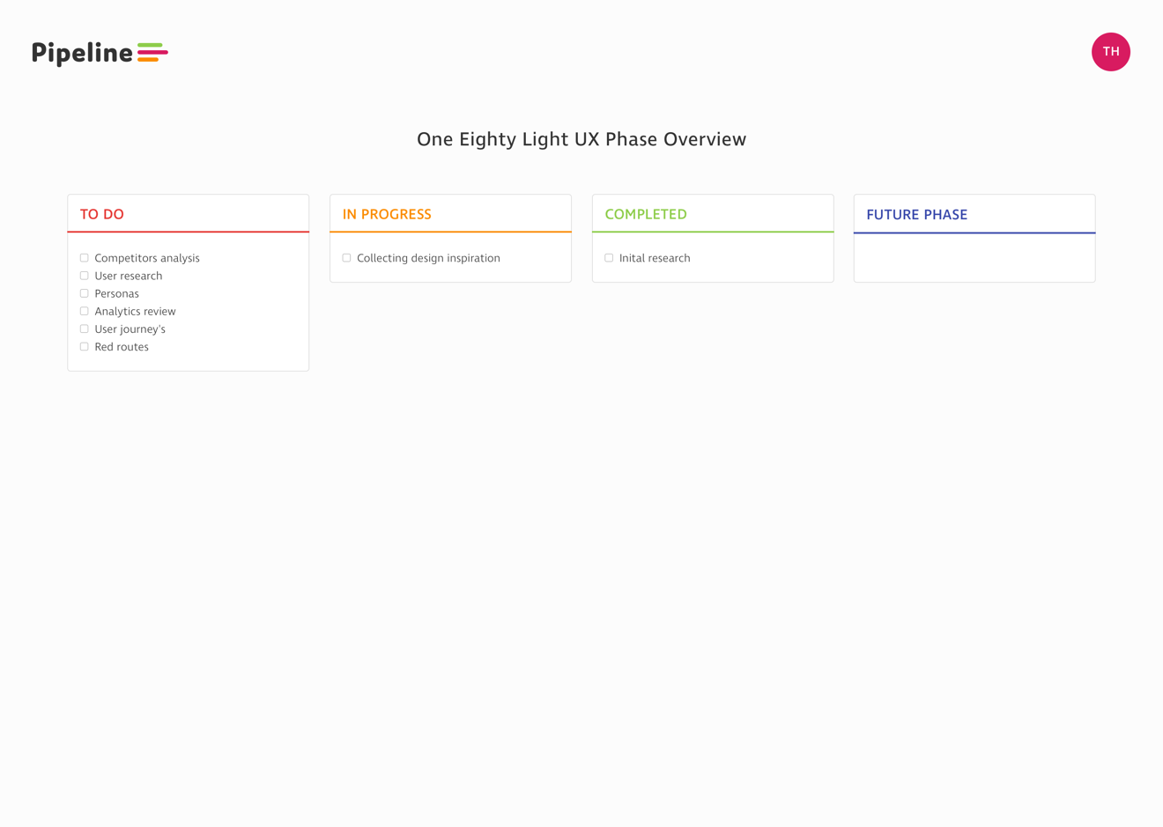**

**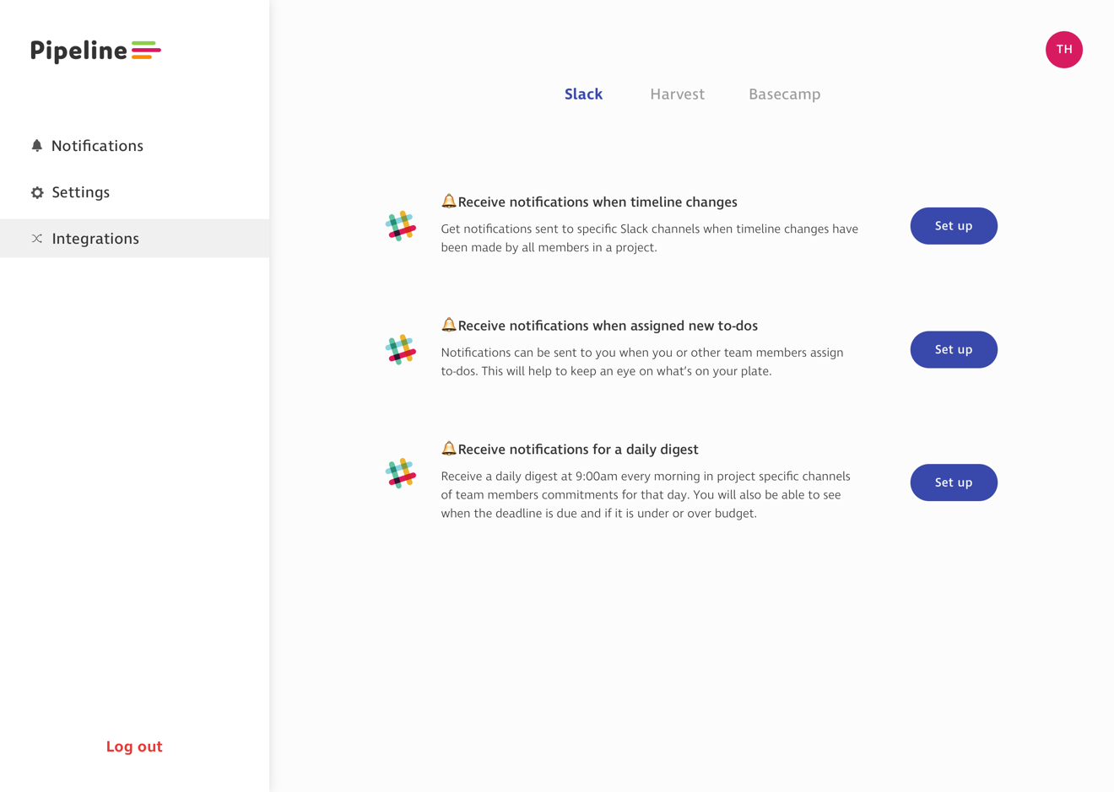**

**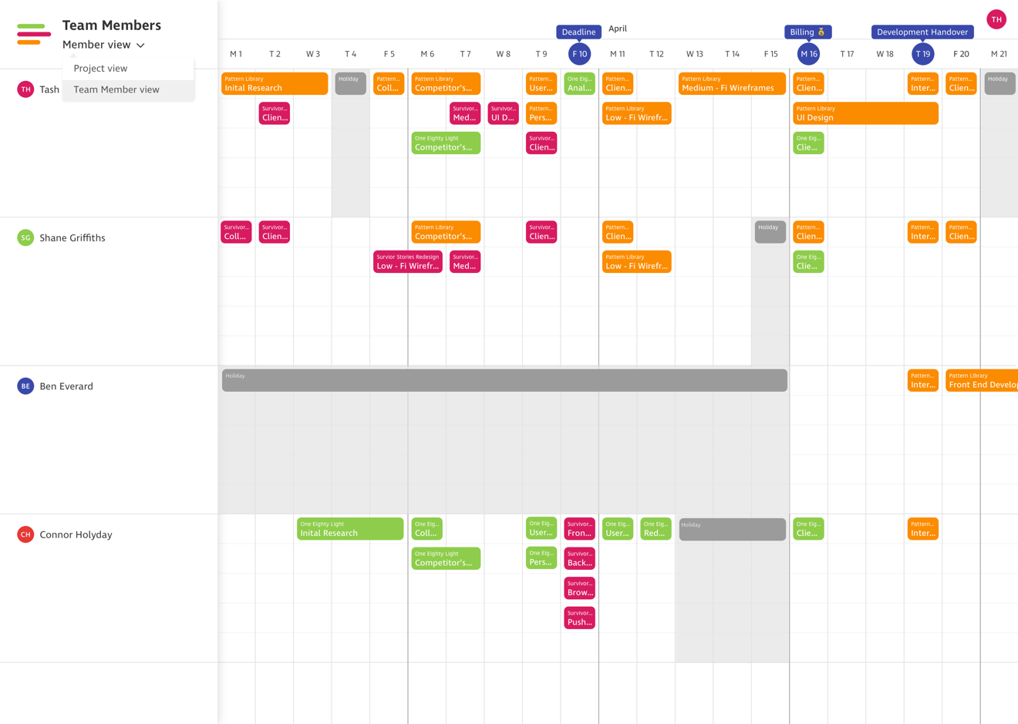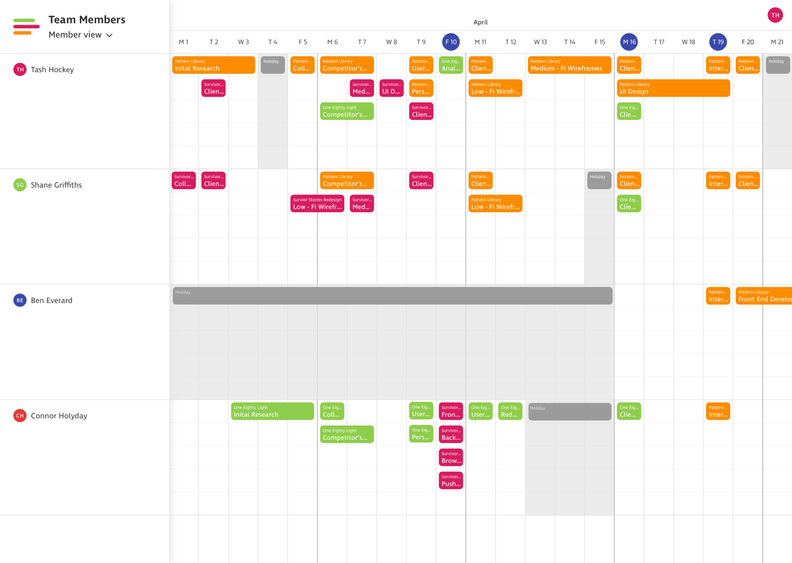**

**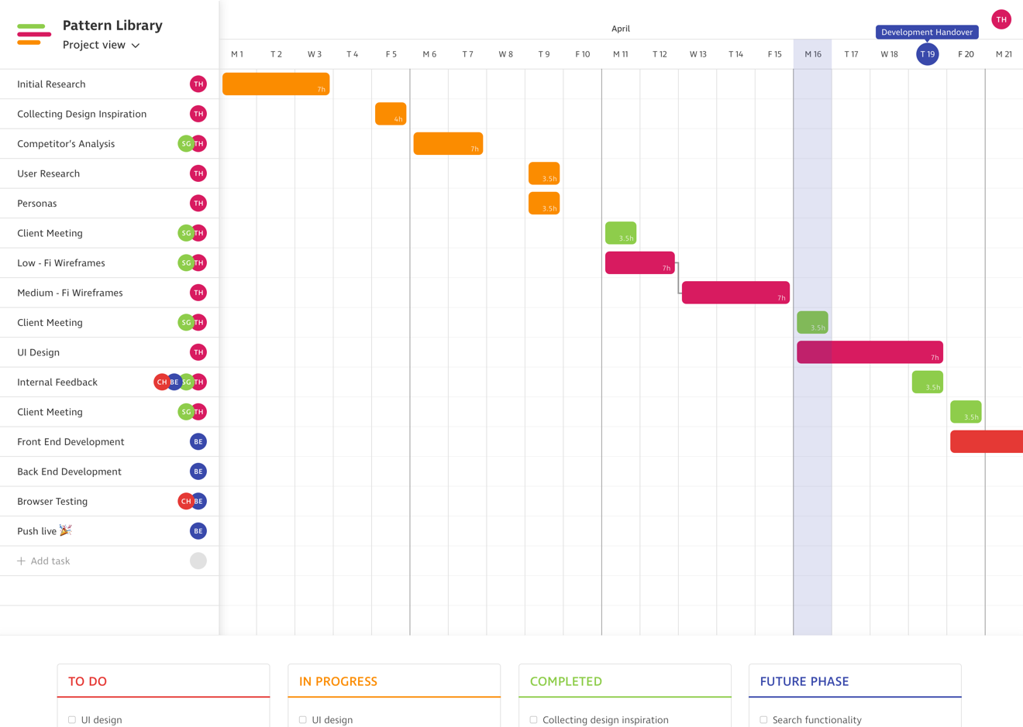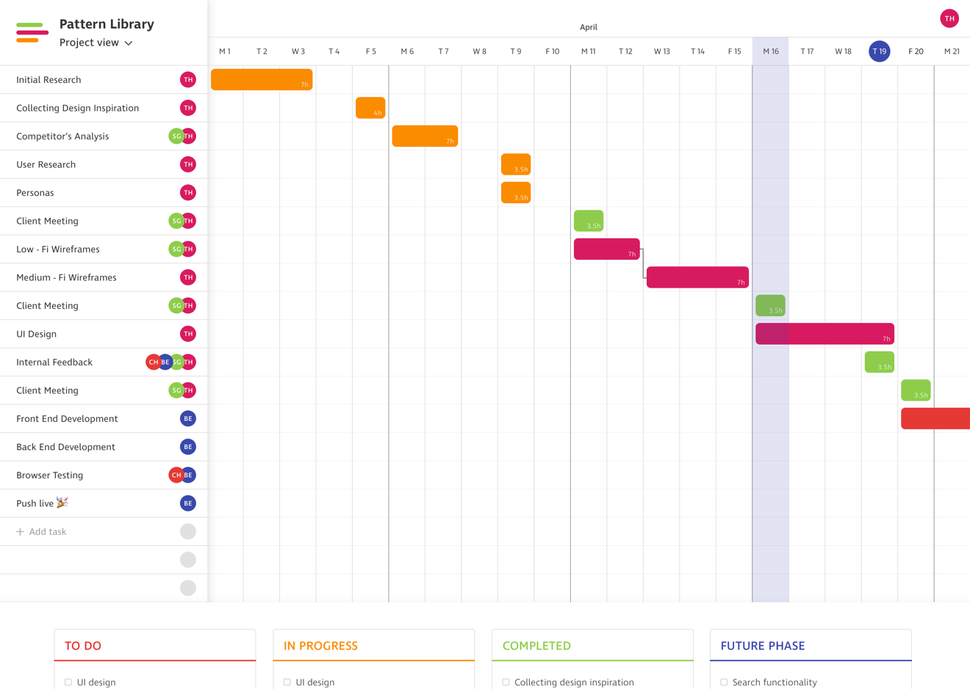**

**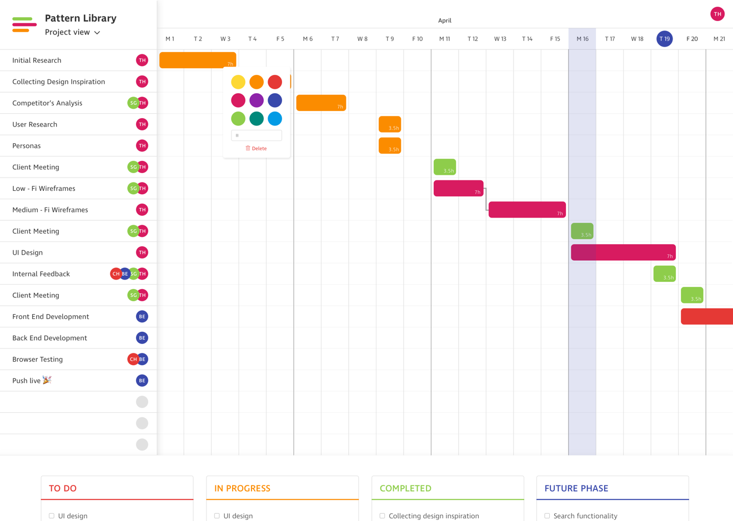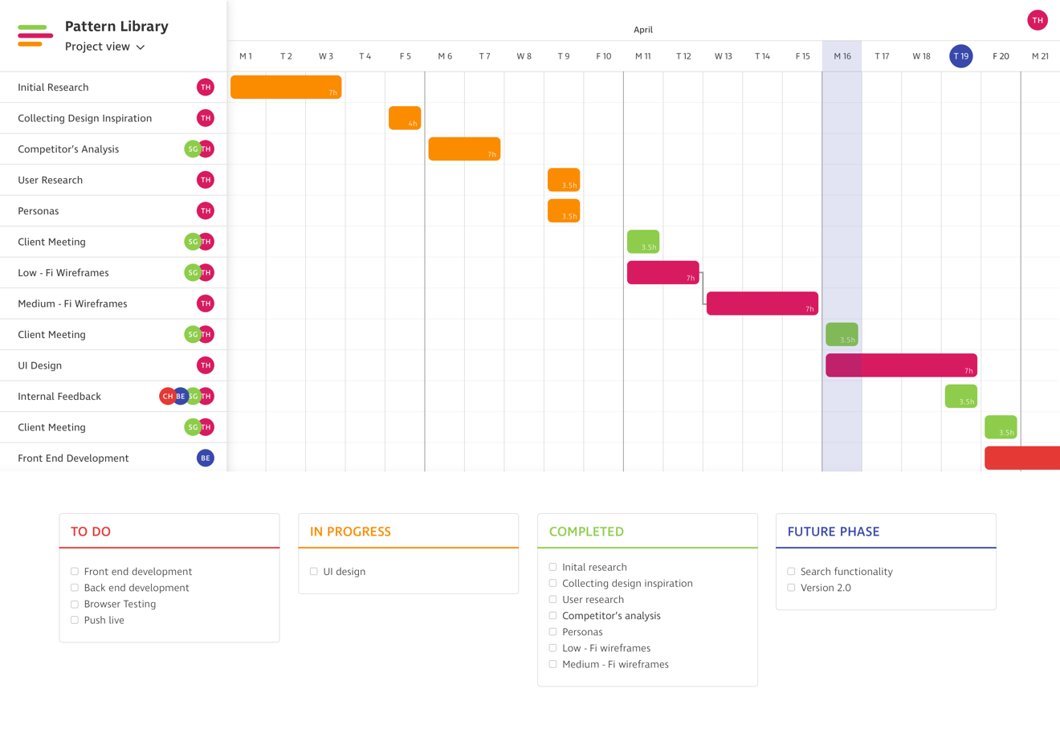**

**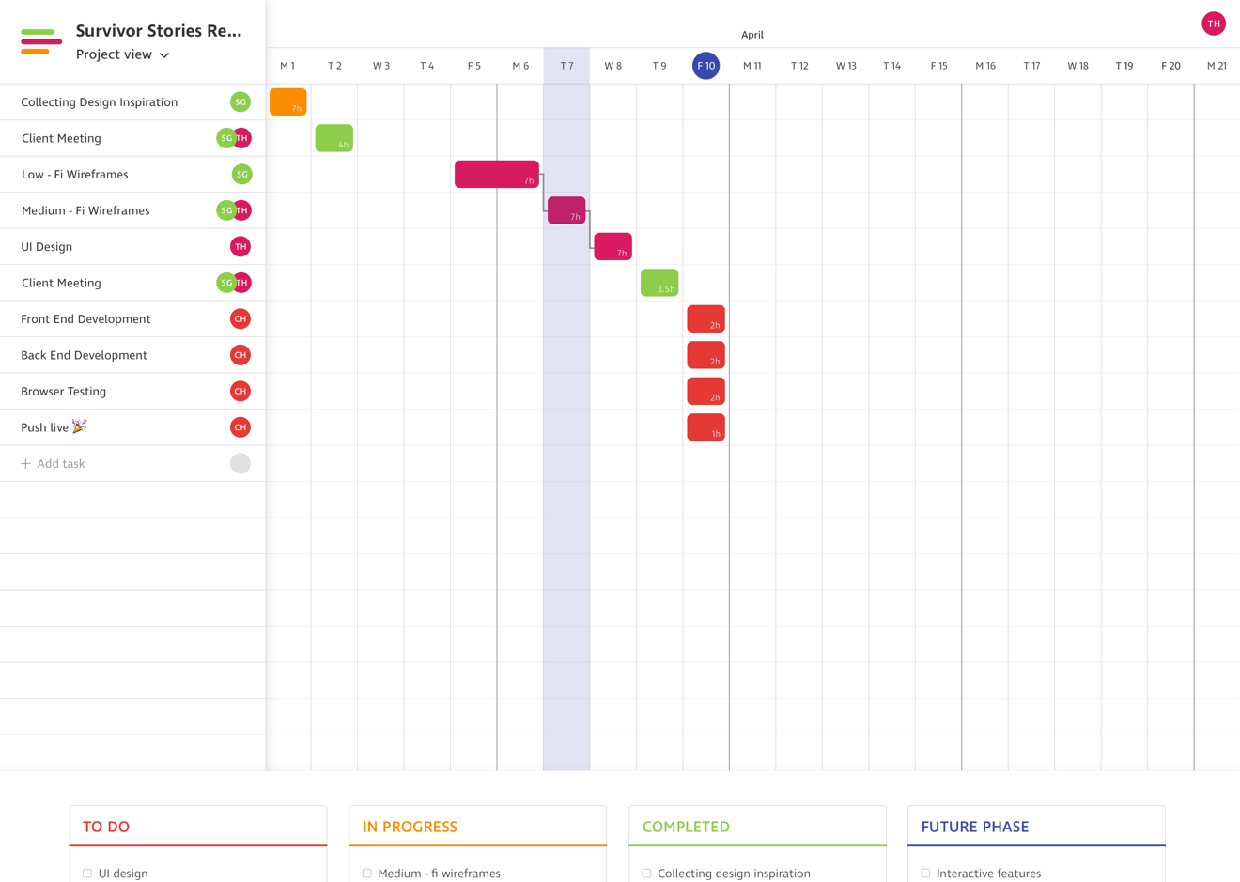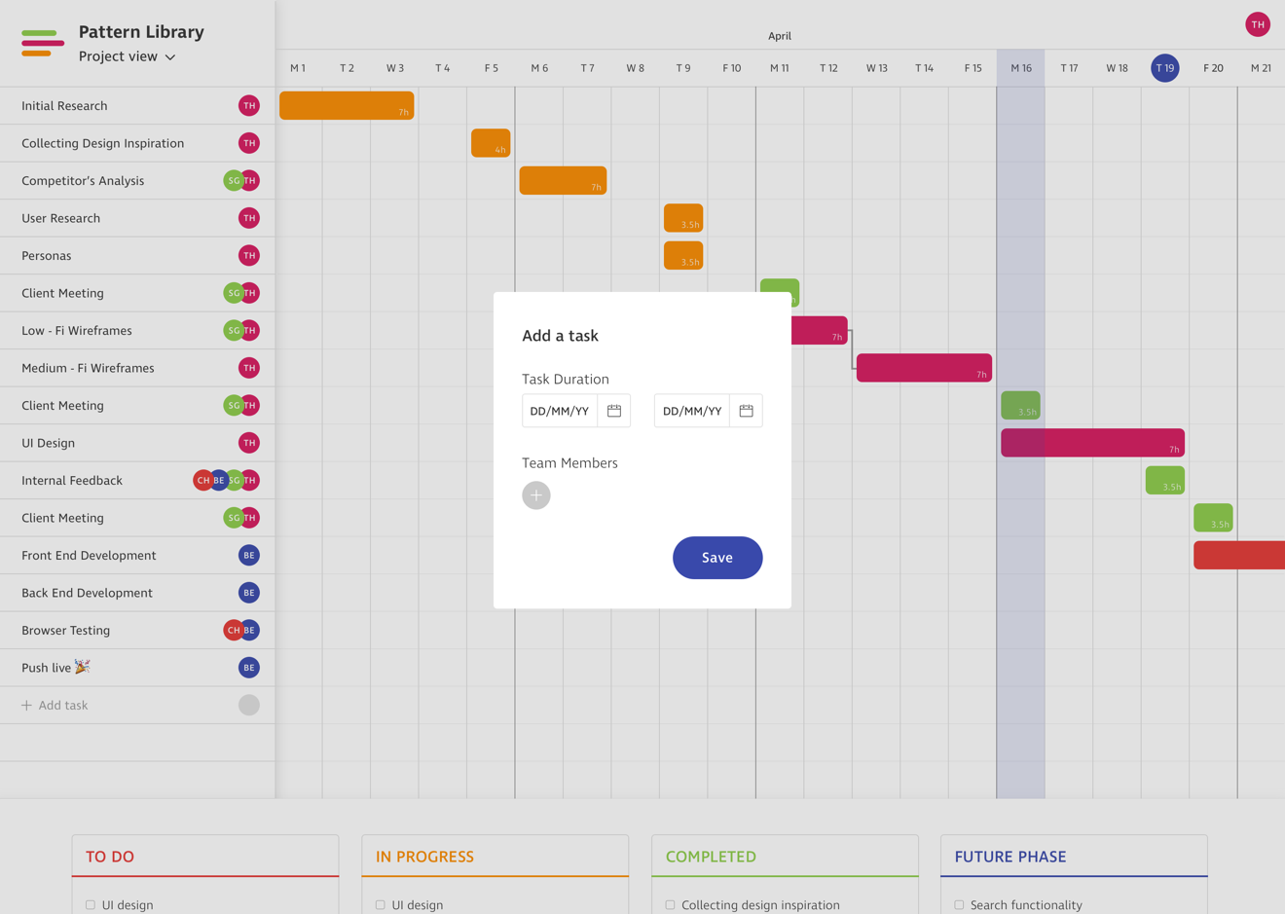**

**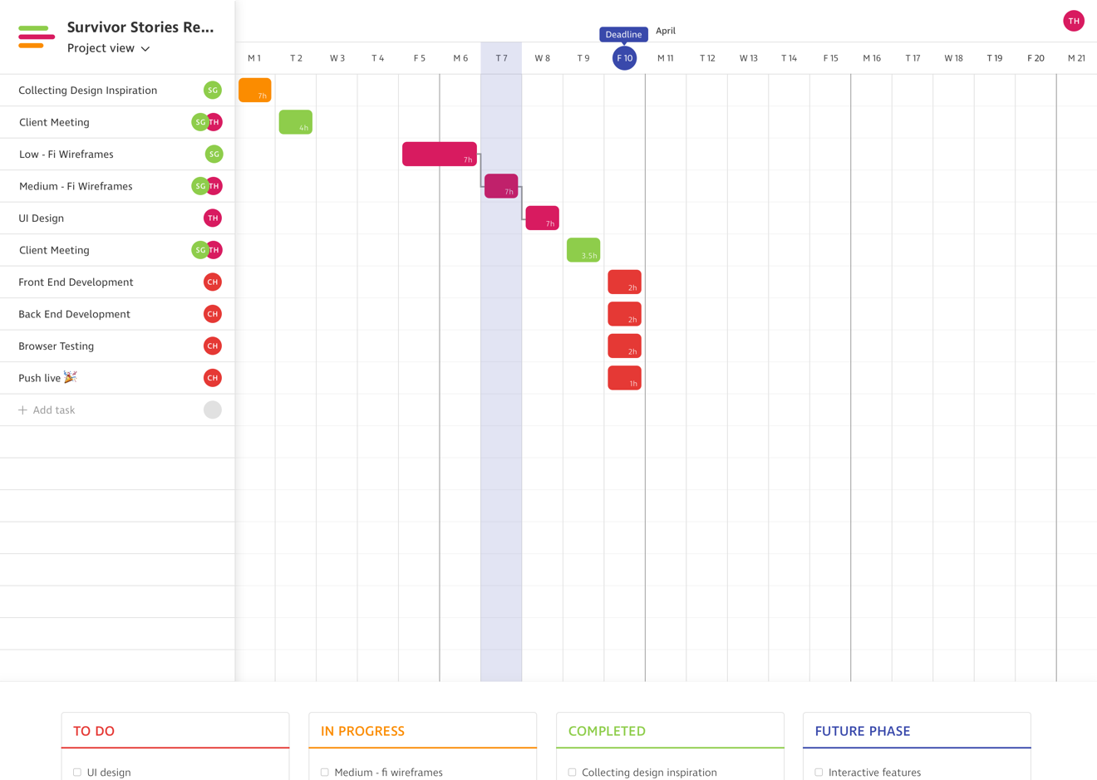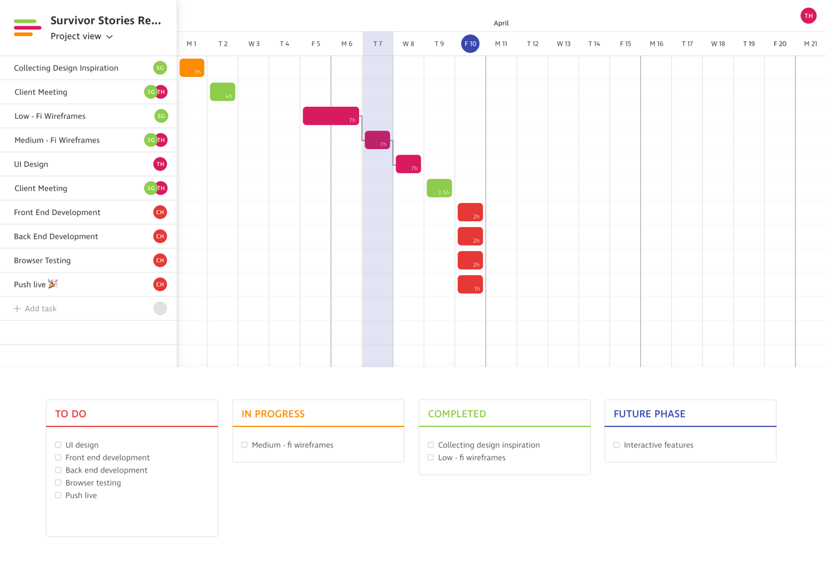**

**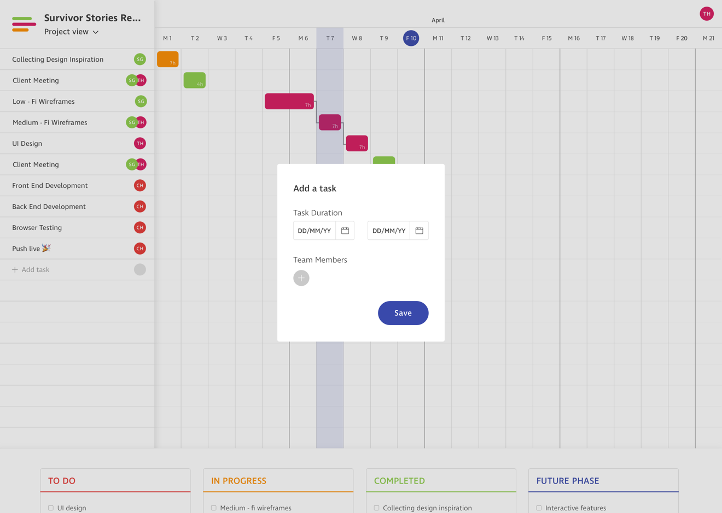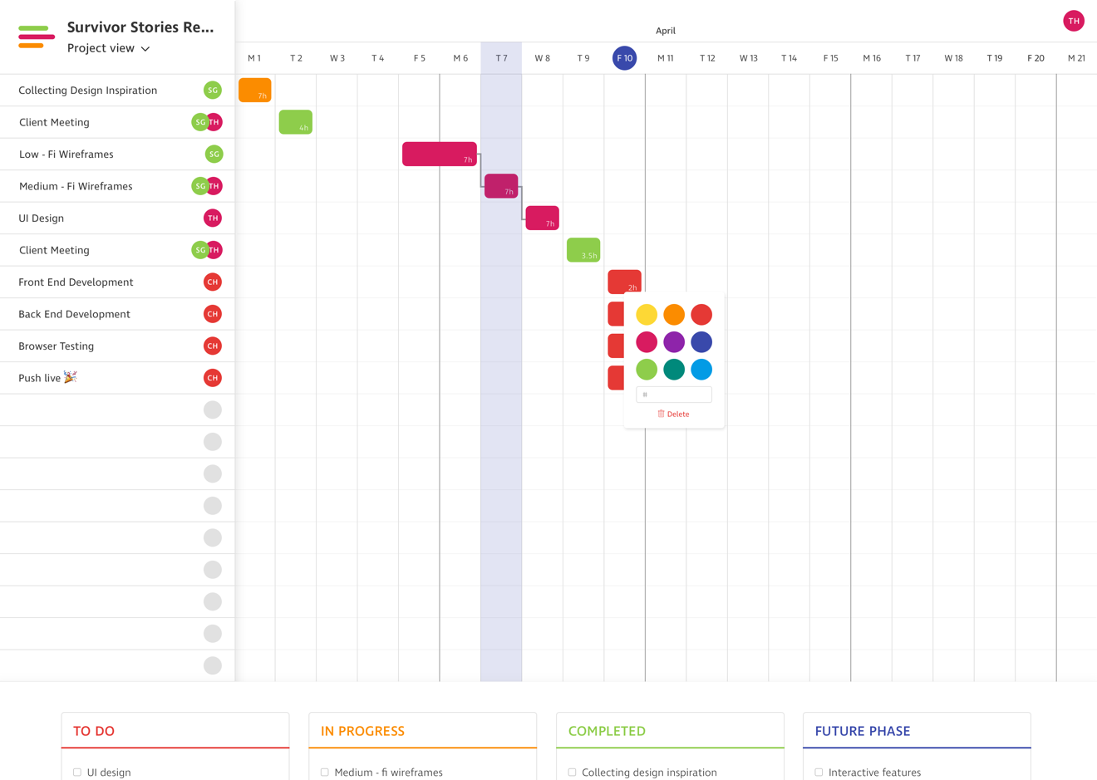**

**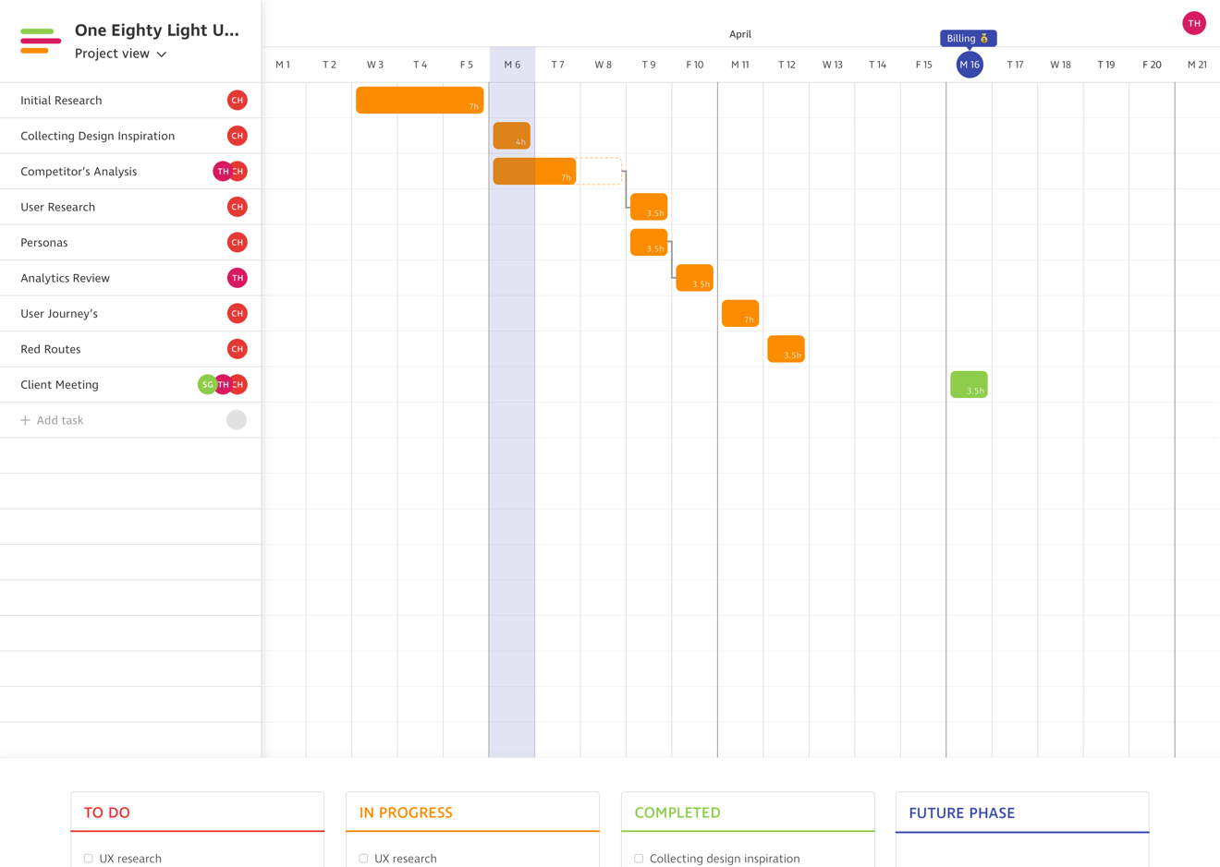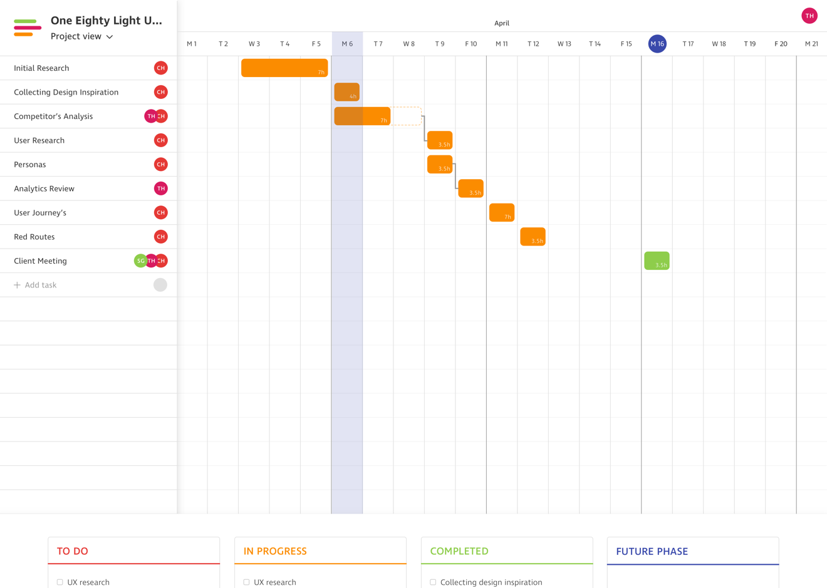**

**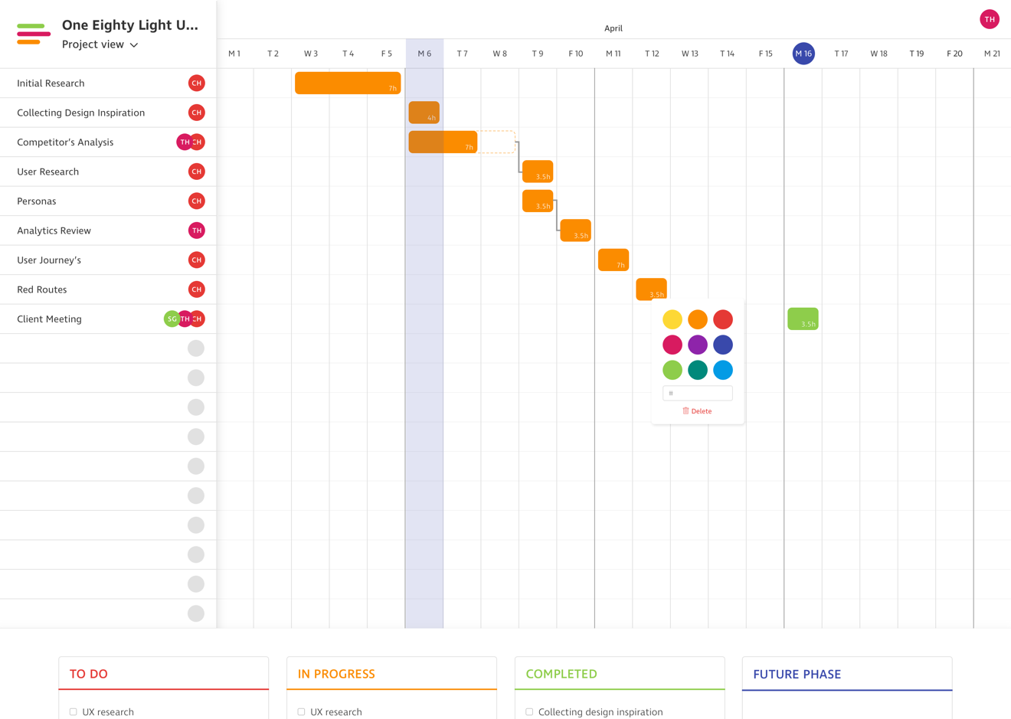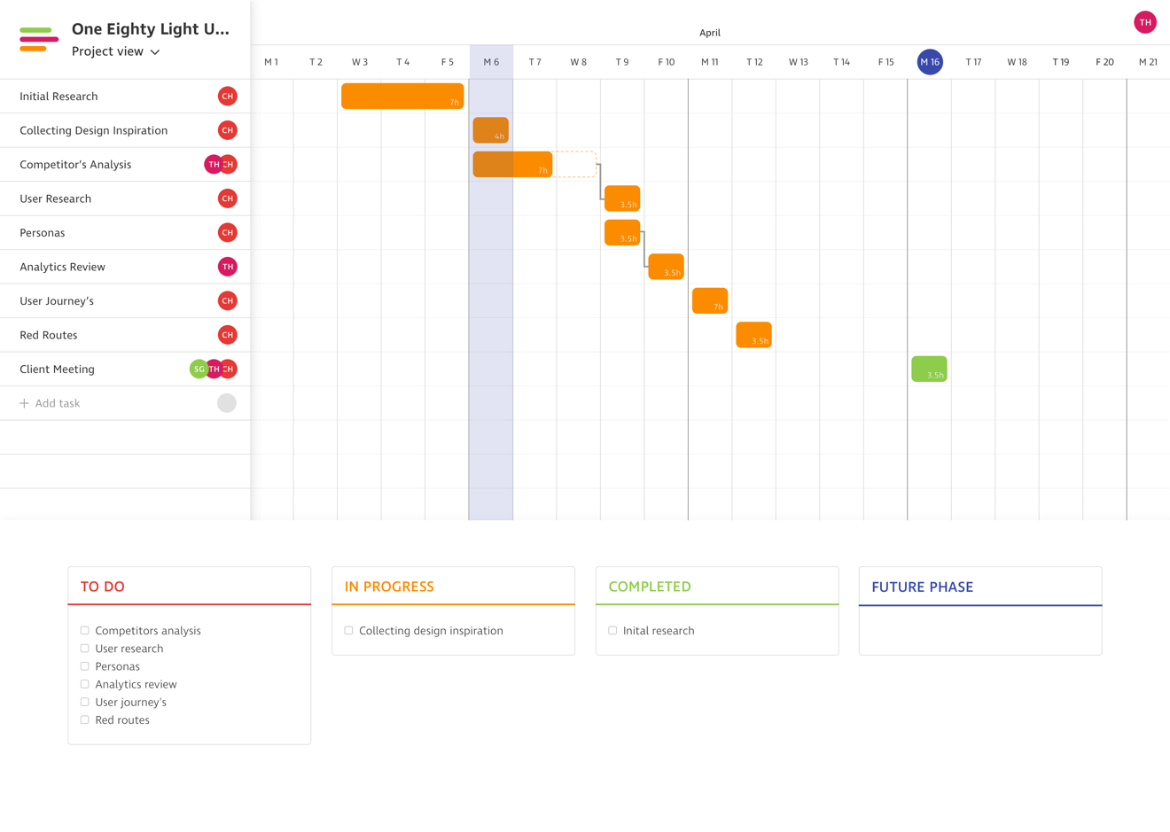**

**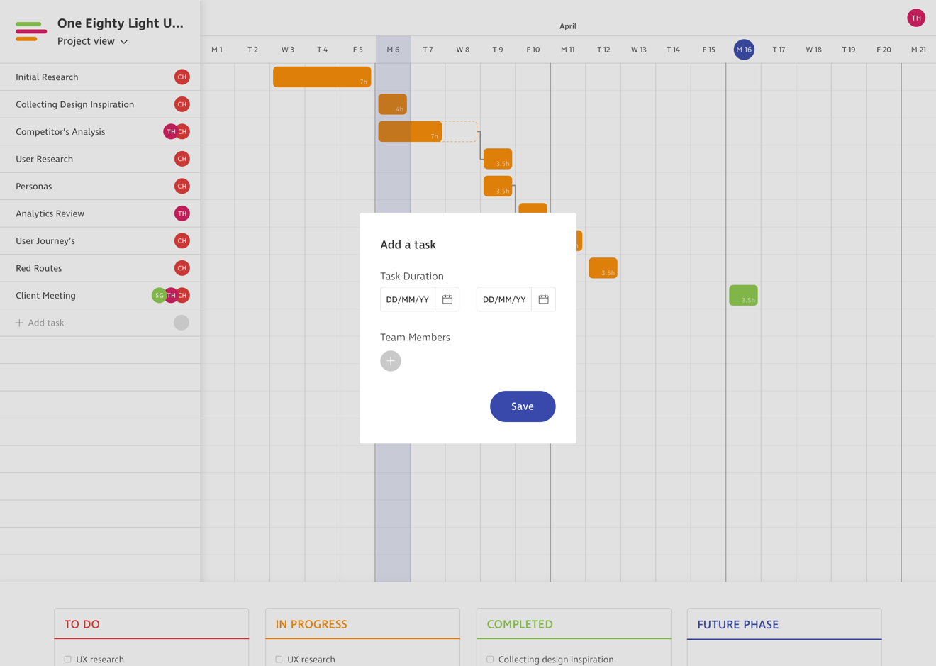**

## **Appendix X – Sketch Plugins**

|  |  |
| --- | --- |
| **Plugin** | **Description** |
| Nudg it | Nudg it allows users to set different spacing rules to the default ones in Sketch. This is particularly helpful when working to an 8px grid. In this instance the small nudge would be set to 1px and the large to 8px. This works really well and is hassle free. |
| Swatches | This plugin provides users with colour swatches of multiple different collections. There are Pantone swatches along with Material Design. This is a simple tool that prevents users from having to look online for these colour swatches. These can easily be added to global or document colours within a Sketch file. |
| Craft | Craft is a tool created by InVision to make Sketch more powerful. It adds multiple features:   1. InVision Sync allows users to upload all or selected artboards directly into InVision projects. This enables the Inspect feature to be used by developers. Inspect provides insights into layout padding, margins etc. 2. There is the ability to create libraries of styles. These can be shared with other team members working on the same project. 3. Craft allows users to use real content within designs. This can be anything from photography to copy. 4. There is a duplicate feature that allows designers to duplicate layer groups. This could be helpful for a design that has multiple blog post objects. 5. Freehand is a new tool that has been released. This allows users to share artboards with collaborators and comment / draw to present feedback on designs. 6. Ability to add photographs to artboards from Unsplash. |
| Auto Layout | Auto Layout helps to create responsive designs in Sketch It helps designers to stop designing for mobile, tablet and desktop devices and to think about the view port sizes in between. Although Project Pipeline is not a responsive design this tool has been used in preparation for future design work. |

## **Appendix X – Comparison of Medium Fidelity Wireframing Tools**

|  |  |  |
| --- | --- | --- |
|  | **Advantages** | **Disadvantages** |
| **Sketch** |  |  |
| **Balsamiq Mockups** |  |  |
| **Omnigraffle** |  |  |

## **Appendix X – Comparison of Prototyping Tools**

|  |  |  |
| --- | --- | --- |
|  | **Advantages** | **Disadvantages** |
| **InVision** |  |  |
| **Marvel** |  |  |
| **Just In Mind** |  |  |

## **Appendix X – Design Features**

|  |  |
| --- | --- |
| **Feature** | **Description** |
| Creating A Project | Users can create new projects to start building up project schedules. There is the option to add duration dates, daily rates, members and a title. |
| Editing A Project | Once a project has been created it can be edited. This gives users the opportunity to update duration, daily rates, members, titles and deleting a project. |
| Adding A Task | Tasks can be added in project schedule views. Once tasks have been added they can be rearranged using drag and drop functionality. |
| Dependencies | Dependencies can be created between tasks. This means that if one task overruns then it will effect the rest of the timeline. |
| Task History | If a task overruns, then this can be clearly seen in the timeline. This is useful information that will help to plan projects better in future. |
| Schedule Notifications | Users receive notifications daily about tasks that are in the pipeline. This can be toggled between a today, tomorrow and weekly view. |
| Card View | Each project has a card view where users can document to-do’s, in progress, completed and future phase work. |
| Integrate Apps | Users can integrate apps such as Harvest, Slack and Basecamp. |
| Milestones | Milestones can be added to project timelines in order to show billing deadlines and project deadlines. |
| Project View | A project view exists as the default view when creating new projects. |
| Team Member View | A team member view shows members availability and any scheduling conflicts that occur. |
| Weekends (On / Off) | Ability to toggle weekends on and off. |
| Email Notifications | Set up daily email notifications to see latest activity. |
| Budgeting | Set daily budgets so that users can be made aware when projects are running over or under budget. |

**Appendix X – Style Guide**

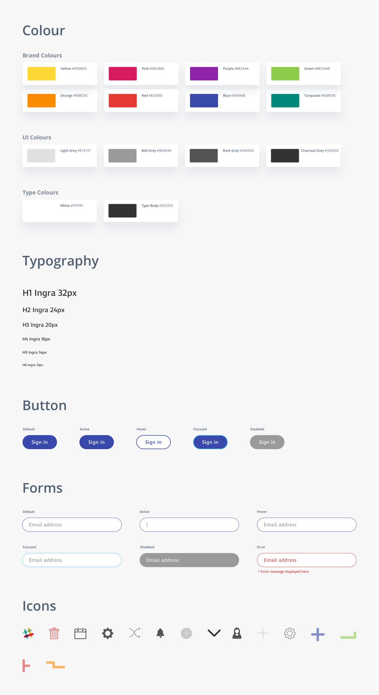

|  |  |  |  |  |
| --- | --- | --- | --- | --- |
| Risk | Likelihood | Impact | Impact Description | Contingency Plan |
| Users unavailable for user interviews | **Medium** | **High** | Not being able to get 5 users available to interview within the time frames for the project. | Ensure that preparation work is done to find 5 users and communication is clear and consistent. |
| Inaccurate estimates | **Medium** | **High** | Making estimates that are too ambitious and will affect the progression of the project. | Thorough research into project timings and allowing extra time at the end of the project incase deadlines overrun. |
| Scope creep | **Low** | **High** | Features and functionalities that were not originally planned for move into the project specifications. | Set out a clear list of the products specifications, which will be shared with The Idea Bureau. This will be discussed and agreed upon before starting any design work. |
| Delays in website content | **Medium** | **Medium** | Before the design phase there is a risk of the websites content still not being approved. | Designing with content first is the ideal scenario. However, it will not make it impossible to continue with designs. This would just be best practice. To avoid this from happening meetings with The Idea Bureau will be held to discuss content. |
| Decision delays | **Low** | **High** | This involves there being delays in feedback on wireframes and high fidelity designs. | This would hold up the design process and could make working to deadlines harder. Using collaborative tools such as InVision will help to encourage The Idea Bureau to feedback on the designs quicker. |
| Update bugs with Sketch | **Low** | **High** | This refers to the possibility of a Sketch update containing bugs and preventing design work. | The likelihood of this happening is low. Over the duration of Sketch being around there has only been one time where a big issue has occurred. This was handled within a couple hours of the update. If the problem is ongoing then other design tools such as Figma and Adobe XD could be used. |
| InVision sync with Craft not working | **Medium** | **Medium** | Craft is a plugin for Sketch and if this does not function properly it could mean that Sketch artboards will not work with InVision’s Inspect feature. | If the final designs can not be uploaded to InVision through the Craft plugin it means that the developers will not have access to assets and styles. In the event that this does happen Zeplin will be used instead. This will mean that the design files will still be production ready for the development team at The Idea Bureau. |
| No assistance with the usability testing lab | **Medium** | **High** | Not having anyone to help out in the usability testing lab. | To use the testing lab effectively there needs to be at least 2 people in the lab. If this is not possible then it will make the usability testing less effective and more stressful. To stop this from happening preparation is going to be done in advance. |
| Failing to meet company standards | **Low** | **High** | This refers to not completing work to The Idea Bureau’s standard as this is an industry based project. | To ensure this does not happen there will be a high level of collaboration throughout the project. This will involve using Slack, Basecamp and having regular meetings. |
| Design lacking flexibility | **Medium** | **High** | This risk is about not having a design system that can easily be tweaked and worked on iteratively. | To prevent this from becoming a problem a style guide will be created. This will document all of the base styles. Symbols in Sketch will also be used so that tweaks can be made to designs quickly and effectively. |